


University of Colorado Medicine
Attorney Requests

Process Definition Document (PDD)

Table of Contents
I. Change Control 3
1.1 Control Guidelines 3
1.2 Document Revisions 3
1.3 Known Future Initiatives 3
II. Introduction 4
2.1 Purpose 4
2.2 Objectives 4
2.3 Key Contacts 4
2.4 Prerequisite Checklist 5
III. Process Outline 5
3.1 Process Overview 5
3.2 Applications Used 6
3.3 Data Inputs 6
3.4 Process Map 7
3.4.1 High Level Process Map 7
3.4.2 Detailed Level Process Map 8
3.4.3 Exceptions Handling 11
3.5 Out of Scope for RPA 11
IV. Metrics 11
4.1 Automation Performance 12
4.2 Business Performance 12
V. Approval 12
5.1 Approval 12

Change Control
This section serves as documentation of all known changes, revisions, and future initiatives that arise.

1.1 Control Guidelines
The guidelines below are followed when changes are requested from the first finalized document. This ensures that the change is feasible and appropriate.
Description | Point of contact(s) | Notes/comments
Approval  (PDD completion, user acceptance, and go-live) | Jennifer Snyder, <Jennifer.Snyder@cumedicine.us>  Lawson, Diane <Shawna.Lawson@cumedicine.us>
Must review  (change requests, deliverables, etc.) | Lawson, Diane <Shawna.Lawson@cumedicine.us>  Dantzler, Jasmine <Jasmine.Dantzler@cumedicine.us>

1.2 Document Revisions
Rev. # | Date | Section/page# | Revision summary | Author
0.1 | 4/24/2025 | All | Initial Draft | Harper Bush
0.2 | 5/12/2025 | Process Map | Edits from Meeting | Harper Bush
0.3 | 5/23/2025 | Process Map | Edits from PSD Review Email | Harper Bush

1.3 Known Future Initiatives
The table below will capture the proposed business, process or application changes to be made soon that would impact the process at hand (if any).
Process action(s) identified | Impact on current automation | Contact person | Expected completion date
 |  |  | unknown

Existing Dependencies: No
Existing Repeatable Modules: Log into IDX
Future Repeatable Modules:

Introduction
This section outlines the documents intended use, as well as applicable stakeholders who will be involved in decision making throughout the automation process.

2.1 Purpose
The Process Definition Document is a development guide that details the process being automated. It serves as a consolidated document for development approval, and should be used following completion of the Identify & Prioritize Toolkits.
The PDD should be authored by a Solution Architect. A Process Owner should consult on the accuracy of the content. Once completed, the Solution Architect can hand off to the RPA developer(s) for development.
The PDD should always be kept up to date.

2.2 Objectives
The automation objectives expected by the Process Owner after automation of the selected business process are: The EDM Indexing process has been selected for RPA within PSD process area.

2.3 Key Contacts
Add stakeholders that contribute to the content and need to be informed of changes:
Governance member | Name | Title | Contact
Process Reviewer | Jennifer Snyder | Associate Director of DSD | Jennifer.Snyder@cumedicine.us
Process SME | Diane Lawson  Jasmine Dantzler | AD of Patient Services  Patient Support Coordinator | Shawna.Lawson@cumedicine.us  Jasmine.Dantzler@cumedicine.us
Process Owner | Diane Lawson | AD of Patient Services | Shawna.Lawson@cumedicine.us
RPA Developer | Justin Cole | RPA Developer | Justin.cole@cumedicine.us
RPA BA | Harper Bush | Sr Automation Analyst | Harper.bush@cumedicine.us
*Add additional columns and titles as needed – this should be limited to key stakeholders in the automation process, and not the entirety of the Governance team

Process Outline
This section outlines the applicable details required for automation development.

3.1 Process Overview
The Process Overview contains general information about the process before the automation is built. The Solutions Architect and Process Owner will coordinate to fill out required details below; most of which can be transferred from the Identify Toolkit.
Item | Answer/description
Process name | Attorney Requests
Short description | Read and Download ROI PDFs from the PSD – Attorney Requests inbox. Determine if the request has all the required HIPPA info. Gather patient information and request date range from the PDF.  Find the patient in IDX under ETM/Customer service. Check the boxes by each invoice that falls within the date range from the PDF. Demand Electronic Statement and fill in the required elements to print to email.  Download the statement from email and merge with the original request PDF. Reply to Original Request email with the Merged File Attached. In IDX, add a task note and completed outcome to the task and scan in the merged PDF.
Process area/department | Patient Services
Process restrictions/prerequisites
Process schedule & frequency | Daily – Time TBD
Process execution time (per action) | 15 minutes per request
Data input source | GECBI/Other
Data input time (export/queue)
Current manual daily volume | 20
*Add more rows to the table to include relevant data for the automation process. No fields should be left empty. Use “n/a” for the items that don`t apply to the selected business process.

3.2 Applications Used
Populate the table below with a comprehensive list of all applications utilized throughout the automation process.
Application | Environment | Access requirements | Access Status
athenaIDX | V7.2 | Credentials | Complete
*Add more rows to the table to include the complete list of applications used throughout the automation process.

3.3 Data Inputs
The following table captures data input details of the process being automated. Outline the data points in the table below if the data field is used in the automation.

Field name | Data type | Input Natively Digital? | Input Structured?
str_PatientName | String | N | N
Dt_PatientDOB | Date | N | N
startDate | Date | N | N
endDate | Date | N | N
* Native Digital: This is data that was created digitally e.g., excel, database or application reports etc. The non-native digital inputs are usually scanned images.
* Structured Data: has a predictable format and exists in fixed fields (e.g., an excel cell or a field in a form) and is tangible. Non-structured data would be a concatenated field, or free text note containing one specified field.

3.4 Process Map
This section contains a process map that represents a step-by-step guide to the process being automated.

3.4.1 High Level Process Map
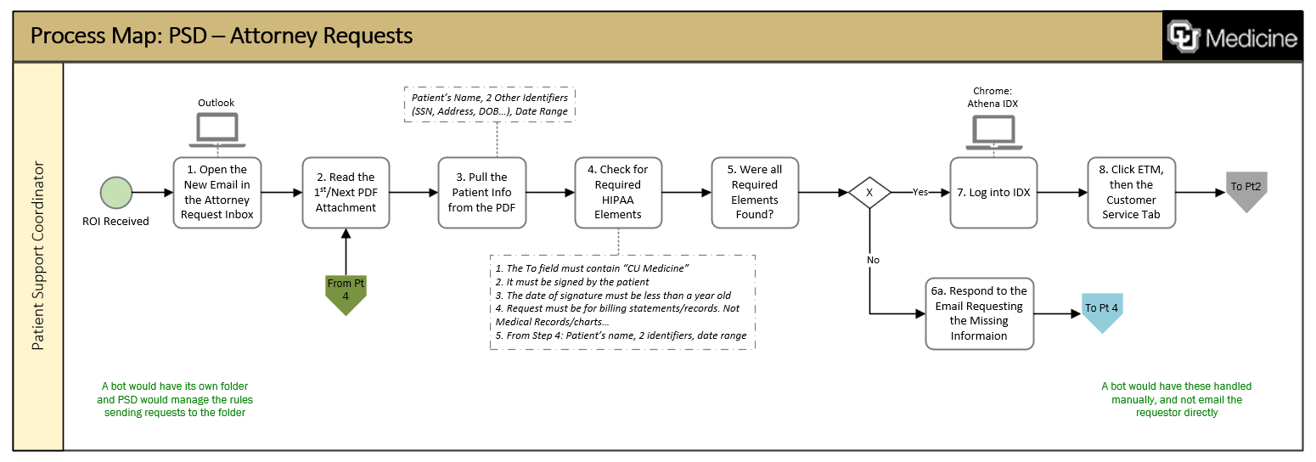
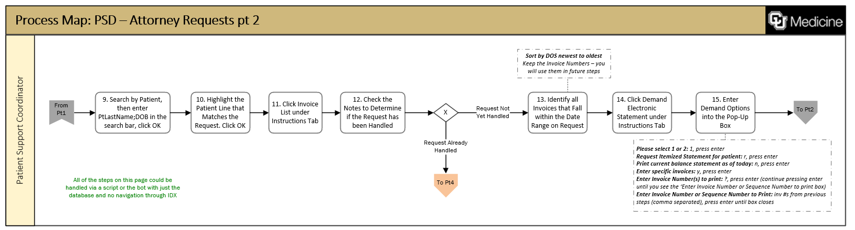
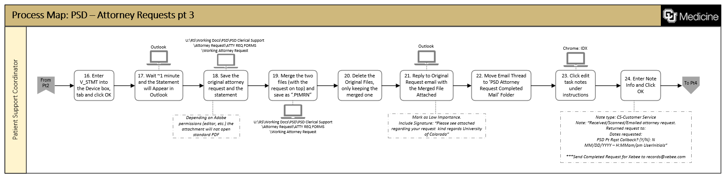
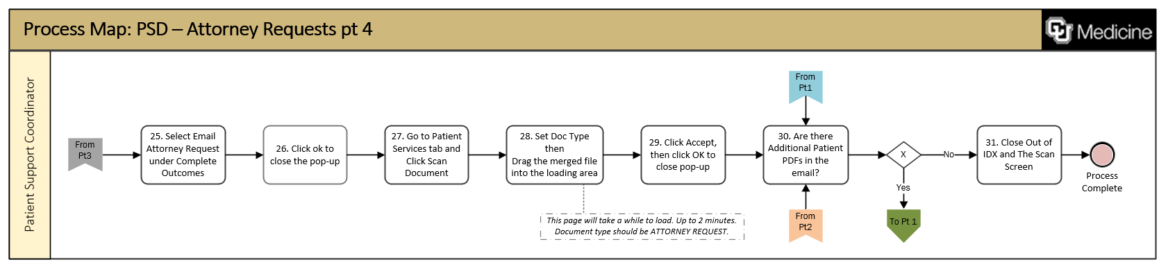
This section should be used in discussions with the Automation Governance team to approve development.

3.4.2 Detail Level Process Map
This section describes the process at an action level, providing additional details to its corresponding step shown above. The identification of exceptions is essential for developers and must be called out in the table below.

Action | Input | Description | Exception
Read New Emails |  | Note: in the future, the bot will either open emails from a folder or receive auto forwards – PSD can set the outlook rules for these emails so that only the Xeebee and Lexitas emails will be sent to the bot  - Open New Email(s) in the PSD – Attorney Requests Inbox  - The emails we can work with will have PDF attachments that are not encrypted
Read and Validate PDF |  | - Check if the PDF contains all the requirements below:  - The To field must contain “CU Medicine”  - It must be signed by the patient  - The date of signature must be less than a year old  - Request must be for billing statements/records. Not Medical Records/charts…  - Patient’s Name  - 2 Identifiers (DOB, Address, SSN)  - Date Range of Request | Loop Start  If the requirements are not met: Respond to the Email Requesting the Missing Information and move on to the next request.
Gather Patient information from PDF |  | - Get the Patient’s Name  - Patient’s DOB  - Date range of the Request
Log Into IDX | AthenaIDX User credentials | - Open AthenaIDX  - enter user credentials and click log in  - Click OK to get to the patient search screen | Changed credentials or failure to open athenaIDX
Find the Patient In ETM Customer Service | PtLastName  PtDOB | - Click ETM  - Click the Customer service tab  - Select Search by Patient  - Enter PtLastName;PtDOB in the search bar  - Click Ok to Search  - Highlight the Patient Line that Matches the Request  - Click OK
Determine if already Handled |  | - Check the notes to see if the ROI was already handled | If yes, go to LOOP END  If No, move forward
Demand Electronic Statement for Selected Invoices | DateRange | - Click Invoice List under Instructions Tab  - Sort by DOS newest to oldest  - Identify all Invoices that Fall within the Date Range on Request (keep the invoice numbers for later use)  - Click Demand Electronic Statement under Instructions Tab
Enter Demand Options into the Pop-Up Box | InvoiceNumber(s) from above step | Fill in the options as specified below:  - Please select 1 or 2: 1, press enter  - Request Itemized Statement for patient: r, press enter  - Print current balance statement as of today: n, press enter  - Enter specific invoices: y, press enter  - Enter Invoice Number(s) to print: inv #s from previous steps (comma separated), press enter  - Press Enter 3 Times (until box closes)  Enter V_STMT into the Device box, tab and click OK
Get the Statement from Outlook | ptMRN | - Wait ~1 minute for statement email to arrive in inbox.  - Save the statement and the original request pdfs to U:\RS\Working Docs\PSD\PSD Clerical Support\Attorney Request\ATTY REQ FORMS\Working Attorney Request  - Merge the 2 files with the request at the top and save as “.ptMRN.pdf”  - Delete the 2 original files (only keep the merged file)
Reply to Request |  | - Reply to Original Request email with the Merged File Attached  - Mark as Low Importance  - Include Signature: “Please see attached regarding your request. Kind regards University of Colorado”  - Move the Email Thread to the PSD Attorney Request Completed Mail Folder
Add task Note |  | - Click edit task notes under instructions  - Enter the following note details:  - Note type: CS-Customer Service  - Note:  “ Received/Scanned/Emailed atty req.  Returned req to:  Dates Requested  PSD Pt Rqst Callback? (Y/N): N MM/DD/YYYY – H:MMam/pm UserInitials”  - Click OK
Add Completed Outcome |  | - Select Email Attorney Request under Complete Outcomes  - Click ok to close the pop-up
Are there additional patient requests? |  | - If yes – go to Loop Start  - If no – move forward | Loop Ends
Log out of IDX

3.4.3 Exceptions Handling
All exceptions must be documented in the table below. An exception is any scenario where the automation makes decisions based on business or process variables. Examples are error messages and proprietary results from an application.
There are two exception types:
- Business = Decision based, where a data input requires an output or record assigned.
- Process = Application based, where a screen/application requires a predetermined action.
Please list the applicable process step from the section above and its exception below:
Process step | Exception type | Scenario encountered (If) | Resolution (Then)
Log into athanaIDX | Process | Failure to Open athenaIDX | Close the open application and retry n times. If all tries fail, send a failure to launch athenaIDX notification to the RPA team
Log into athanaIDX | Process | Failure to login because credentials have changed | Send out a failure to login notification to the RPA team
Read and Validate PDF | Process | HIPPA Requirements are Not Met | Respond to the Email Requesting the Missing Information and move on to the next request.

Please list all automation actions that are out of scope or unobtainable in the table below:
Activity/action | Reason for out of scope | Impact on process | Possible measures for future avoidance
Reading Encrypted Emails | Requires different handling for each encryption method | Fewer emails can be handled
*Add more rows to the table to reflect the complete documentation provided to support the RPA process.

V. Approval
This section should be used when the PDD has been reviewed and approved by all stakeholders.

Approval
Diane Lawson: 5/27/2025

