Deaconess
Additional Documentation - Anthem
Process Definition Document

Purpose: The Process Definition Document (PDD) formalizes the final design of an automation solution. It functions as an approval artifact for automation and operations teams, enabling the transition from design to development once approved.

Table of Contents
I. Automation Overview 3
1.1 Objectives 3
1.2 Operational metrics 3
1.3 Design Team 3
II. Automation Details 3
2.1 Automation Overview 3
2.2 Applications 3
2.3 Global Process Map 4
2.4 Detailed Process 4
2.4 Toolkit documentation 17
2.5 Out of scope 18
III. Approval 18
3.1 Approval 18
3.2 Future Initiatives 18
3.3 Downtime Plans 18
3.4 Revisions 19

Automation Overview

1.1 Objectives
The automation will achieve
- Fulfillment of additional documentation requests from Anthem via Availity
  - Requesting or downloading documentation in Epic
  - Consolidation of documentation into a single file
  - Uploading documentation into Availity
  - Notation of upload into Epic

1.2 Operational metrics
The automation will impact the following operational metrics
- [additional metrics to be determined]

1.3 Design Team
The following individuals contributed to the automation design, must be informed of changes, and agree to support the maintenance of this automation
Name | Role / Title | Contact
Abby Schmitt | Operational Owner | Abby.Schmitt@hcrsolutions.com
Kirstie Springston | Operational SME(s) | Kirstie.Springston@hcrsolutions.com
Michael Bordador | Solution Architect | Michael.Bordador@tarponhealth.com
Matt Cheney | Developer | Matt.Cheney@tarponhealth.com

Automation Details

2.1 Automation Overview
Item | Description
Area / Department
Automation Name | Additional documentation - Anthem
Automation Description | Bot will fulfill additional documentation requests from Anthem

2.2 Applications
The table below lists the applications being utilized by the automation
Application | Comments / Access Needs
Epic | Require ability to access user accounts and post fulfillment comments
Availity | Require ability to view requests and upload requested documentation

2.3 Global Process Map
The diagram below contains the steps the automation will take (the ‘to-be’ process map)
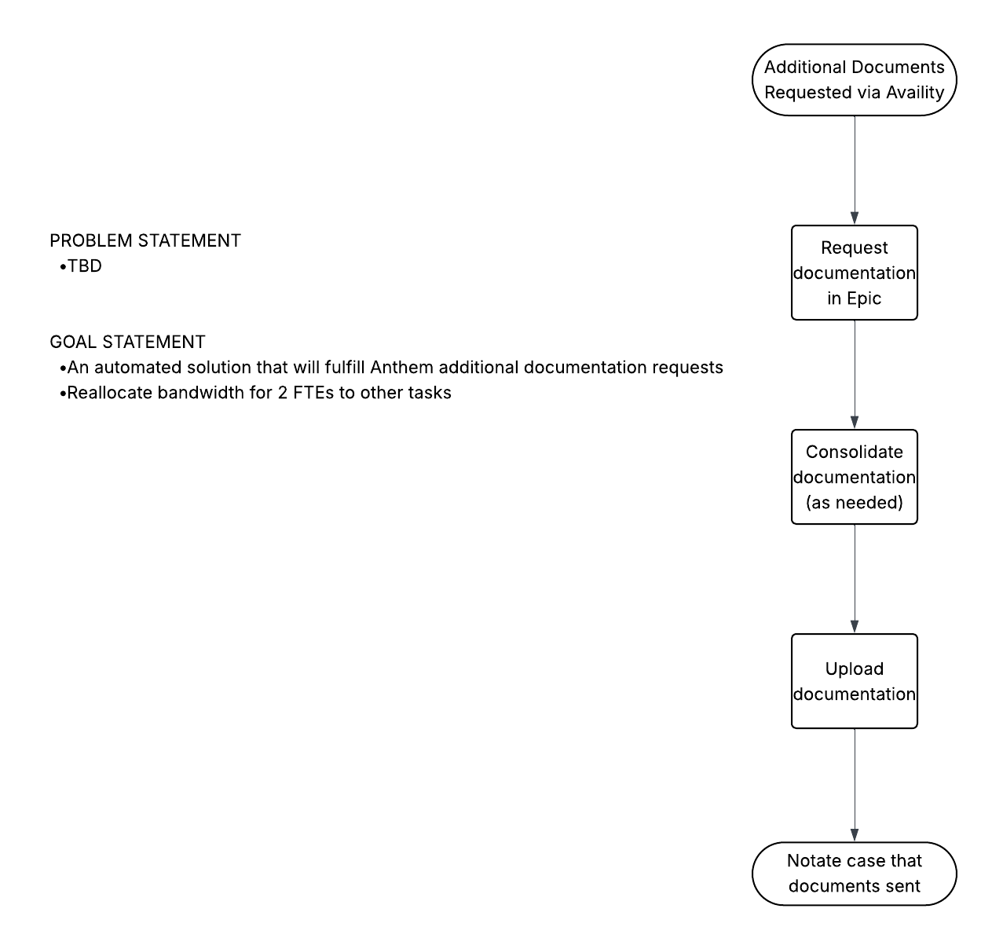

2.4 Detailed Process
Assumptions:
- [PLACEHOLDER]
Steps below outline the future state process:
- Bot Schedule
  - Process will be run off hours (5PM – 5AM Central Time) to ensure that BOT does not collide with normal workflow
- Download worklist
  - Login to Availity with stored credentials
  - Navigate to ‘Claims and Payments’
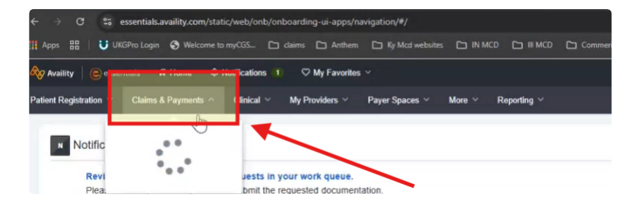
  - Navigate to ‘Attachments-New’ from Claims section
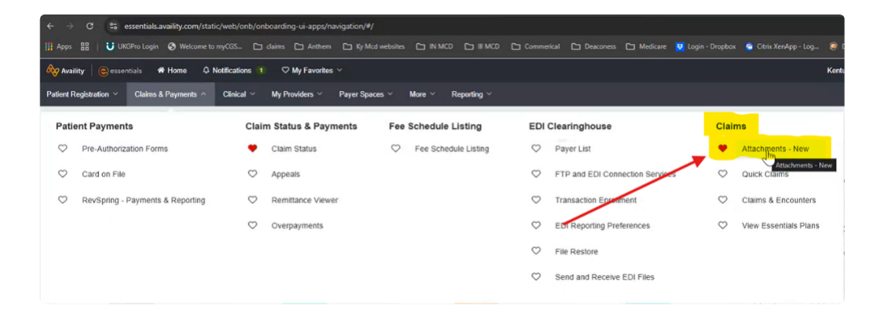
  - Click ‘Filter List’ to expose filter options
    - Transaction type = ‘Facility Claim Attachment’
    - Request Number = ‘RFAI’
  - Trigger Dispatcher to download flat file output list and store into array
    - Navigate to ‘Claims and Payments’
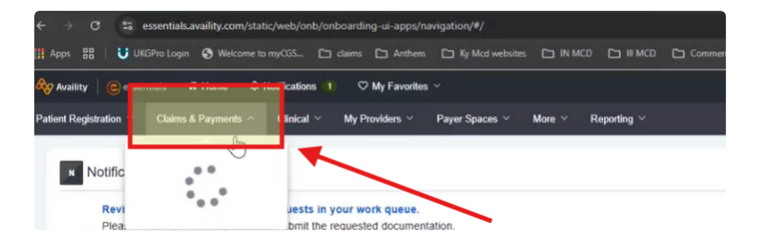
    - Click ‘Reporting’
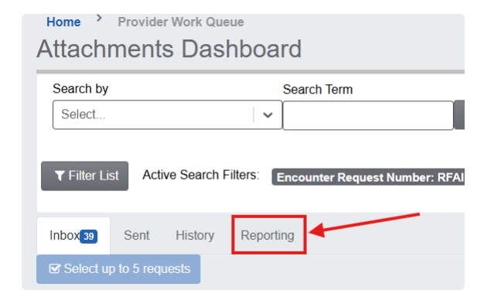
    - Under ‘Select a Workqueue’ dropdown, select ‘Inbox’
    - Click ‘Export CSV’
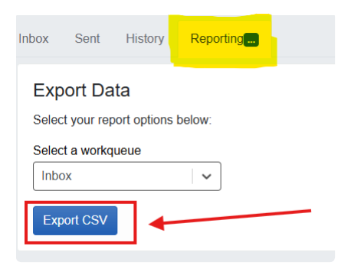
- Performer to capture Epic lookup elements
  - If HAR prefix = JH (Jennie Stewart Medical Center) and DOS >= 10/5/2025 or if HAR prefix = HB, BH, FH, HD, then capture Epic lookup elements
    - HAR
      - First 5 characters of ‘Patient Account Number’ in Availity export
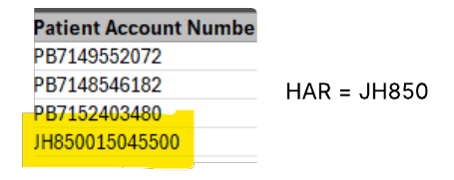
    - Pt Acct Number
      - 10 characters of ‘Patient Account Number in Availity export
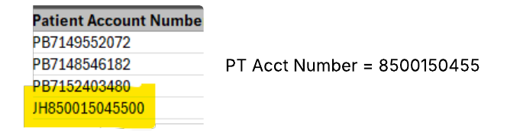
    - The following fields can be pulled as is from Availity export
      - Name
      - DOS
      - DOB
      - Billed Amount
  - Else if HAR prefix = JH and account is not INPT or OBS then mark as exception and move on to next record
    - Exception message: ‘JH accounts prior to 10/5/2025 are out of scope’
  - Lookup elements to be stored in lookup array
- Performer to look up accounts in Epic
  - Launch lookup array
  - Login to Epic with stored credentials
  - Launch Hospital Account Lookup
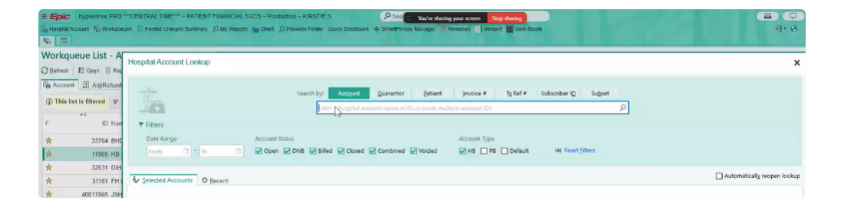
  - Enter Pt Acct Number into Account Search field
  - Validate that Pt Name, DOS, DOB, and Pt Acct Number from lookup array match search result
    - If yes, click ‘Accept’
    - If no, mark as exception and move on to next record
      - Exception message: ‘Epic search results do not match Availity request.’
  - Open Patient Chart
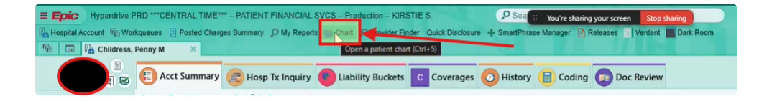
  - Click on Patient tile and Accept
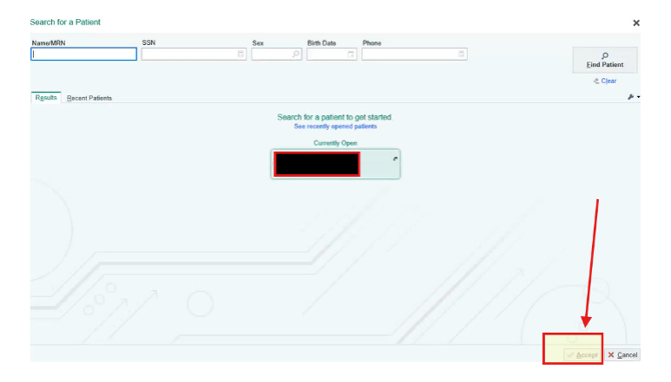
  - From ‘Account Overview’ section, take note of PT Type under PT Name
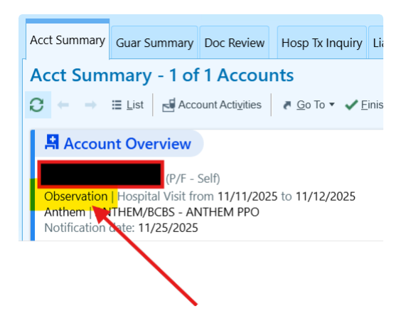
- Performer to gather/ compile records
  - If Claim is an INPT claim, then records need to be requested before uploading
    - Navigate to ‘Liability Buckets’
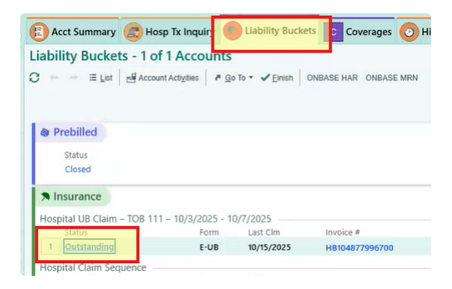
    - Click ‘Outstanding’
    - Look for option to reprint records in ‘Claims’ section
      - If option to reprint, then:
        - Click ‘Reprint’
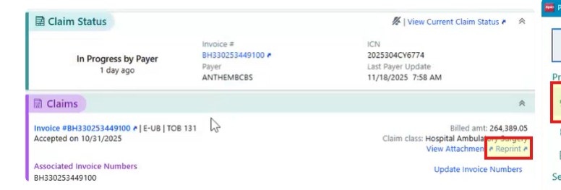
        - Click to show available printers under ‘Printer’ heading
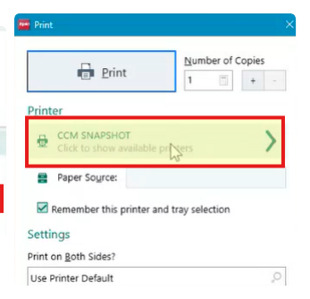
        - Choose PDF Xchange Lite under Local Printers and click ‘Print’
          - TODO: Better means of this??
        - Save file at the following network location: \\deaconess.com\shares\Departments\Patient Financial Service\Patient Accounts\Share\RequestedCharts\Automated Documentation for Upload\COMBINED PAGES
          - TODO: create subfolder
      - If no option to reprint, then need to request records
        - Click ‘Account Activities’
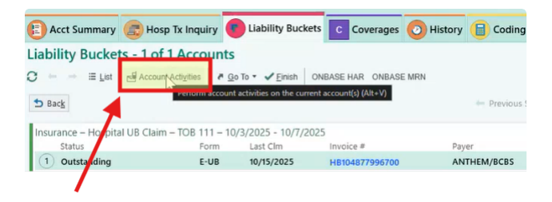
        - Click ‘Set Billing Indicator [299]’
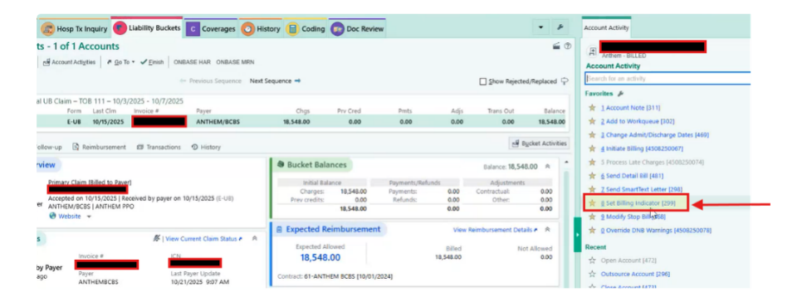
        - Type '.hbrecords' in Notes box to expose HBRECORDS smartphrase and press enter
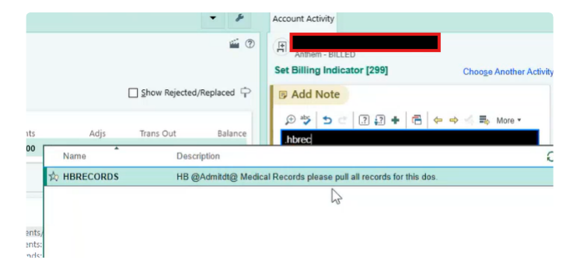
        - Click down arrow beside 'records' in smartphrase and choose option to NOT put on CD if > 500 pages
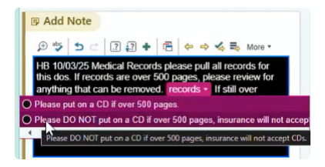
        - Enter '1273' in 'Update Billing indicators' and click 'Add'
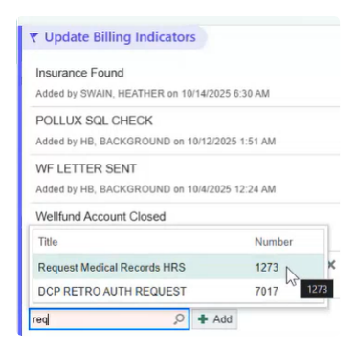
        - Click 'Accept'
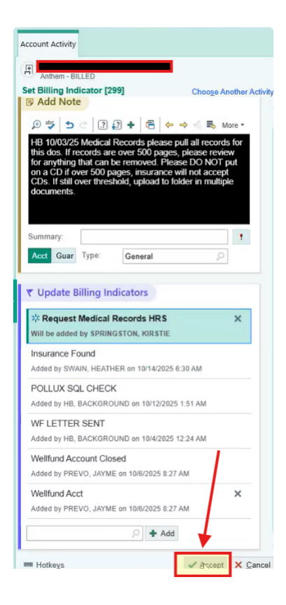
        - Navigate to appropriate shared folder within 7 days of request to gather records
          - Begin search for file 2 business days after initial request
          - Crosswalk to shared folders
Site Name | HAR Prefix | Shared Folder Path
Deaconess | HB1, HB4, HB9 | \\deaconess.com\shares\Departments\Patient Financial Service\Patient Accounts\Share\RequestedCharts
Deaconess Women's | HB51 | \\deaconess.com\shares\Departments\Patient Financial Service\Patient Accounts\Share\RequestedCharts\TWH Records
Deaconess Gibson | HB80 | \\deaconess.com\shares\Departments\Patient Financial Service\Patient Accounts\Share\RequestedCharts\DGH Records
Deaconess Memorial | HB78 | \\deaconess.com\shares\Departments\Patient Financial Service\Patient Accounts\Share\RequestedCharts\DMMC Records
Deaconess IL | HD | \\deaconess.com\shares\Departments\Patient Financial Service\Patient Accounts\Share\RequestedCharts\DIH Records
Baptist | BH | \\deaconess.com\shares\Departments\Patient Financial Service\Patient Accounts\Share\RequestedCharts\BHDM Records
Jennie Stewart | JH | \\deaconess.com\shares\Departments\Patient Financial Service\Patient Accounts\Share\RequestedCharts\JSH Records

          - File Name will match Pt Name in respective folder
          - Save file copy at the following network location: \\deaconess.com\shares\Departments\Patient Financial Service\Patient Accounts\Share\RequestedCharts\Automated Documentation for Upload\REQUESTED DOCS
            - TODO: create subfolder
          - Move file to ‘Completed’ folder once uploaded to Availity
            - If file is not present, then retry search for 3 business days
            - If file is not present after 7 business days, enter the following exception
              - ‘Chart details not uploaded to shared drive within 7 business days’

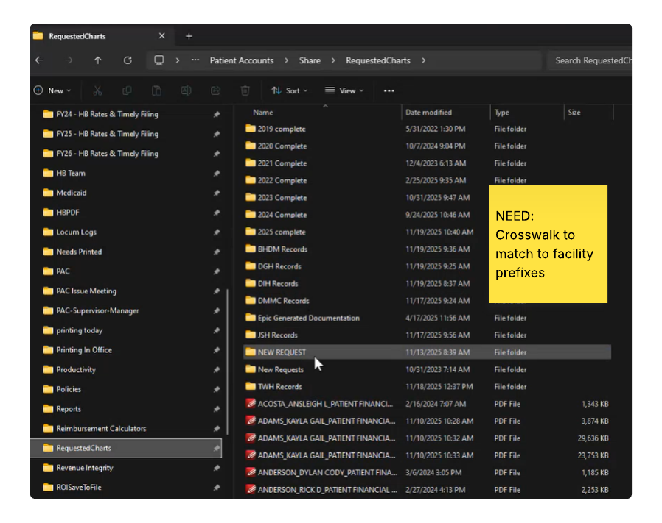
  - If Claim is not INPT claim, records can be downloaded
    - Click ‘Chart Review’
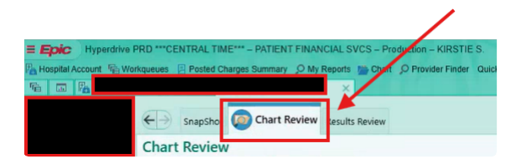
    - Click ‘Encounters’ tab and click ‘Filters’

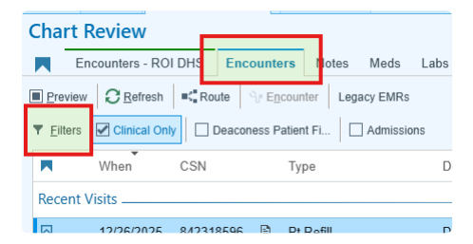
    - Set filter for DOS date range
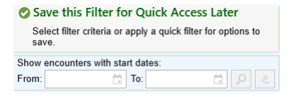
    - Enter DOS from WQ file into filter
      - Does DOS from input file yield data?
        - If yes, go to step (v)
        - If yes, and case is ‘Break the Glass’
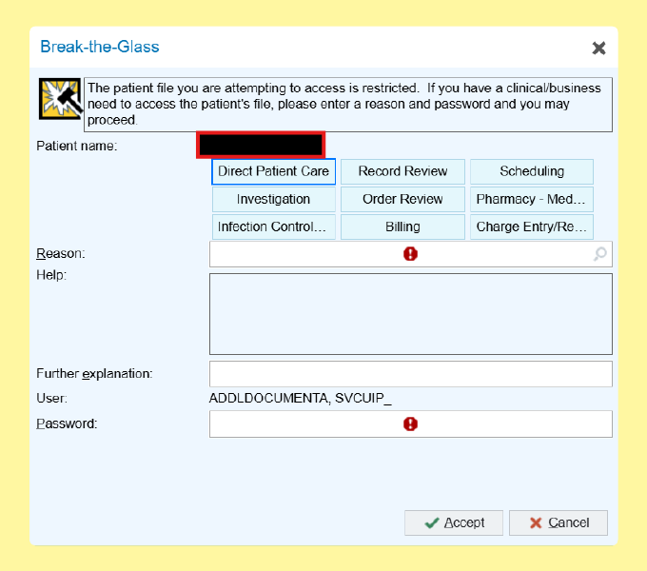
          - Create Business Exception to route case back to Business Team for manual processing and move to next record in WQ for processing
        - If no, create a business exception that no data for DOS is available and move to next record in WQ for processing

    - Extract records for each line item
      - Click line item to open side menu
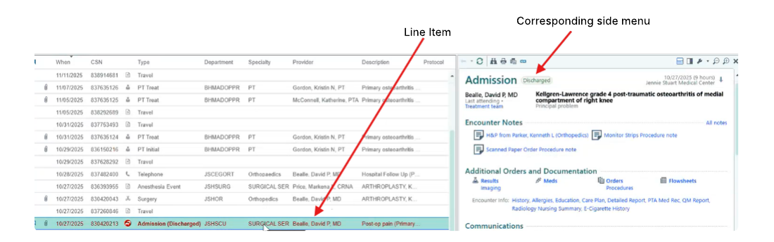
      - Click ‘Print Current Report’ icon
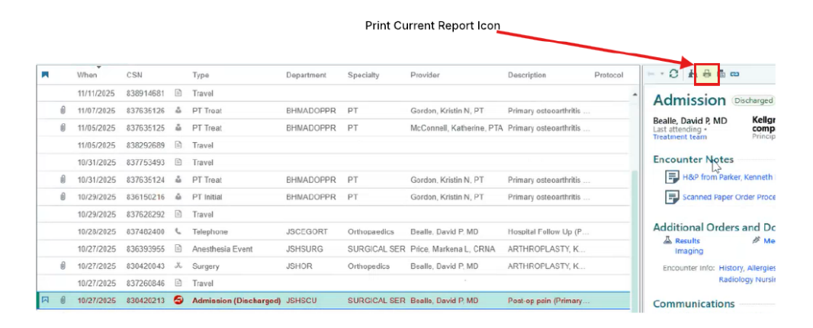
      - Click ‘Print All’ in dialog box
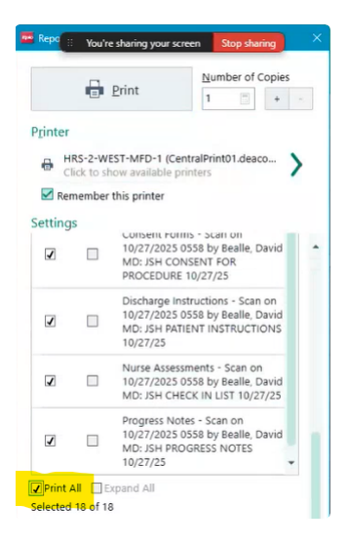
      - Change printer to PDF Xchange Lite and click print
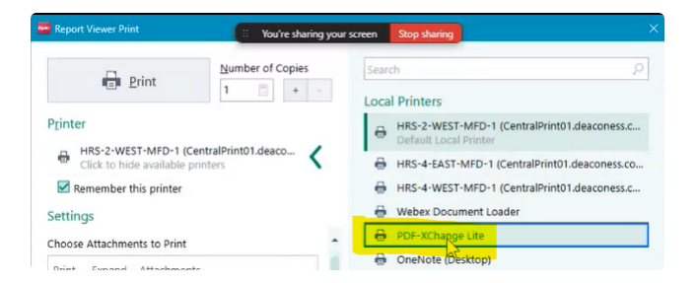
      - Select destination for downloads (\\deaconess.com\shares\Departments\Patient Financial Service\Patient Accounts\Share\RequestedCharts\Automated Documentation for Upload\COMBINED PAGES)
        - TODO: Create above subfolder
      - Save each page as [LastName_DOS-Attachment#]
        - Ex. Adams_102725-1
      - Click ‘Save’
      - Repeat for each corresponding file with ascending attachment #
        - Adams_101725-2
        - Adams_102725-3
        - Adams_102725-4
      - Once all files downloaded and names, select all files, right click and show more options
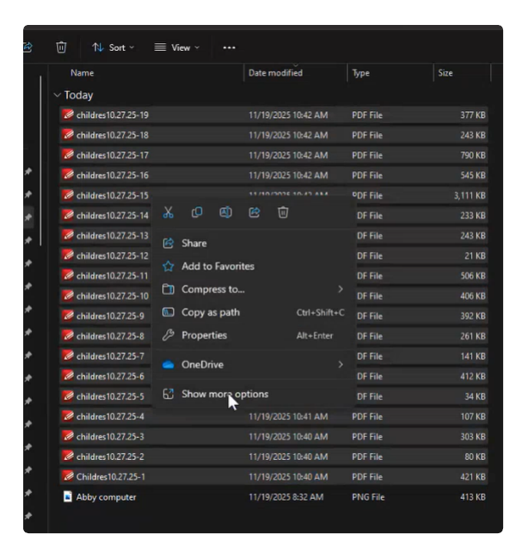
      - Click ‘Combine in PDF Xchange Editor’
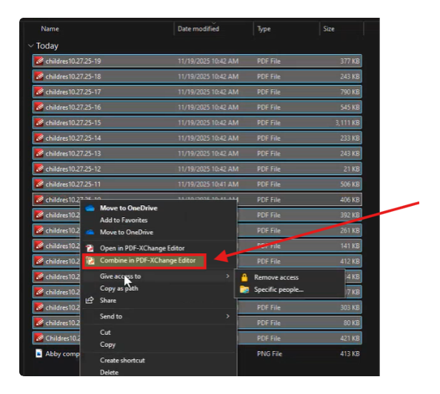
      - Click OK
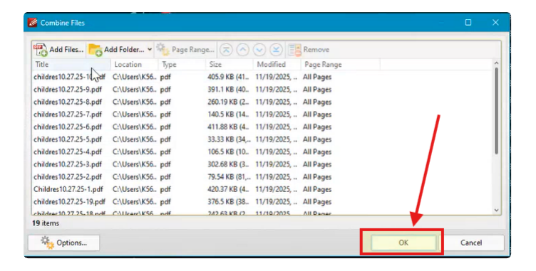
      - Click ‘File’ from New Document pop up
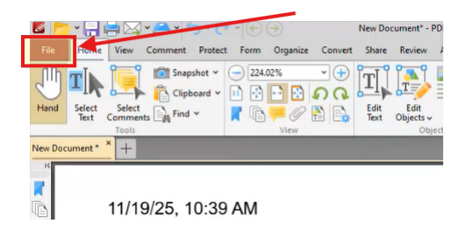
      - Click ‘Save As’ into designated Save File path
      - Close Document

- Upload attachments into Availity
  - Launch Availity using stored credentials
  - Repeat steps 2(a) – 2(d)
  - Search for attachment request in shared folder
    - \\deaconess.com\shares\Departments\Patient Financial Service\Patient Accounts\Share\RequestedCharts\Automated Documentation for Upload\REQUESTED DOCS
    - TODO: Create subfolder in above file path
  - Navigate to ‘Attachments Detail’ and click ‘Add File’
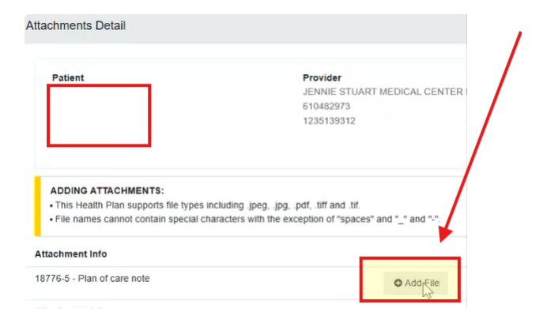
  - Selected previously saved file in designed network file path and click ‘Open’
  - Click ‘Submit’
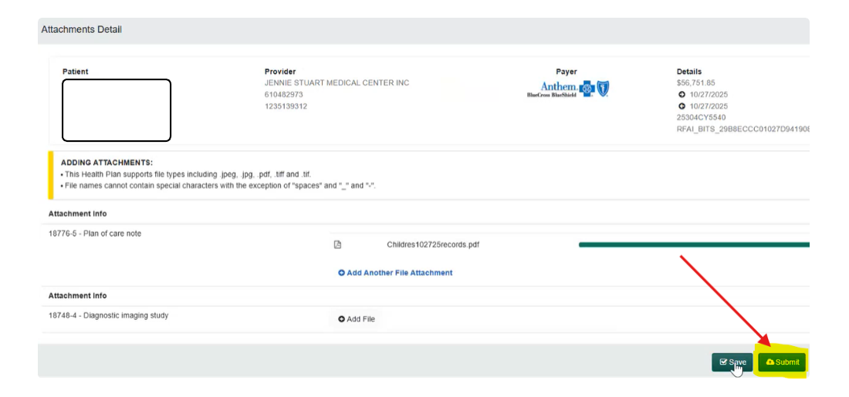
- Enter note into Epic
  - Repeat steps 4(b) – 4(g)
  - Click ‘Quick Disclosure’ and click Pt in ‘Currently Open’ box
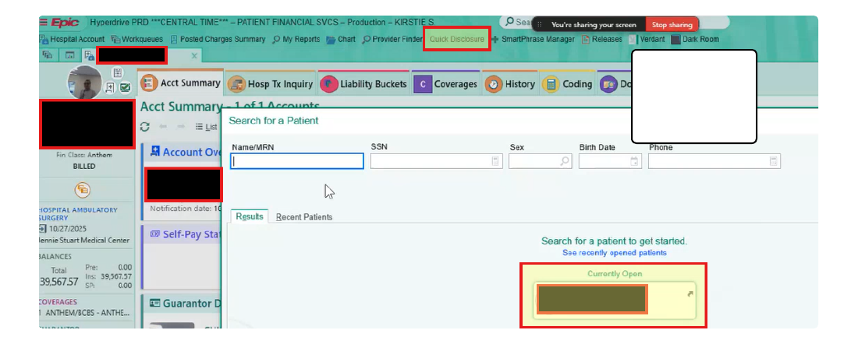
  - Select ‘Anthem [8100000485]’
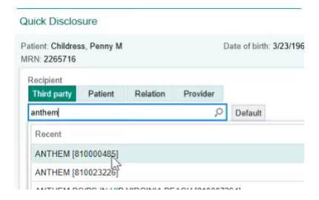
  - Select ‘Billing/ Claims Additional Info’ for ‘Purpose’ and ‘Progress Notes’ for ‘Info Released’
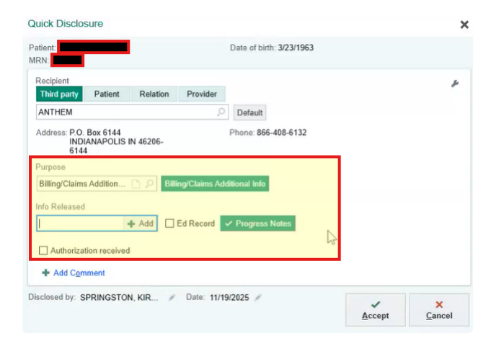
  - Click ‘Accept’
  - Navigate to ‘Account Activities’
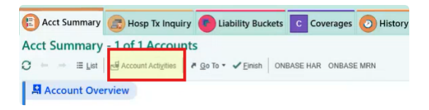
  - Click ‘Account Note’
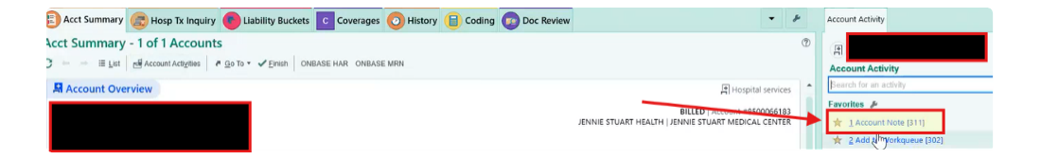
  - Enter ‘.iosa’ to expose relevant smartphrase
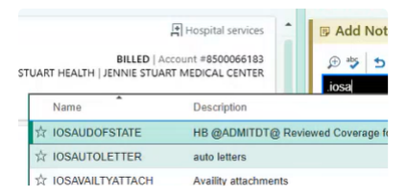
  - Select IOSAVAILITYATTACH smartphrase
  - Once smartphase is populated, click on drop down beside ‘AvailityAttachment’ and select ‘Anthem Pulled Medical Records from chart’ option
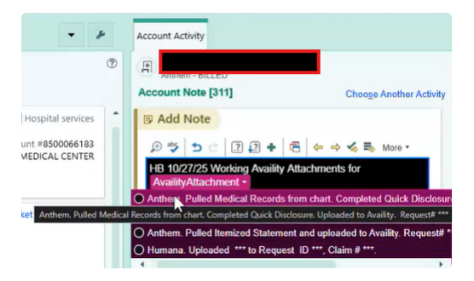
  - Click ‘****’ in note
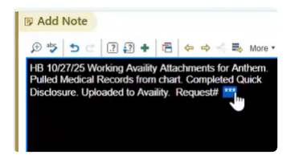
  - Paste previously captured ‘Availity Transaction ID’ and ‘Health Plan Transaction ID’ and click ‘Accept’
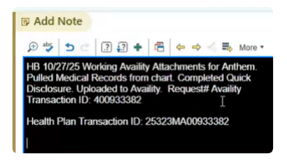
  - NEED ACCESS TO SMARTPHRASES

2.4 Toolkit documentation
The table below provides a list of toolkits and links to the completed ROI, planning toolkits, and any additional design documentation
Toolkit | Link to documentation | Comments
Plan Toolkit

2.5 Out of scope
The table below provides a list of automation scenarios or account populations that are out of scope or unobtainable
Scenario / Population | Rationale | Comments

Approval

3.1 Approval
Upon review and approval of this Process Definition Document (PDD), I, ______ on _________ hereby approve this plan for development.
I acknowledge that while this automation will experience downtime, the ultimate responsibility for the process remains with my department. I commit to collaborating with the automation team to maintain the automation and meet our uptime goal. This commitment extends to ongoing responsibilities, including but not limited to: testing, implementing enhancements, handling break-fix scenarios, managing application upgrades, and supporting process changes or improvements as required.

3.2 Future Initiatives
Below is a list of future operational, technical, or known application changes that may impact the automation
- ENTER
- ENTER

3.3 Downtime Plans
Below are the actions the operational team will take in the event of automation downtime
Scenario | Action (taken by operations) | Contact
Level 1
Downtime = 1-2 days
Level 2
Downtime = 2-7 days
Level 3
Downtime = 7-14 days
Level 4
Downtime = Indefinitely

3.4 Revisions
Complete the table below for any document revisions
Rev. # | Date |  | Section/page | Revision summary | Author
1 |  | 12/9/2025 | All | Added detailed prose | Michael Bordador
2 |  | 1/6/2026 | All | Added shared drive detail | Michael Bordador
3 |  | 2/26/2026 | All | Added Break the Glass handling | Michael Bordador
4
5
6
7


