Deaconess
Additional Documentation - Humana
Process Definition Document

Purpose: The Process Definition Document (PDD) formalizes the final design of an automation solution. It functions as an approval artifact for automation and operations teams, enabling the transition from design to development once approved.

Table of Contents
I. Automation Overview 3
1.1 Objectives 3
1.2 Operational metrics 3
1.3 Design Team 3
II. Automation Details 3
2.1 Automation Overview 3
2.2 Applications 3
2.3 Global Process Map 4
2.4 Detailed Process 4
2.4 Toolkit documentation 15
2.5 Out of scope 16
III. Approval 16
3.1 Approval 16
3.2 Future Initiatives 16
3.3 Downtime Plans 16
3.4 Revisions 17

Automation Overview

1.1 Objectives
The automation will achieve
- Fulfillment of additional documentation requests from Anthem via Availity
  - Requesting or downloading documentation in Epic
  - Consolidation of documentation into a single file
  - Uploading documentation into Availity
  - Notation of upload into Epic

1.2 Operational metrics
The automation will impact the following operational metrics
- [additional metrics to be determined]

1.3 Design Team
The following individuals contributed to the automation design, must be informed of changes, and agree to support the maintenance of this automation
Name | Role / Title | Contact
Abby Schmitt | Operational Owner | Abby.Schmitt@hcrsolutions.com
Kirstie Springston | Operational SME(s) | Kirstie.Springston@hcrsolutions.com
Michael Bordador | Solution Architect | Michael.Bordador@tarponhealth.com
Matt Cheney | Developer | Matt.Cheney@tarponhealth.com

Automation Details

2.1 Automation Overview
Item | Description
Area / Department
Automation Name | Additional documentation - Anthem
Automation Description | Bot will fulfill additional documentation requests from Anthem

2.2 Applications
The table below lists the applications being utilized by the automation
Application | Comments / Access Needs
Epic | Require ability to access user accounts and post fulfillment comments
Availity | Require ability to view requests and upload requested documentation

2.3 Global Process Map
The diagram below contains the steps the automation will take (the ‘to-be’ process map)
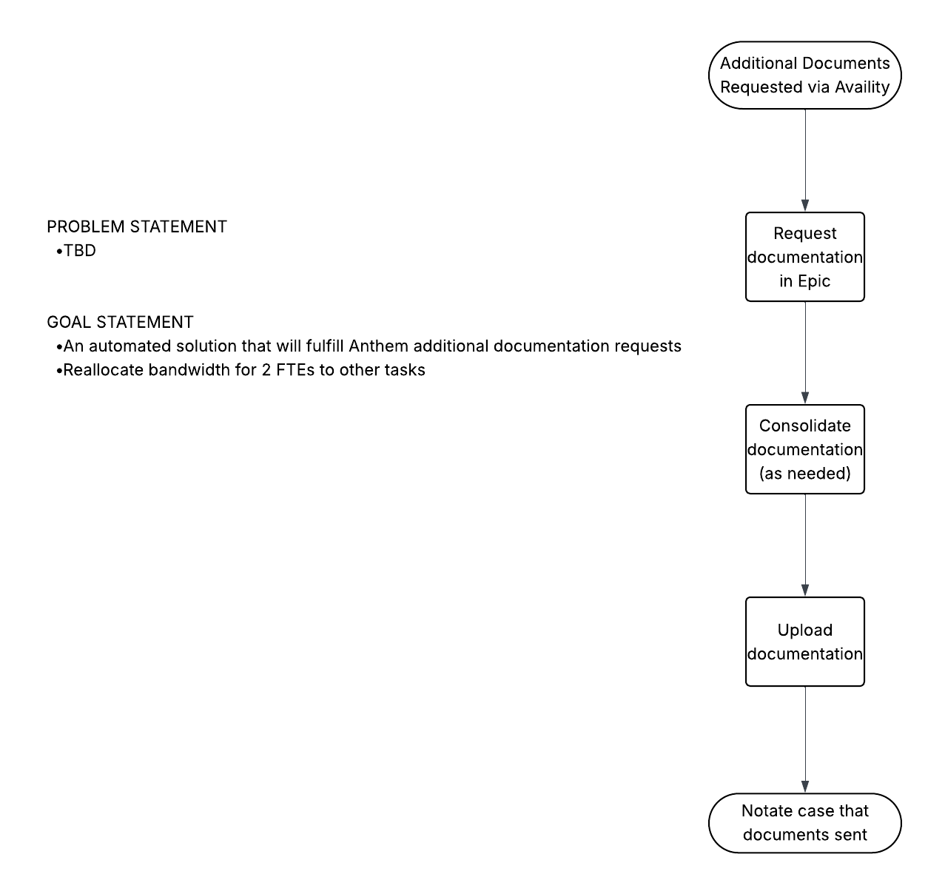

2.4 Detailed Process
Assumptions:
- [PLACEHOLDER]
Steps below outline the future state process:
- Bot Schedule
  - Process will be run off hours (5PM – 5AM Central Time) to ensure that BOT does not collide with normal workflow
- Download worklist
  - Login to Availity with stored credentials
  - Navigate to ‘Payer Spaces’ and type ‘Humana’ into filter
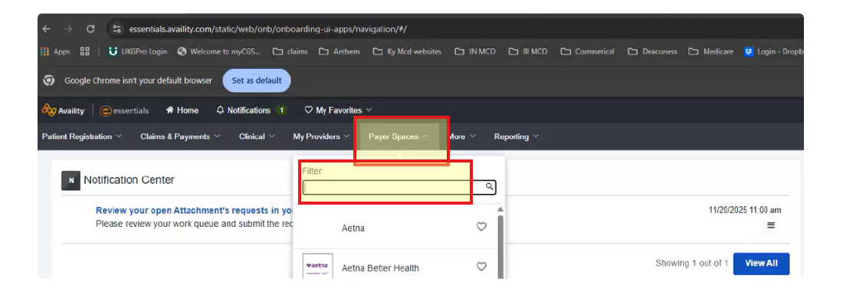
  - Navigate to ‘Medical Records Management’
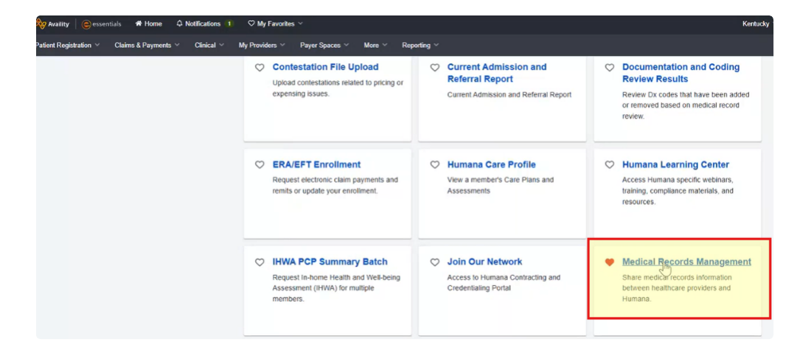
  - Hover over checkboxes for ‘Organizations’ and ‘Tax ID’ and click to select all
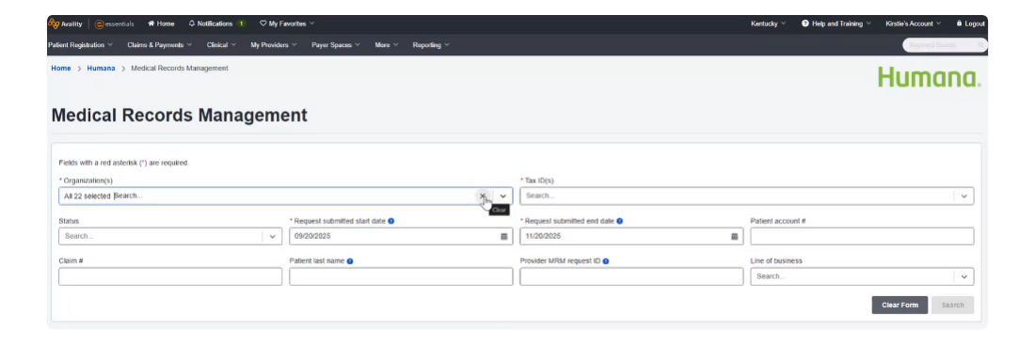
  - Select status of ‘Verified Unfulfilled’ and select ‘Search’
  - Once list is returned, focus on items with Host System = Pre Pay
  - Trigger Dispatcher to download flat file output list and store into array
    - Click ‘Export Requests to Excel’
    - Apply the following filters to exported list:
      - Status = ‘Verified Unfulfilled’
      - Host System = ‘Pre Pay’

- Performer to capture Epic lookup elements
  - Capture the following elements for Epic lookup:
    - Epic PT Acct # - see below for details
      - 10 characters following Facility Prefix from Availity extract
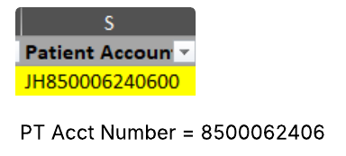
    - Facility Prefix
      - In Scope prefixes – JH, HB, BH, FH, HD
      - First 2 characters of ‘Patient Account’ from Availity extract
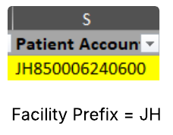
    - PT Name = Member Name from extract
    - PT DOB = Member DOB from extract
    - PT DOS = Date of Service Start. Date of Service End from extract

- Performer to look up accounts in Epic
  - Launch lookup array
  - Login to Epic with stored credentials
  - Launch Hospital Account Lookup
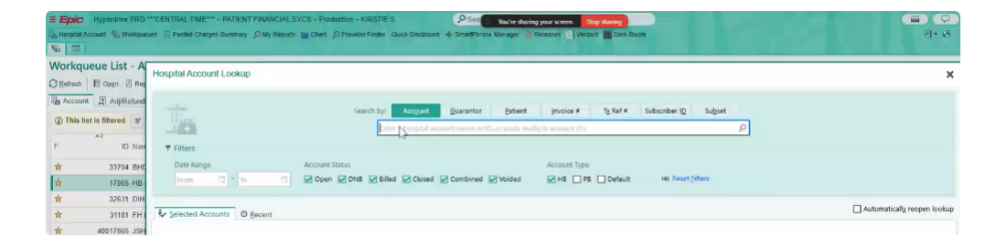
  - Enter Pt Acct Number into Account Search field
  - Validate that Pt Name, DOS, DOB, and Pt Acct Number from lookup array match search result
    - If yes, click ‘Accept’
    - If no, mark as exception and move on to next record
      - Exception message: ‘Epic search results do not match Availity request.’
  - Open Patient Chart
    - Type ‘Chart’ into Search bar
    - Select Patient tile and ‘Accept’
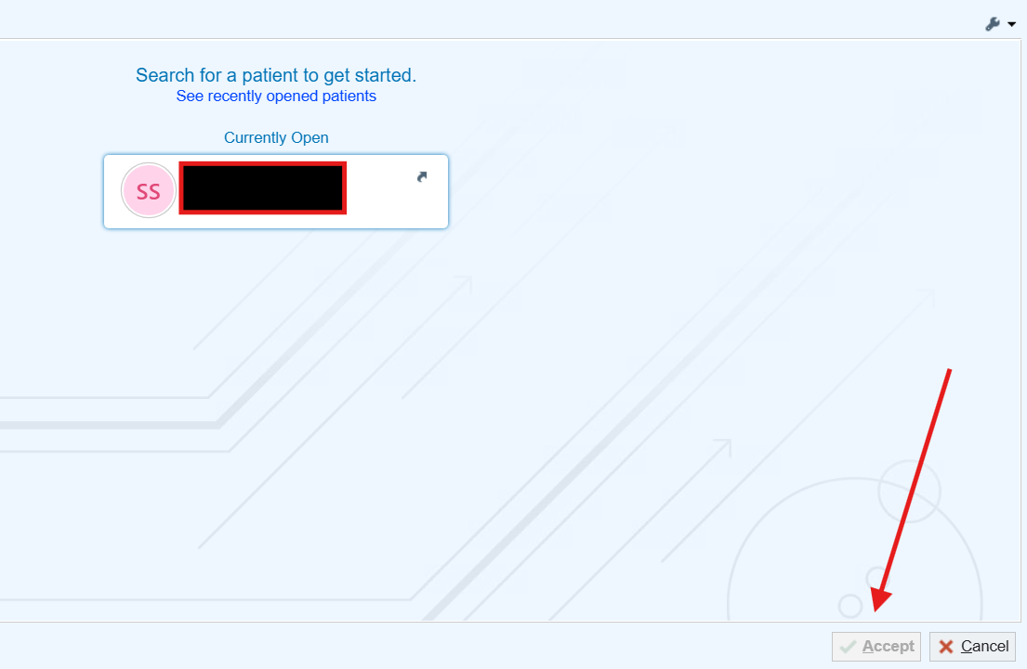

- Records need to be requested before uploading
  - Click ‘Chart Review’
  - Navigate to ‘Liability Buckets’
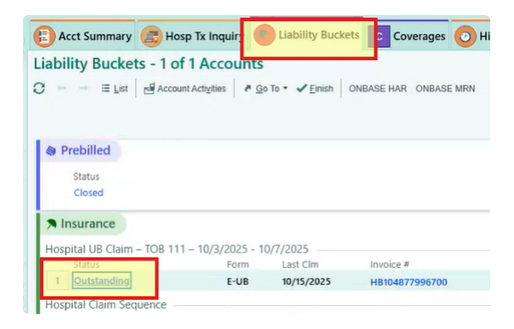
  - Click ‘Outstanding’
  - Request records
    - Click ‘Account Activities’
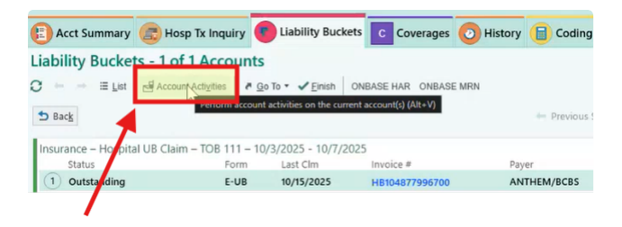
    - Click ‘Set Billing Indicator [299]’
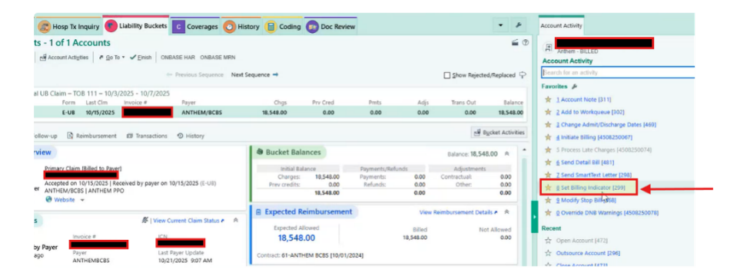
    - Type '.hbrecords' in Notes box to expose HBRECORDS smartphrase and press enter
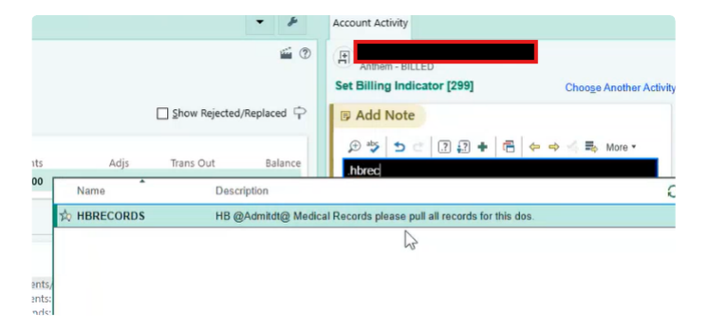
    - Click down arrow beside 'records' in smartphrase and choose option to NOT put on CD if > 500 pages
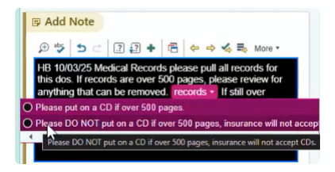
    - Enter '1273' in 'Update Billing indicators' and click 'Add'
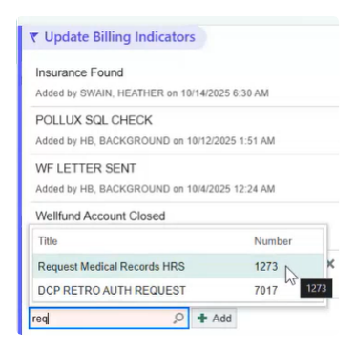
    - Click 'Accept'
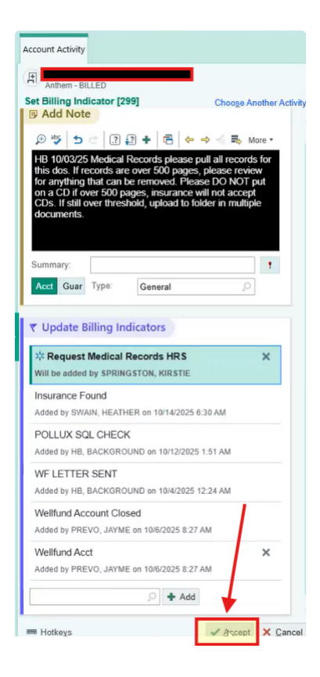
    - Navigate to appropriate shared folder within 7 days of request to gather records
      - Begin search for file 2 business days after initial request
      - Crosswalk to shared folders
Site Name | HAR Prefix | Shared Folder Path
Deaconess | HB1, HB4, HB9 | \\deaconess.com\shares\Departments\Patient Financial Service\Patient Accounts\Share\RequestedCharts
Deaconess Women's | HB51 | \\deaconess.com\shares\Departments\Patient Financial Service\Patient Accounts\Share\RequestedCharts\TWH Records
Deaconess Gibson | HB80 | \\deaconess.com\shares\Departments\Patient Financial Service\Patient Accounts\Share\RequestedCharts\DGH Records
Deaconess Memorial | HB78 | \\deaconess.com\shares\Departments\Patient Financial Service\Patient Accounts\Share\RequestedCharts\DMMC Records
Deaconess IL | HD | \\deaconess.com\shares\Departments\Patient Financial Service\Patient Accounts\Share\RequestedCharts\DIH Records
Baptist | BH | \\deaconess.com\shares\Departments\Patient Financial Service\Patient Accounts\Share\RequestedCharts\BHDM Records
Jennie Stewart | JH | \\deaconess.com\shares\Departments\Patient Financial Service\Patient Accounts\Share\RequestedCharts\JSH Records

        - File Name will match Pt Name in respective folder
        - Save file copy at the following network location: \\deaconess.com\shares\Departments\Patient Financial Service\Patient Accounts\Share\RequestedCharts\Automated Documentation for Upload\REQUESTED DOCS
          - TODO: create subfolder
        - Move file to ‘Completed’ folder once uploaded to Availity
          - If file is not present, then retry search for 3 business days
          - If file is not present after 7 business days, enter the following exception
            - ‘Chart details not uploaded to shared drive within 7 business days’

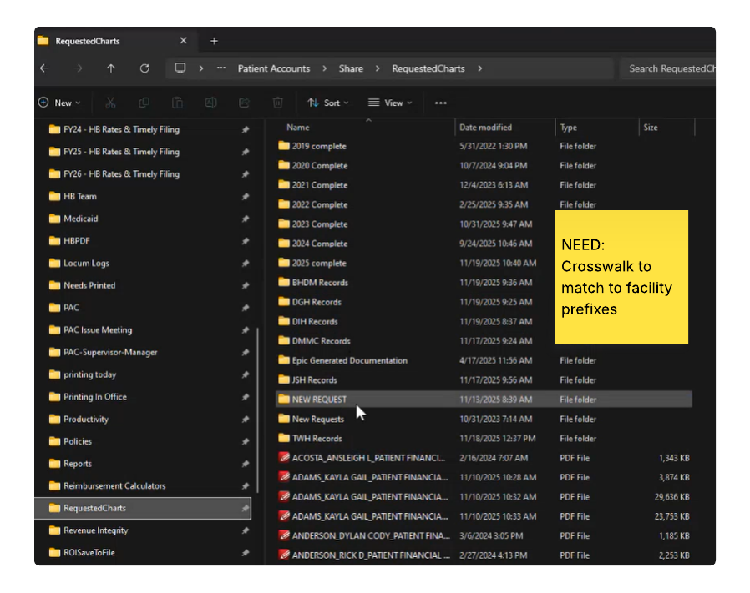
e. If Claim is not INPT claim, records can be downloaded
- Click ‘Chart Review’
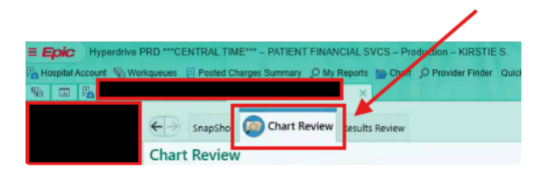
- Click ‘Encounters’ tab and click ‘Filters’

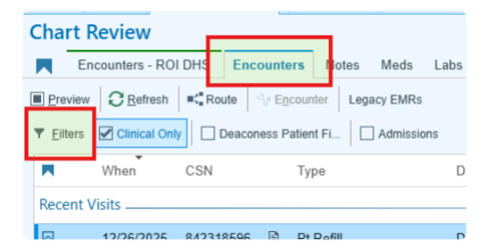
- Set filter for DOS date range
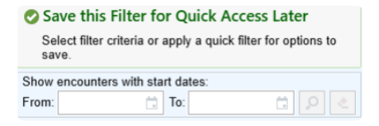
- Enter DOS from WQ file into filter
- Does DOS from input file yield data?
- If yes, go to step (v)
- If yes, and case is ‘Break the Glass’
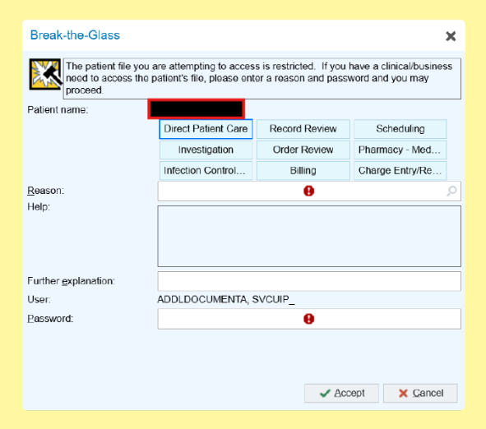
- Create Business Exception to route case back to Business Team for manual processing and move to next record in WQ for processing
c. If no, create a business exception that no data for DOS is available and move to next record in WQ for processing
v. Extract records for each line item
- Click line item to open side menu
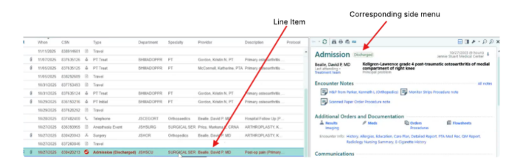
- Click ‘Print Current Report’ icon
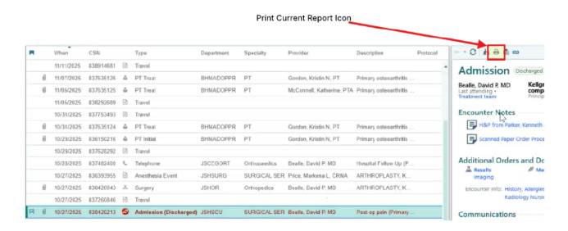
- Click ‘Print All’ in dialog box
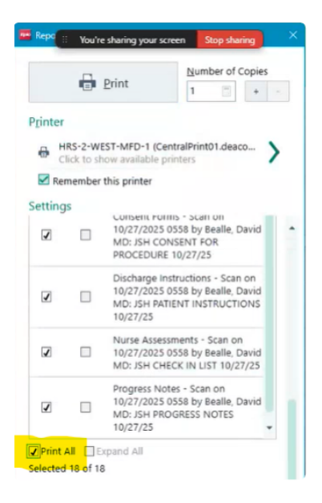
- Change printer to PDF Xchange Lite and click print
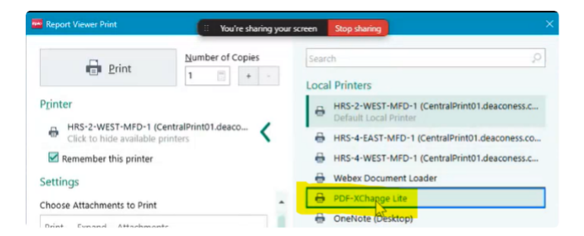
- Select destination for downloads (\\deaconess.com\shares\Departments\Patient Financial Service\Patient Accounts\Share\RequestedCharts\Automated Documentation for Upload\COMBINED PAGES)
- TODO: Create above subfolder
- Save each page as [LastName_DOS-Attachment#]
- Ex. Adams_102725-1
- Click ‘Save’
- Repeat for each corresponding file with ascending attachment #
- Adams_101725-2
- Adams_102725-3
- Adams_102725-4
- Once all files downloaded and names, select all files, right click and show more options
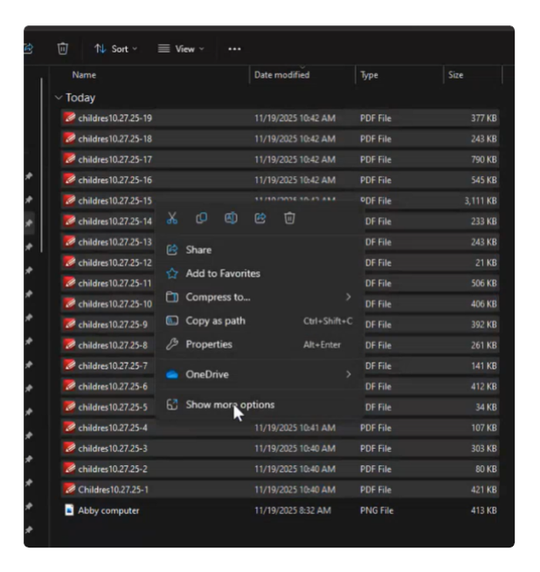
- Click ‘Combine in PDF Xchange Editor’
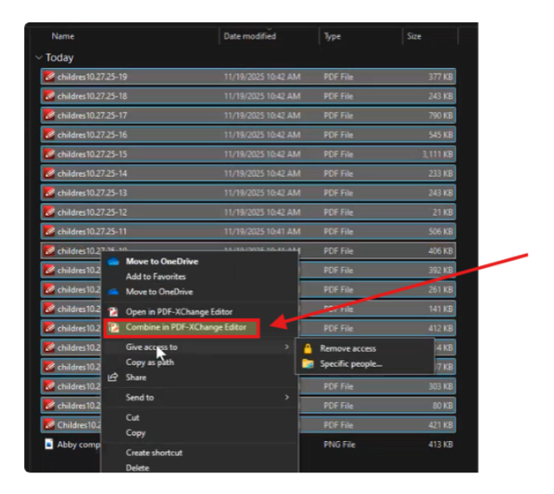
- Click OK
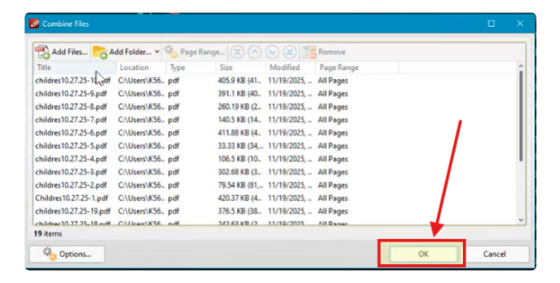
- Click ‘File’ from New Document pop up
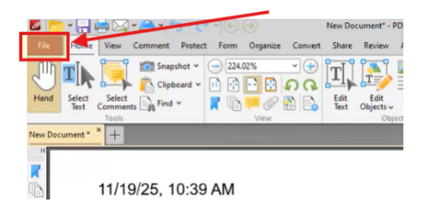
- Click ‘Save As’ into designated Save File path
- Close Document

- Upload attachments into Availity
  - Launch Availity using stored credentials
  - Repeat steps 2(a) – 2(f)
  - Search for attachment request
    - \\deaconess.com\shares\Departments\Patient Financial Service\Patient Accounts\Share\RequestedCharts\Automated Documentation for Upload\REQUESTED DOCS
    - TODO: Create subfolder in above file path
  - Click Actions Menu button
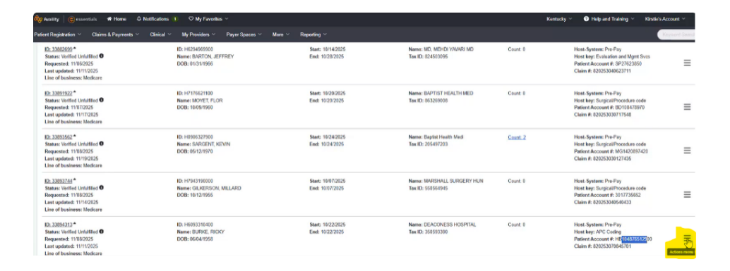
  - Click Upload
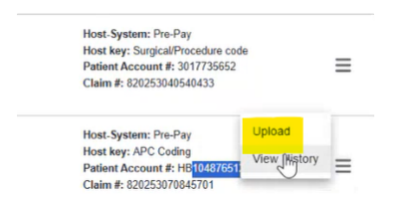
  - Click ‘Medical Record’ as document type
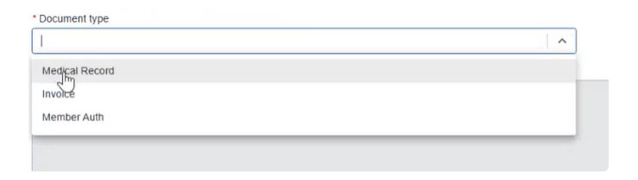
  - Click 'Browse Files' and navigate to network save location and click 'Open'
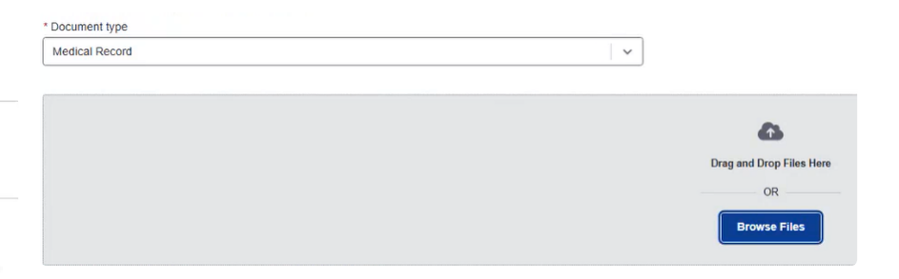
  - Click 'Submit' once file is uploaded
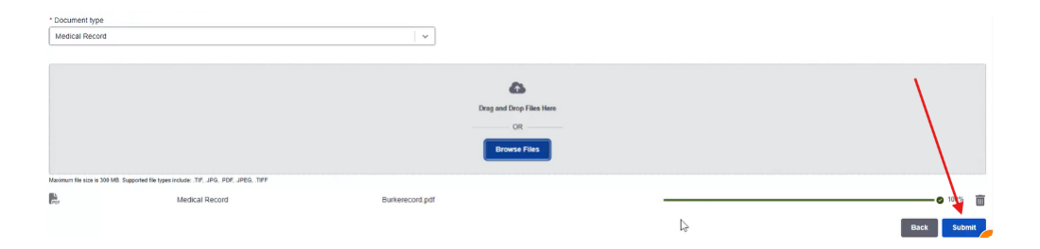
  - Click Proceed
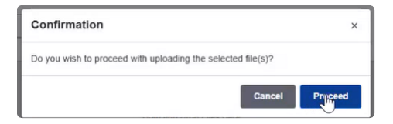
  - Count value updates to '1' once file is uploaded

- Enter note into Epic
  - Repeat steps 4(b) – 4(g)
  - Click ‘Quick Disclosure’ and click Pt in ‘Currently Open’ box
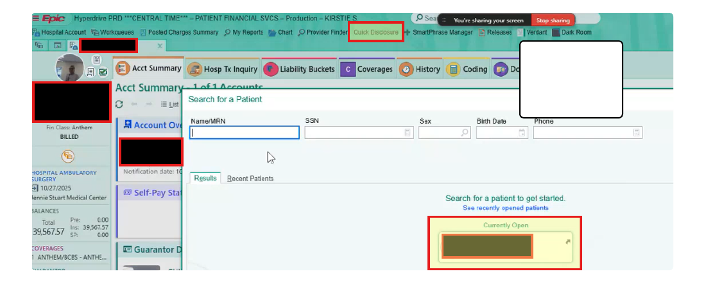
  - Select 'Humana [810003303]’
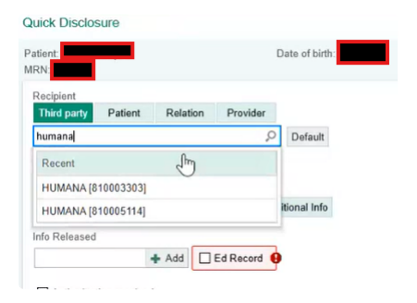
  - Select ‘Billing/ Claims Additional Info’ for ‘Purpose’ and ‘Progress Notes’ for ‘Info Released’
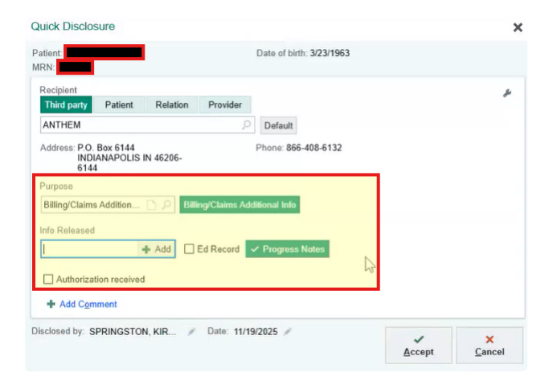
  - Click ‘Accept’
  - Navigate to ‘Account Activities’
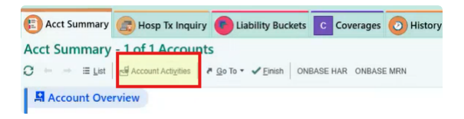
  - Click ‘Account Note’
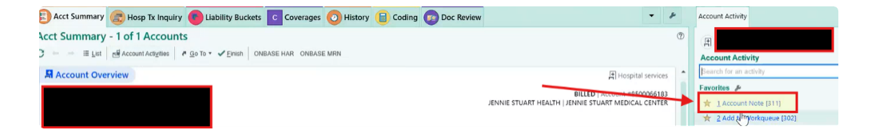
  - Enter ‘.iosav’ to expose relevant smartphrase
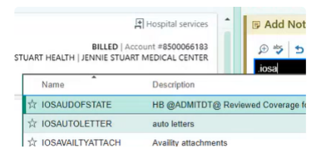
  - Select IOSAVAILITYATTACH smartphrase
  - Once smartphase is populated, click on 'Humana. Uploaded *** to Request ID***' radio button
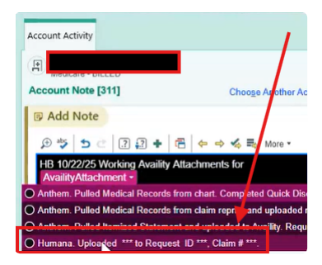
  - Click ‘****’ in note
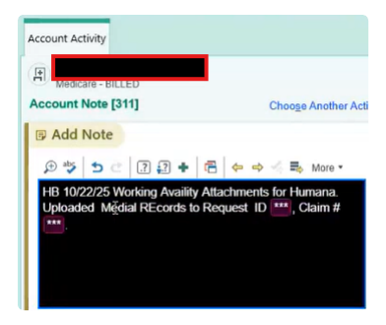
  - Capture 'ID' and 'Claim #' from Availity Results and enter into *** beside Request ID and *** beside Claim # in notes field, respectively
  - Click Accept
  - NEED ACCESS TO SMARTPHRASES

2.4 Toolkit documentation
The table below provides a list of toolkits and links to the completed ROI, planning toolkits, and any additional design documentation
Toolkit | Link to documentation | Comments
Plan Toolkit

2.5 Out of scope
The table below provides a list of automation scenarios or account populations that are out of scope or unobtainable
Scenario / Population | Rationale | Comments

Approval

3.1 Approval
Upon review and approval of this Process Definition Document (PDD), I, ______ on _________ hereby approve this plan for development.
I acknowledge that while this automation will experience downtime, the ultimate responsibility for the process remains with my department. I commit to collaborating with the automation team to maintain the automation and meet our uptime goal. This commitment extends to ongoing responsibilities, including but not limited to: testing, implementing enhancements, handling break-fix scenarios, managing application upgrades, and supporting process changes or improvements as required.

3.2 Future Initiatives
Below is a list of future operational, technical, or known application changes that may impact the automation
- Epic currently at Version: February 2025. There are 2 planned upgrades in 2026:
1. The first Epic Upgrade project is already underway and involves a double upgrade, bringing us to versions May 2025 and August 2025. We plan to upgrade our Epic production environment on Sunday, April 12, 2026.

2. Following that, in early May, we’ll kick off our next Epic Upgrade project. This will also be a double upgrade, taking us to versions November 2025 and February 2026. The upgrade for this project is scheduled for Sunday, July 12, 2026.

3.3 Downtime Plans
Below are the actions the operational team will take in the event of automation downtime
Scenario | Action (taken by operations) | Contact
Level 1
Downtime = 1-2 days
Level 2
Downtime = 2-7 days
Level 3
Downtime = 7-14 days
Level 4
Downtime = Indefinitely

3.4 Revisions
Complete the table below for any document revisions
Rev. # | Date |  | Section/page | Revision summary | Author
1 |  | 12/9/2025 | All | Added detailed prose | Michael Bordador
2 |  | 1/6/2026 | All | Added shared drive detail | Michael Bordador
3 |  | 4/3/2026 | 3.2 | Added Epic upgrades for 2026 | Kim Anderson
4
5
6
7


