Business Summary
Epic DEPs are built with many addresses including the suite address when it’s not necessary for the claim. The suite address will impact the USPS zip +4. The address on the insurance claim must match the address that was used for provider enrollment.

Business Value
Introducing bot technology to clean-up the street address and zip +4 will:
- Reduce the amount of denials related to the claims address not matching the provider enrollment address
- Avoid the manual effort to validate 1900 DEP addresses on the USPS website
- Provide an automated method for routinely validating zip +4

Success can be measured by:
- Reduction in enrollment related denials

Data Flow Diagrams
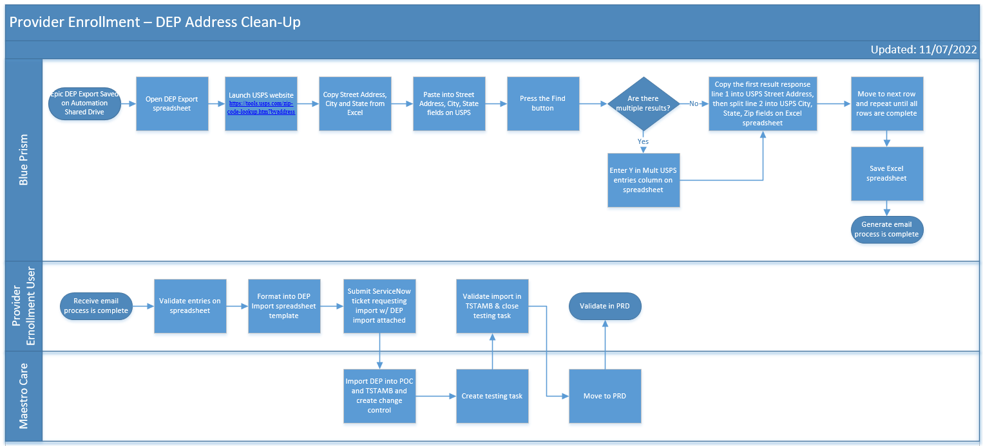

Programming Requirements
Blue Prism
Build bot logic to read an Excel spreadsheet, copy/paste to USPS website (https://tools.usps.com/zip-code-lookup.htm?byaddress), copy/paste results back to Excel spreadsheet

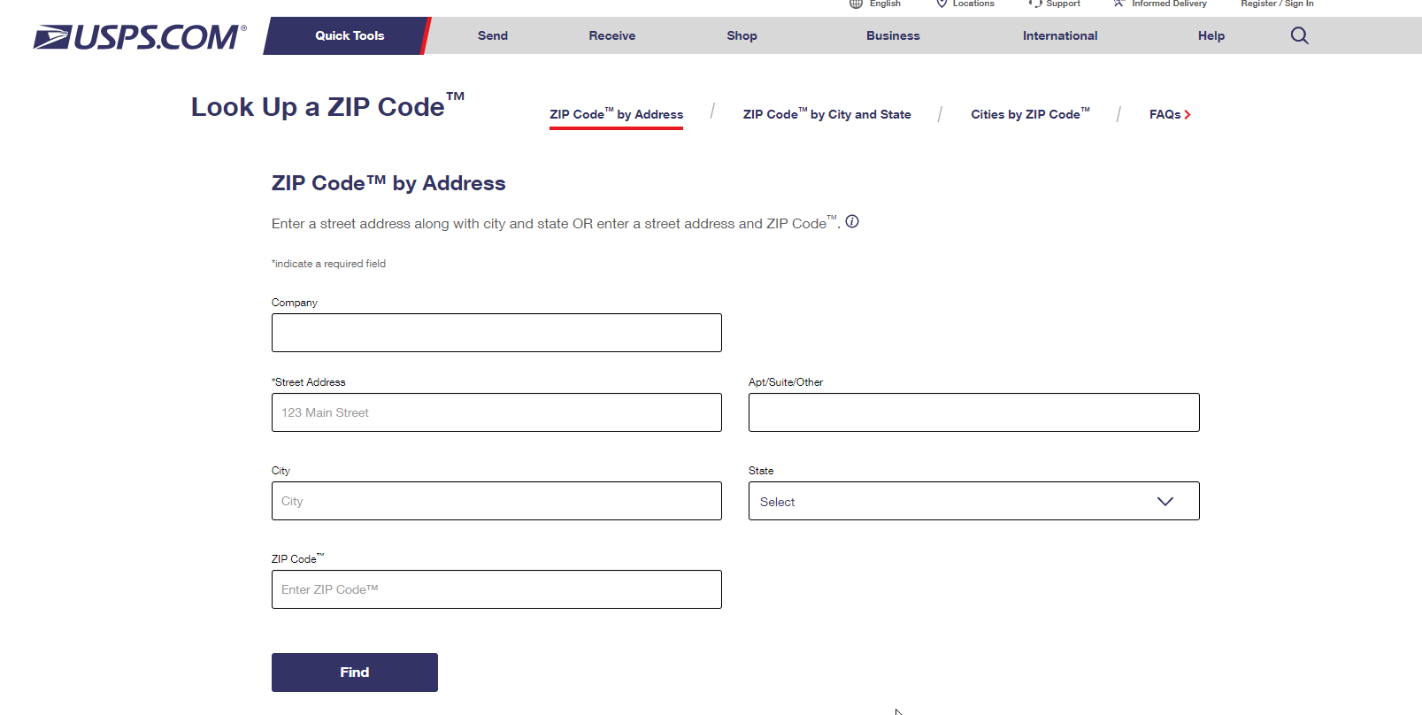

Example responses:

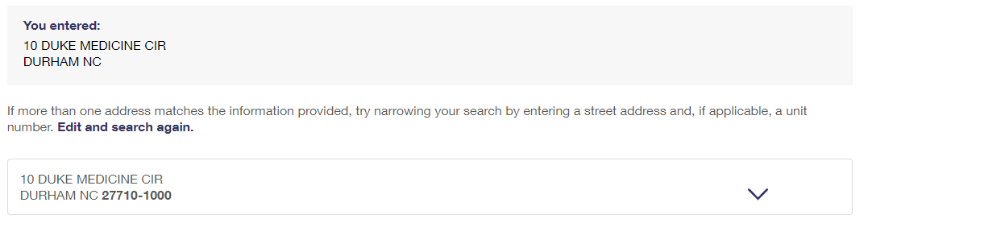

ID # | Department Name | Address | City | State | Zip Code | USPS Street Address | USPS City | USPS State | USPS Zip Code | Mult USPS entries
1000100104 | DMP ENDOSCOPY BRONCHOSCOPY | 10 Duke Medicine Cir | Durham | North Carolina | 27710-1000 | 10 DUKE MEDICINE CIR | DURHAM | NC | 27710-1000

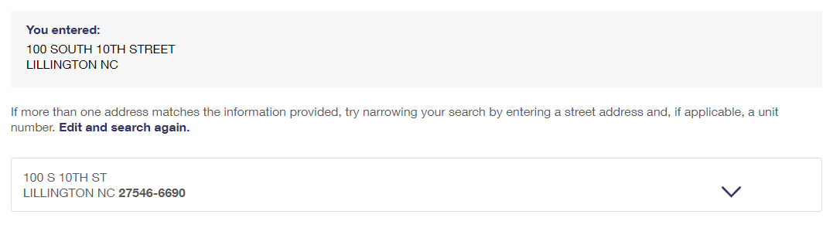

ID # | Department Name | Address | City | State | Zip Code | USPS Street Address | USPS City | USPS State | USPS Zip Code | Mult USPS entries
5000400001 | BJSC - EDGEWATER MEDICAL CENTER | 100 South 10th Street | Lillington | North Carolina | 27609-5862 | 100 S 10TH ST | LILLINGTON | NC | 27546-6690

If response has multiple entries, use the first entry and flag mult responses
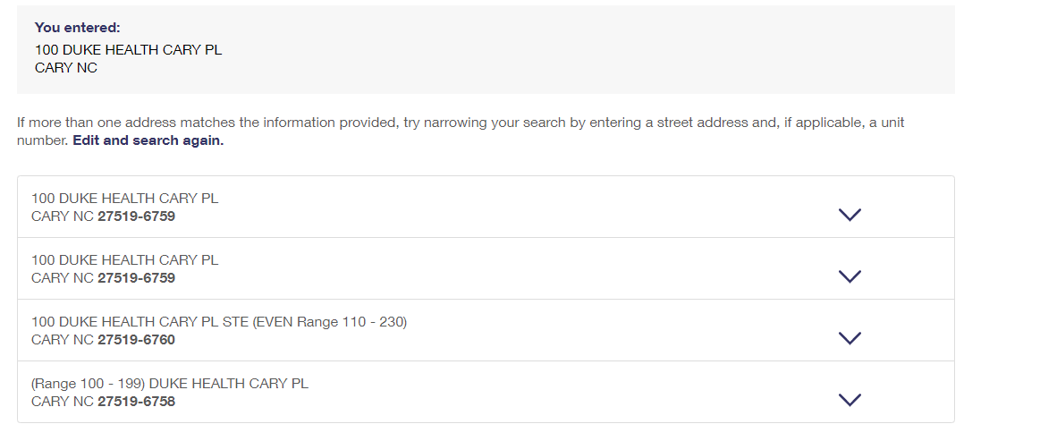

ID # | Department Name | Address | City | State | Zip Code | USPS Street Address | USPS City | USPS State | USPS Zip Code | Mult USPS entries
1002000103 | DUKE WOMEN'S HEALTH GREEN LEVEL | 100 Duke Health Cary Pl | Cary | North Carolina | 27519-0000 | 100 DUKE HEALTH CARY PL | CARY | NC | 27519-6579 | Y

Epic
- Provide DEP export with claims address item #’s
- Accept import spreadsheet to correct the addresses

Frequency & Downtime Impact
Frequency
- One-time clean up
- TBD – potential for monthly or quarterly run to check for changes in Zip +4 and validate new entries

Impact of downtime
No impact

Test Plan
The returned results would be manually reviewed for accuracy by Provider Enrollment
Then, an import spreadsheet created and attached to a ServiceNow ticket for importing into the DEP to correct the addresses.

Outstanding Design Issues

Date | Status | Review w/ | Description | Response

Reviewed and approved by RPA Governance: 11/15/2022
Attendees: Becky Mangum, Kevin Babb, Alison Ervin

