Business Summary
NC Tracks communicates Medicaid provider enrollment and claims interactions through their Message Center. The Message Center is a one-way communication tool that publishes announcements to the NCID login associated with the individual or group provider NPI.

Failure to react to these notifications has a variety of outcomes from denial of a single claim to termination of a provider’s Medicaid enrollment. Currently, the messages are not being reviewed by provider enrollment staff due to capacity limitations.

Business Value
Introducing bot technology to review the messages and create tasks in the Echo Credentialing system will:
- Reduce the amount of terminated and suspended Medicaid provider enrollments as a result of not responding to these requests
- Eliminates the need for staff to access the message center streamlining their workflow within Echo
- Prevent addition of 1-2 FTEs to work the messages ($45,000 annual salary per FTE)

Success can be measured by:
- Reduction in enrollment approval times for new providers and provider changes
- Reduction in provider terminations as a result of slow/no licensure updates within NC Tracks
- Reduction in enrollment related denials

Data Flow Diagrams
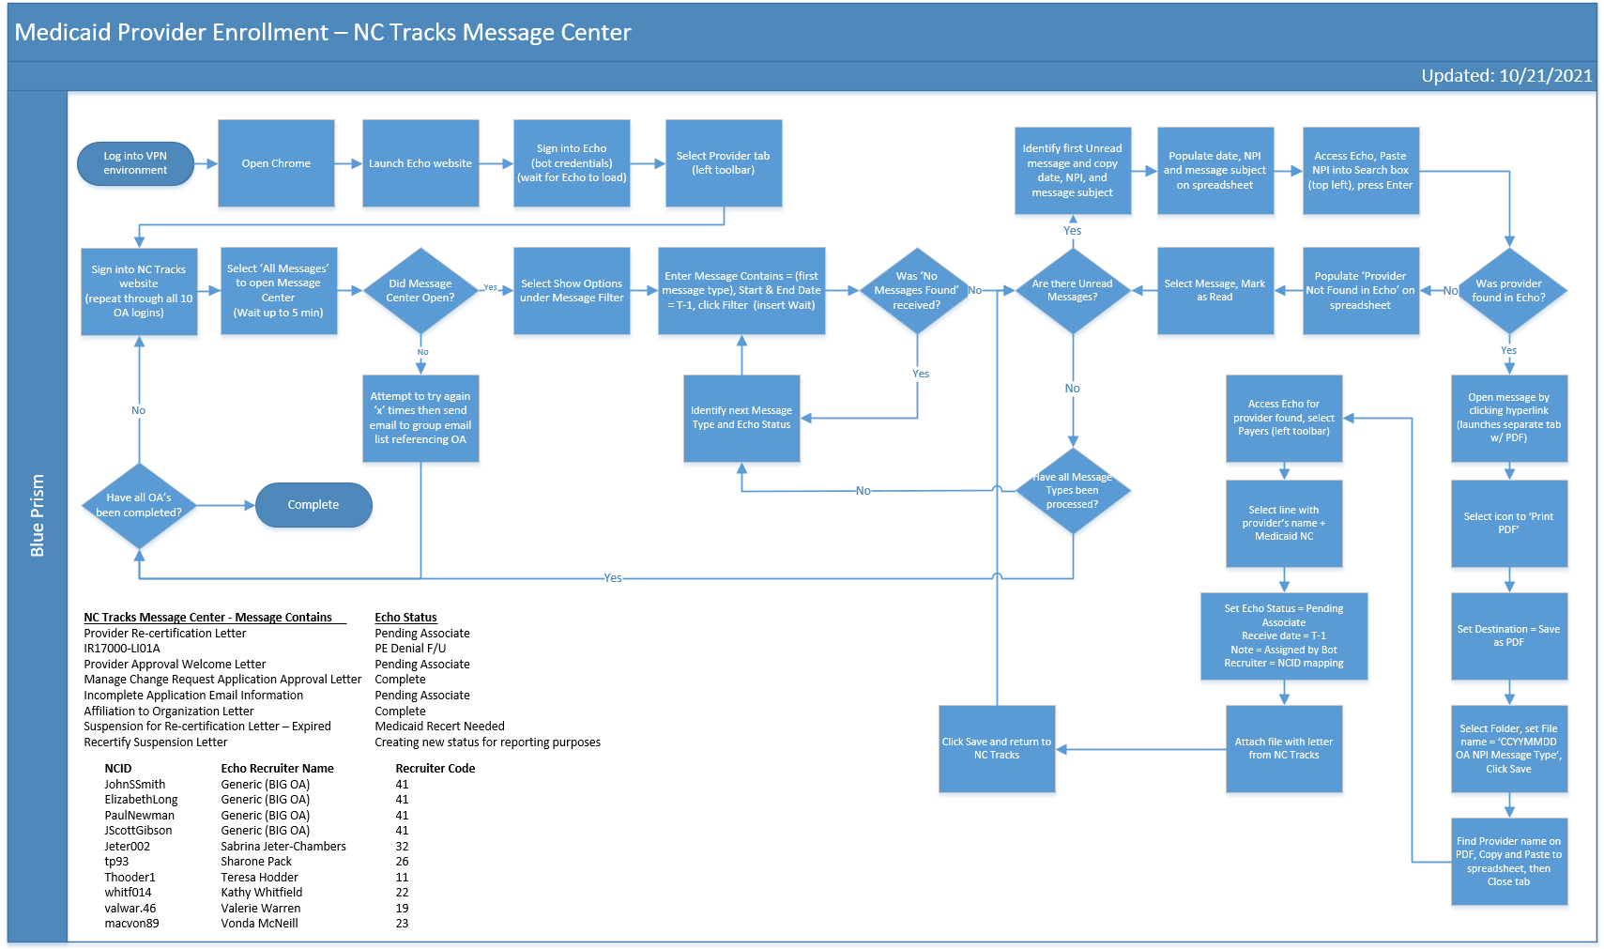

Programming Requirements
Blue Prism
- Build bot logic for each NC Tracks message type and OA (Office Administrator) login

Echo Credentialing
Pre-requisites:
- Login credentials for the bot
- VPN is required to access Echo

Frequency & Downtime Impact
Frequency
- Ongoing, daily (7 days/week) processing off hours to allow for system slowness and avoid logging in at the same time as a user
- One-time back log run – April 1, 2021, no Echo tasks, create file.

Impact of downtime
If the bot is unable to process messages due to NC Tracks or Echo downtime, Provider Enrollment would need to be notified for manual processing for the day(s) skipped. If possible, the bot would retry throughout the day outside of the hours of 8-5pm M-F prior to resorting to manual processing.
If the bot is unable to login to Echo or NC Tracks, an error message with the OA username included should be sent to Provider Enrollment to obtain new login credentials for the bot.

Test Plan
Test systems are not available for NC Tracks or Echo. Therefore, testing identified scenarios in production will be required to validate system functionality. Test providers are in Echo and will be used to the extent possible for testing.
Each of the ten OA logins will need to be tested by processing a message through to creation of an Echo task to verify login mapping is accurate and logins to NC Tracks are correct.
Each of the message types in NC Tracks will need to be processed to validate the mapping to Echo status, the population of the fields in the Echo task and the PDF attachment.

Testing Approval to be obtained from Rhonda Boyd, Angie Cane, Christina Blevins and Makia Harris prior to implementation.

Outstanding Design Issues

Date | Status | Review w/ | Description | Response
10/15/21 | Complete | DHTS & Operations | Would a spreadsheet with provider name, NPI, downloaded file name and status of bot processing assist with auditing and/or processing through to Echo? | Yes, a daily spreadsheet saved in the shared drive folder would be needed for internal controls
10/15/21 | Complete | DHTS | Would it be more efficient to run through all messages for all OA’s before creating tasks in Echo? | Yes, this approach was taken
10/15/21 | Complete | Operations | Need to set up a shared drive or OneDrive folder for the bot to save and pull files | Create folder for Provider Enrollment in PB shared drive – Christina to send drive mapping
10/15/21 | Complete | Operations | Can a department shared email be created for errors vs hard-coding user emails? | Create new PB Billing and Collections Automations  - Makia, Christina, Paul, Belinda Fields, Shalanda
10/15/21 | Pending | DHTS | If the website is down, is the bot able to process the message the next day or later in the day?

Reviewed and approved by RPA Governance: 10/19/21
Attendees: Allen Coleman, Kevin Babb, Alison Ervin, Derek Robinson

