Confidential

HR Enterprise-Wide Licensure and Certification

Step by Step Guide v4.0

v1.0

Table of Contents
1. INTRODUCTION 3
Purpose 3
2. Step by Step AS IS Process Details 3
Overview 3
3. Step by Step TO BE Process Details 3
Overview 3
4. Other 12
4.1 Version Details 12

1. INTRODUCTION

Purpose
The Step-by-Step Guide provides comprehensive, sequential documentation of both the As-Is and To-Be states of a business process selected for automation. It captures each step with precise instructions, annotated screenshots, and visual callouts to ensure clarity, accuracy, and consistency.
The Step-by-Step guide is intended to:
- Support RPA developers and Solution Architects by serving as a detailed reference during the solution design and build phases, ensuring a clear understanding of the process flow, system interactions, and user actions.
- Enable process owners and subject matter experts (SMEs) to validate that the documented steps accurately reflect the current and future operational workflows.

2. Step by Step AS IS Process Details

Overview
The As-Is process documents the current workflow before any changes are made. It should clearly outline each step, the tools or systems used, and the roles involved. Each step must be broken into sub-steps (e.g., Step 1.1, Step 1.2) and supported by screenshots with key elements highlighted using boxes, arrows, or callouts for clarity. Be sure to blur any sensitive or confidential information in the screenshots to maintain data privacy and compliance.
Step 1: This is a future process and the AS IS process is unknown, nor needs to be documented.

3. Step by Step TO BE Process Details

Overview
The To-Be process describes the improved future state of a workflow after changes are implemented. It should outline each step, highlighting updates in tools, systems, or responsibilities. Steps must be broken into sub-steps (e.g., Step 1.1, Step 1.2), each supported by a screenshot with key elements clearly marked using boxes, arrows, or callouts to show changes from the As-Is process. Be sure to blur any sensitive or confidential information in the screenshots to maintain data privacy and compliance.

1.
1. Start Dispatcher
2. Remove any transactions in UiPath queue with status of “New”
3. Navigate to network folder:
\\HHCsystem.org\AppSrvShares\RPA_HR\Enterprise_Wide_Licensure_and_Certification_Process_NonProduction (only during testing)
OR
\\HHCsystem.org\AppSrvShares\RPA_HR\Enterprise_Wide_Licensure_and_Certification_Process_Production

4. Select Input folder
2.1 Locate file named: HHC_RN_W_LIC_MAX_RPA_MMDDYY
(MMDDYY = Current date)
5. Is excel report in folder?
3.1 If NO: Retry 3 times at top of the hour
3.1.1 Exception BE009: Input file missing. Please research and resolve.
3.1.2 Fail job
3.2 If YES: Go to step 6.

6. Open excel file and read data
7. Transfer the below columns and data from report to data table
ID
Name
Accomp
License #
Expire Dt

8. Add the fields (headers) below to data table in first open columns
CDPH Expire Date
PeopleSoft Ingestion

9. Loop through rows in the data table and add the data to the UiPath queue

10. Start Performer

11. Get first UiPath queue transaction with status of NEW
11.1 Go to step 13

12. Next queue item

13. Is license # cell blank?
13.1 If YES: Enter in the spreadsheet in Exception column: BE001: License # is blank on PeopleSoft output report. Please research.
13.1.1 Go to next queue item (step 12)
13.2 If NO: Go to step 14

14. Does license # match the below examples,
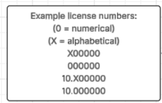
14.1 If NO: Enter in spreadsheet in Exception column: BE002: License # field has something other than a 10 preceding the 6-digit license number in export report. Please research.
14.1.1 Go to next queue item (step 12)
14.2 If YES: Go to step 15
15. Navigate to: eLicense Online
15.1 (see Lucid flow for alternative option)

16. Is website opening?
16.1 If NO: Close browser and relaunch
16.1.1 Retry 3 times
16.1.2 Exception SE002: Website not responding. Please research
16.1.3 Go to next queue item (step 12)
16.2 If YES: Go to step 17

17. Is there a Captcha present?
17.1 If YES: Close browser and relaunch
17.1.1 Retry 3 times
17.1.2 Exception SE003: Captcha please research
17.1.3 Go to next queue item (step 12)

18. Navigate to license number box (or tab 8 times)
18.1 Enter 10 in the first box (always enter a 10 even if not on report)
18.2 Enter 6-digit license number in second box
18.3 Select submit (or enter)
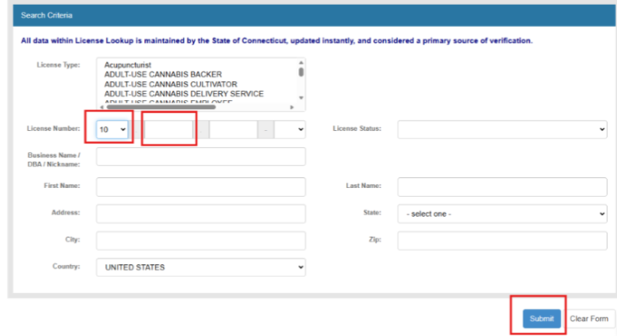
19. Did the search return any results?
19.1 If NO: Enter in spreadsheet in Exception column: BE003: State of Connecticut website search returns no results using license #. Please research.
19.1.1 Go to next queue item (step 12)
19.2 If YES: Go to step 20
20. Does the first name AND last name in queue match the internet search results?
20.1 If NO: Go to step 21
20.2 If YES: Go to step 22
21. Does either the first name OR last name match?
21.1 If YES: Update the record
21.1.1 Enter in exception column: BE005: Website search returns either First OR last name matches on PeopleSoft export report. Record was still updated, but please still research.
21.1.2 Go to step 22
21.2 If NO: Enter in spreadsheet in Exception column: BE004: Website search returns names that do not match the PeopleSoft export report. Please research.
21.2.1 Go to next queue item (step 12)
22. Does search box status reason say current?
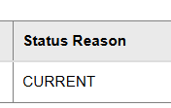

22.1 If NO: Enter in spreadsheet in Exception column: BE006: Website shows employee license status reason is not = to current. Please research.
22.1.1 Go to next queue item (step 12)
22.2 If YES: Go to step 23

23.Click on detail button
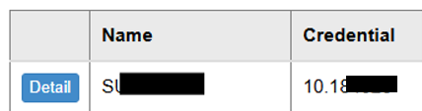

23.1 The license detail screen will open

24. Locate expiration date in website search within license details
24.1 Capture and store the expiration date in data table in CDPH Expire Date column
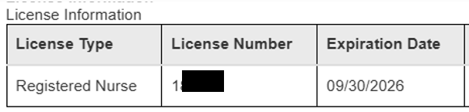

25. Select Printable View button
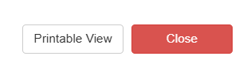
26. Select save as PDF
26.1 Select save
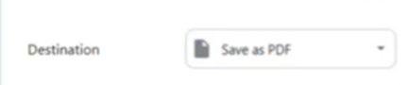

27. Navigate to network folder to save document
\\hhcsystem\dfs\peoplesofthhc\InterfaceFiles\HHCHRDEV\Evercheck\Inbound\ ---For Testing
OR
\\hhcsystem\dfs\peoplesofthhc\Interfaces\HHCHRPRD\Evercheck\Inbound\
28. Name file:
28.1 Name document: EmployeeID_License#_LastName_MMDDYY
28.2 (MMDDYY = Current date)
29. Close “X” out of the print lookup details screen

30. Select close on current window (License Details)
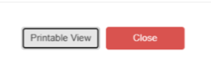
31. Close “X” out of the search screen
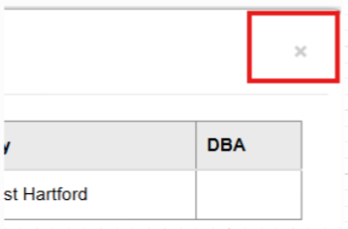

32. In license lookup window, select clear form
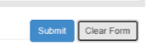
33. Have all queue items been worked?
33.1 if YES: Go to step 34
33.2 If NO: Go to next queue item (step 12).
34. Refer to dates in data table
35. Start on first row item
35.1 Go to step 37
36. Go to next row item
37. Does CDPH Expire Date column = Expire Dt column
37.1 If YES: Enter in exception column: BE007: CDPH expiration date = Expire Dt. Skipped record.
37.1.1 Go to next row item (step 36)
37.2 If NO: Go to step 38
38. CDPH Expire Date column is less than the Expire Dt column (occurred in the past)
38.1 If YES: Enter in exception column: BE008: CDPH expiration date is less than (in the past) from Expire Dt. Skipped record.
38.1.1 Go to next row item (step 36)
38.2 If NO: Go to step 39
39. Confirm CDPH Expire Date column is greater than the Expire Dt column (future date)
39.1 Mark in data table column named PeopleSoft Ingestion: True
39.1.1 Go to step 40
40. Have all row items been worked?
40.1 If YES: Go to step 41
40.2 If NO: Go to next row item (step 36)
41. Filter data in table to include only row items marked as TRUE in PeopleSoft Ingestion column
42. Remove columns with the following headers:
Expire Dt
PeopleSoft Ingestion
43. Separate Name column into 2 columns.
43.1 Move first name (after comma) to column to the right
Before:
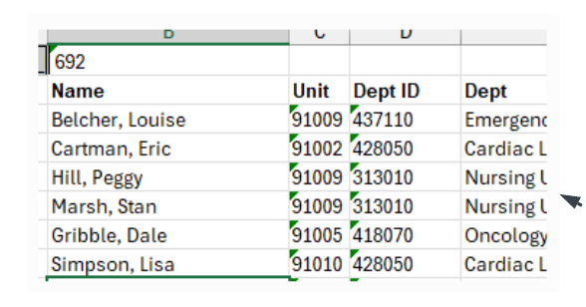
After:
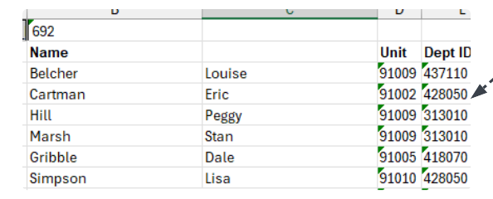
44. Rename header titles:
ID emplid
Name last_name
‘blank’ first_name
Accomp content_item_id
License # license_number
CDPH Expire expiration_dt
45. In last open column type a header: issuing_agency
46. In the cells under issuing_agency enter: CDPH – RPA updated record in all the rows with data
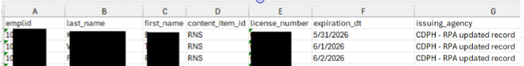

47. Select File and save a copy
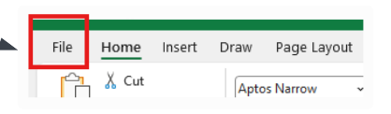
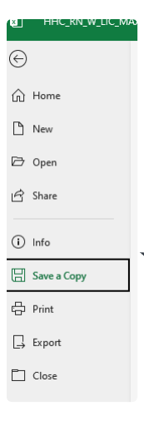
47.1 Navigate to and select the below network folder depending on if test or production: \\HHCsystem.org\AppSrvShares\RPA_HR\Enterprise_Wide_Licensure_and_Certification_Process_NonProduction\output
\\HHCsystem.org\AppSrvShares\RPA_HR\Enterprise_Wide_Licensure_and_Certification_Process_Production\output
47.2 Name the file as HHC_ExportData_MMDDYYYY .csv (where MMDDYYY is the current date)
47.2.1 Select the file type as CSV (*.csv)
47.2.2 select the Save button
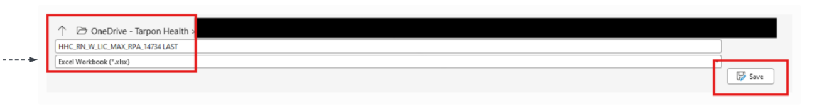
48. Close “X” out of the file
49. Navigate to and select the below network folder depending on if test or production:
\\HHCsystem.org\AppSrvShares\RPA_HR\Enterprise_Wide_Licensure_and_Certification_Process_NonProduction\output
\\HHCsystem.org\AppSrvShares\RPA_HR\Enterprise_Wide_Licensure_and_Certification_Process_Production\output
50. Select (highlight) file named: HHC_ExportData_MMDDYYYY.csv (current date)
51. Right click and open the .csv file with Notepad
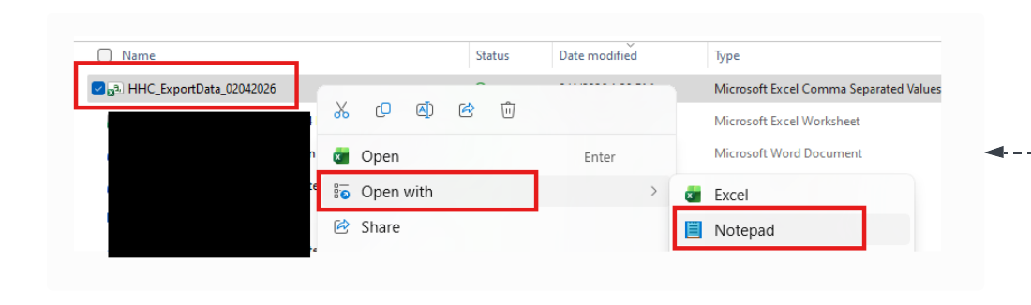
52. Ctrl F for find and replace function. (may need to use carrot to expand box)
52.1 Enter comma in top box and enter a pipe in second box
52.2 Select Replace all
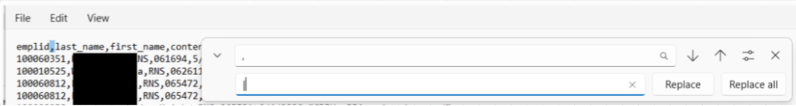
53. Close the find and replace box (X out)
54. Go to File Save As
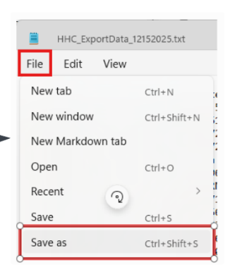
55. Navigate to:
\\hhcsystem\dfs\peoplesofthhc\InterfaceFiles\HHCHRDEV\Evercheck\Inbound\--->only during testing
OR
\\hhcsystem\dfs\peoplesofthhc\Interfaces\HHCHRPRD\Evercheck\Inbound\
55.1 File name: HHC_ExportData_MMDDYYYY (MMDDYYY = current date)
55.2 Save as type: Text documents (*.txt)
55.3 Click Save button
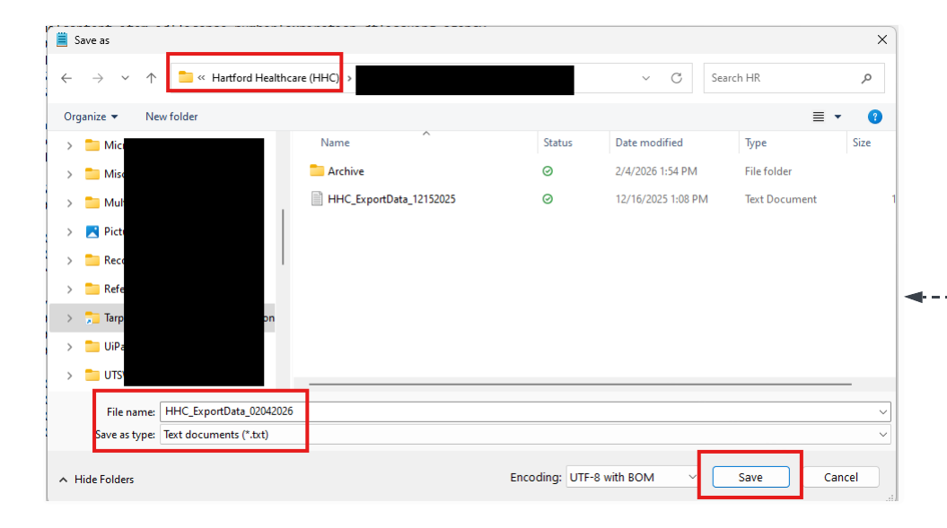
56. Close File (X out)
57. Navigate to:
\\HHCsystem.org\AppSrvShares\RPA_HR\Enterprise_Wide_Licensure_and_Certification_Process_NonProduction
(FOR TESTING ONLY)
OR
\\HHCsystem.org\AppSrvShares\RPA_HR\Enterprise_Wide_Licensure_and_Certification_Process_Production
58. Move all excel files to the Archive folder
59. Create an exception report
56.1 1 tab for successful transactions
56.2 1 tab for exceptions
56.3 Send to:
peter.weisenberg@hhchealth.org
laura.woodworth@hhchealth.org
60. End Process

4. Other

4.1 Version Details
Date | Author | Title | Version | Comments
12/15/2025 | Kim Anderson | Solution Architect/Tarpon Health | 1.0
12/17/2025 | Kim Anderson | Solution Architect/Tarpon Health | 2.0 | Revisions
1/9/2026 | Kim Anderson | Solution Architect/Tarpon Health | 3.0 | Revisions
1/12/2026 | Kim Anderson | Solution Architect/Tarpon Health | 4.0 | Revisions


