Confidential

HHC SC PO OnBase Indexing

Process Design Document v1.0

v1.0

Table of Contents
1. INTRODUCTION 4
1.1 Purpose 4
1.2 Objectives 4
1.3 Key Contacts 4
1.4 Minimum Pre-requisites for the Automation 5
2. AS IS Process details 5
2.1 Process Overview 5
2.2 Applications Used 6
2.3 AS IS Process Map 9
2.3.1 High Level Process Map 9
2.3.2 Detailed Level Process Map 9
2.4 Exceptions Handling 9
2.5 Input Details 13
3. TO BE Process details 13
3.1 High Level Process Map 14
3.2 Detailed Level Process Map 14
3.3 In Scope For RPA 14
3.4 Out Of Scope for RPA 14
3.5 Business Exceptions Handling 14
3.5.1 Known Business Exceptions 14
3.5.2 Unknown Business Exceptions 14
3.6 Applications Errors & Exceptions Handling 15
3.6.1 Known Applications Errors and Exceptions 15
3.6.2 Unknown Applications Errors and Exceptions 15
3.7 Reporting 15
4. Other 15
4.1 Additional sources of process documentation 15
4.2 Version Details 19

1. INTRODUCTION

1.1 Purpose
The Process Definition Document outlines the business process chosen for automation. The document describes the sequence of actions performed as part of the business process, the conditions and rules of the process prior to automation (AS IS) as well as the new sequence of actions that the process will follow as a result of preparation for automation (TO BE).
The PDD is a communication document between:
- The RPA Business Analyst and the SME/Process Owner. The goal is to ensure that the RPA Business Analyst has the correct understanding of the process and has represented it accurately.
- The RPA Business Analyst and the Development team (represented by the Solution Architect and RPA Development Lead). The goal is to ensure that the process is documented appropriately and to a sufficient level of detail so that the Solution Architect can then create the solution based on the PDD content.

1.2 Objectives
The business objectives and benefits expected by the Business Process Owner after automation of the selected business process are:
- The objective is to save staff time on manual data entry (indexing) in the OnBase repository application for P.O. invoices. The automation will scan the email documents and extract data points to ingest into OnBase along with the email document(s). The automation will also let staff know if documents need further review.
- The return on investment after 3 years is estimated at $240, 943

1.3 Key Contacts
Stakeholders that need to be informed or to approve changes to the process:
Role | Name | Contact Details (email, phone number) | Notes
Subject Matter Expert | Sreemayee Bose | sreemayee.bose@hhchealth.org | Lead, Accounts Payable (no longer with HHC as of 3/13/2026)
OnBase Application Expert | Scott Sopp | Scott.Sopp@hhchealth.org | ITS Application Analyst III (Responsible for providing workflow guidance and answering questions related to OnBase during process design to ensure the automation outputs are compatible for application integration)
Process Owner/Manager | Ryan Donahue | Ryan.Donahue@hhchealth.org | Sr. Director, Procure to Pay (Key contact currently)
Supply Chain Point of Contact | Vikas Gangal | vikas.gangal@hhchealth.org | Supply Chain Management Consultant
Project Lead | Krishna Thiruvengadachari | krishna.thiruvengadachari@hhchealth.org | Director of Applications

1.4 Minimum Pre-requisites for the Automation
- Filled in Process Definition Document
- Test Data to support development
- User access and user accounts creations (licenses, permissions, restrictions to create accounts for robots)
- Credentials (user ID and password) required to log on to machines and applications
- No applications, outside of email and network folders, will be accessed.
Access to Microsoft Outlook, Microsoft Edge, and Microsoft Excel
- Application Point of Contact will communicate OnBase application downtimes or upgrades that will impact the automation to Business and RPA team

2. AS IS Process details

2.1 Process Overview
Invoices are received in a dedicated email box. OnBase scans the inbox and transfers legitimate emails to an OnBase queue. HHC Accounts Payable staff goes into the OnBase queue and reviews the documents and enters the data points to index the invoice within OnBase. In some instances, research is needed to resolve the issue before indexing by an AP associate.

2.2 Applications Used
The table includes a comprehensive list of all the applications that are used as part of the process to be automated to perform the given actions in the flow.
Application/System Name, Version, URL | System Availability  (Downtime) | Application Language (Program/UI) | Application Type (Desktop/Web) | APIs Available(Y/N) | MFA (Y/N) | Environment/ Access method | Application Owner Contact | Comments
Microsoft Outlook  Production:  AP@hhchealth.org  subfolders: RPA Working  RPA Archive  Test:  APTestscan@hhchealth.org  subfolders: RPA Working  RPA Archive | Unknown | UI | Web | N | N | AD Group | HHC | Outlook is used to receive incoming invoices. It will also be used to communicate certain errors to teams.
Network Drive  \\hhcsystem.org\AppSrvShares\RPA_SupplyChain\AP_Onbase_Indexing\Non_production | Unknown | UI | Desktop | N | N | AD Group | HHC | Used to store and read the documents to prepare file for testing.
Network Drive  \\hhcsystem.org\AppSrvShares\RPA_SupplyChain\AP_Onbase_Indexing\Production | Unknown | UI | Desktop | N | N | AD Group | HHC | Used to store and read the documents to prepare file for production.
Network Drive  Non-Production:  \\hhcsystem\AppSrvShares\OnBaseFinancial\TstFiles\AP\RPAInvoices | Unknown | UI | Desktop | N | N | AD Group | Scott Sopp  scott.sopp@hhchealth.org | Used to place file for ingestion into OnBase for testing.
Network Drive  Production:  \\hhcsystem\AppSrvShares\OnBaseFinancial\PrdFiles\AP\RPAInvoices | Unknown | UI | Desktop | N | N | AD Group | Scott Sopp scott.sopp@hhchealth.org | Used to place file for ingestion into OnBase for production.
Microsoft Excel | Unknown | UI | Desktop | N | N | AD Group | HHC | Contains crosswalk for entity names, taxable BUs, and exception report.
PDF (portable document format) | Unknown | UI | Desktop | N | N | AD Group | HHC | Emails and attachments will need to be converted to a .pdf file for UiPath document understanding/IXP.
TIFF (tagged image file format) | Unknown | UI | Desktop | N | N | AD Group | HHC | The OnBase ingested documents need to be in a TIFF format.
Text File | Unknown | UI | Desktop | N | N | AD Group | HHC | The data will be placed in a text file for ingestion into OnBase application.
Microsoft Edge | Unknown | UI | Web | N | N | AD Group | HHC | Edge will be used to access the test and production email boxes.

2.3 AS IS Process Map

2.3.1 High Level Process Map

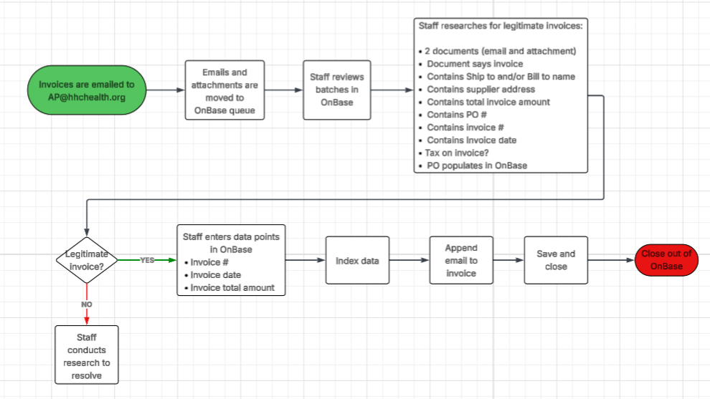

2.3.2 Detailed Level Process Map

HHC SC OnBase Indexing AS IS.pdf

2.4 Exceptions Handling

Exception Type | Application Involved | Exception Details | Action(s) To be taken by the Bot(s):
Business Exception | All | BE000: Unknown business exception occurred. Please research | 1. Take a screenshot of the current screen.  Email screenshot and any additional exception details to  RPA_AP_ONBASEINDEX@hhchealth.org  EBSRPASupport@hhchealth.org  for investigation and remediation.  2. Include in exception report that is emailed at end of process.
Business Exception | Microsoft Outlook | BE001: No attachment in email. Please resolve manually | 1. Send email to:  RPA_AP_ONBASEINDEX@hhchealth.org  cc: EBSRPASupport@hhchealth.org  No attachment in email. Please resolve manually  2. Attach original email to exception email being sent to teams above  3. Include in exception report that is emailed at end of process.  4. Exclude from ingestion files
Business Exception | PDF | BE002: Contains non-invoice document(s) only. Please resolve manually | 1. Send email to:  RPA_AP_ONBASEINDEX@hhchealth.org  cc: EBSRPASupport@hhchealth.org  Contains non-invoice document(s) only. Please resolve manually  2. Attach original email to exception email being sent to teams above  3. Include in exception report that is emailed at end of process.  4. Exclude from ingestion files
Business Exception | PDF | BE003: “Ship to” and/or “Bill to” has unknown entity name. Please research | 1. This will route into OnBase review queue for AP team to review and resolve.  2. Include in exception report that is emailed at end of process.  RPA_AP_ONBASEINDEX@hhchealth.org  cc the RPA Support team with the exception details.  EBSRPASupport@hhchealth.org
Business Exception | PDF | BE004: Missing "Ship to" and/or "Bill to" name. Please research | 1. This will route into OnBase review queue for AP team to review and resolve.  2. Include in exception report that is emailed at end of process.  RPA_AP_ONBASEINDEX@hhchealth.org  cc the RPA Support team with the exception details.  EBSRPASupport@hhchealth.org
Business Exception | PDF | BE005: Missing supplier address. Please research | 1. This will route into OnBase review queue for AP team to review and resolve.  2. Include in exception report that is emailed at end of process.  RPA_AP_ONBASEINDEX@hhchealth.org  cc the RPA Support team with the exception details.  EBSRPASupport@hhchealth.org
Business Exception | PDF | BE006: Missing total invoice amount. Please research | 1. This will route into OnBase review queue for AP team to review and resolve.  2. Include in exception report that is emailed at end of process.  RPA_AP_ONBASEINDEX@hhchealth.org  cc the RPA Support team with the exception details.  EBSRPASupport@hhchealth.org
Business Exception | PDF/Microsoft Outlook | BE007: Missing PO number. Please research | 1. This will route into OnBase review queue for AP team to review and resolve.  2. Include in exception report that is emailed at end of process.  RPA_AP_ONBASEINDEX@hhchealth.org  cc the RPA Support team with the exception details.  EBSRPASupport@hhchealth.org
Business Exception | PDF | BE008: Tax exempt, adjusting total less tax. Please research | 1. This will route into OnBase review queue for AP team to review and resolve.  2. Include in exception report that is emailed at end of process.  RPA_AP_ONBASEINDEX@hhchealth.org  cc the RPA Support team with the exception details.  EBSRPASupport@hhchealth.org
Business Exception | PDF/Microsoft Outlook | BE009: Contains more than 5 documents (email and attachments). Please resolve manually | 1. Send email to:  RPA_AP_ONBASEINDEX@hhchealth.org  cc: EBSRPASupport@hhchealth.org  Contains more than 5 documents (email and attachments). Please resolve manually  2. In original email being sent to teams above, include the details of email document with more than 5 pages (date, time and document name) and don’t attach original email since it may be large.  3. Include in exception report  4. Exclude from ingestion files
Business Exception | Microsoft Outlook | BE010: Can’t open or read email attachment. Please resolve manually | 1. Send email to:  RPA_AP_ONBASEINDEX@hhchealth.org  cc: EBSRPASupport@hhchealth.org  Can’t open or read P.O. email and attachment. Please resolve manually  3. Attach original email to exception email being sent to teams above  4. Include in exception report that is emailed at end of process.  5. Exclude from ingestion files
Business Exception | PDF | BE011: Missing invoice date. Please research | 1. This will route into OnBase review queue for AP team to review and resolve.  2. Include in exception report that is emailed at end of process.  RPA_AP_ONBASEINDEX@hhchealth.org  cc the RPA Support team with the exception details.  EBSRPASupport@hhchealth.org
Business Exception | PDF | BE012: Missing invoice #. Please research | 1. This will route into OnBase review queue for AP team to review and resolve.  2. Include in exception report that is emailed at end of process.  RPA_AP_ONBASEINDEX@hhchealth.org  cc the RPA Support team with the exception details.  EBSRPASupport@hhchealth.org
Business Exception | PDF | BE013: Can’t match invoice to non-invoice documents. Please resolve manually | 1. Send email to:  RPA_AP_ONBASEINDEX@hhchealth.org  cc: EBSRPASupport@hhchealth.org  Can’t match invoice to non-invoice documents. Please resolve manually  3. Attach original email to exception email being sent to teams above  4. Include in exception report that is emailed at end of process  5. Exclude from ingestion files
System Exception | All | SE000: Unknown system exception occurred. Please research. | 1. Take a screenshot of the current screen.  Email screenshot and any additional exception details to RPA Support Team  EBSRPASupport@hhchealth.org  for investigation and remediation.  2. Include in exception report that is emailed at end of process.
System Exception | Outlook/network folders | SE001: Issue moving emails from Outlook to network folder. Please research | 1. Retry 3 times  2. Loop through moving all emails  3. Send email to:  EBSRPASupport@hhchealth.org  Issue moving email to network folder. Please research  4. Include in exception report that is emailed at end of process.
System Exception | PDF | SE002: Issue combining email and attachment into one document. Please resolve manually | 1. Retry 3 times  2. Send email to:  EBSRPASupport@hhchealth.org  RPA_AP_ONBASEINDEX@hhchealth.org  Issue combining email and attachment into one document. Please resolve manually.  3. Attach original email to exception email being sent to teams above  4. Include in exception report that is emailed at end of process  5. Exclude from ingestion file
System Exception | PDF/TIFF | SE003: Unable to convert PDF to Tiff file format. Please research | 1. Retry 3 times  2. Loop through converting all pdf to tiff files  3. Send email to:  EBSRPASupport@hhchealth.org  Issue converting PDF to TIFF file format. Please research
System Exception | Network folders | SE004: Unable to move all files to OnBase ingestion folder. Please research | 1. Retry 3 times  2. Loop through process  3. Send email to:  EBSRPASupport@hhchealth.org  Unable to move all files to OnBase ingestion folder. Please research

2.5 Input Details
#Action | Sample | Input Type | Location | Are inputs Natively Digital*? | Are the Inputs Structured*?
Invoices are received in a dedicated AP email inbox. Those emails and attachments are moved to a network folder to be scanned by UiPath DU/IXP and extracting data points and decision points. | Input example.PDF | Semi-structured and nonstructured data from .pdf files. | \\hhcsystem.org\AppSrvShares\RPA_SupplyChain\AP_  Onbase_Indexing\Non_production  \\hhcsystem.org\AppSrvShares\RPA_SupplyChain\AP_  Onbase_Indexing\Production | Yes | No

3. TO BE Process details
The invoice emails will go to the main AP email box. Through a series of rules, invoices from PO vendors, and internal emails, with the words PO or purchase order will be routed to a subfolder where the automation will copy to a network folder. It will go through a process of converting the email and attached document into a single PDF document. UiPath DU and IXP will scan the attachment, (not the email) looking for certain data points. These data points will be added to a data table and then organized into a file to be ingested into OnBase along with the corresponding attachments. The AP staff will work out of an OnBase workflow to review the indexing.

3.1 High Level Process Map
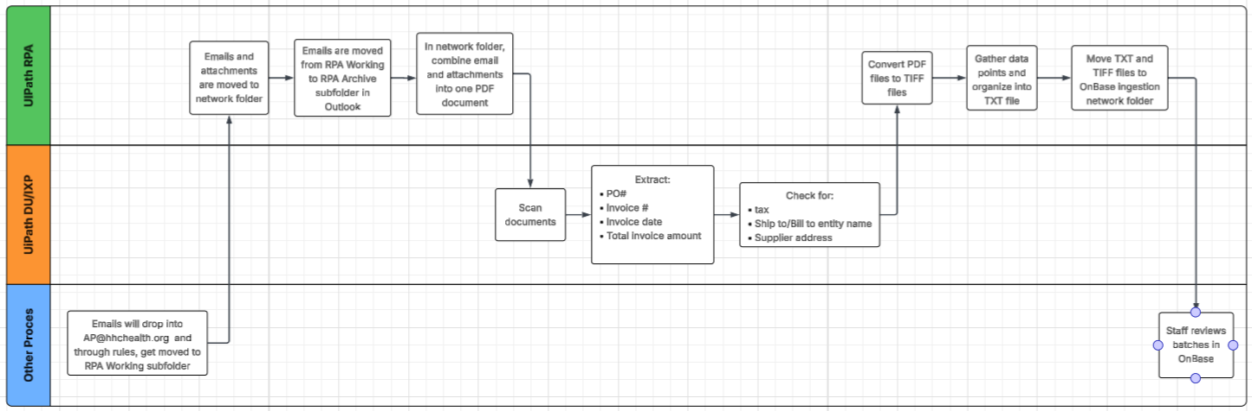

3.2 Detailed Level Process Map
HHC SC OnBase Indexing TO BE.pdf

3.3 In Scope For RPA
The actions in scope for this process are listed below:
- Purchase Order (PO) Invoices
- Only invoices received through the email box for Supply Chain
- Purchase Order emails with less than or equal to 5 attachments

3.4 Out Of Scope for RPA
- Non-PO Invoices
- Invoices outside of Supply Chain
- Emails with no attachments
- Non-invoice documents
- Purchase order emails with more than 5 attachments

3.5 Business Exceptions Handling

3.5.1 Known Business Exceptions
Send an email to:
- RPA_AP_ONBASEINDEX@hhchealth.org
- Scott.Sopp@hhchealth.org
- EBSRPASupport@hhchealth.org

3.5.2 Unknown Business Exceptions
Send an email to:
- RPA_AP_ONBASEINDEX@hhchealth.org
- Scott.Sopp@hhchealth.org
EBSRPASupport@hhchealth.org

3.6 Applications Errors & Exceptions Handling

3.6.1 Known Applications Errors and Exceptions
1. Take a screenshot of the current screen.
2. Email EBSRPASupport@hhchealth.org with the exception details
3. For ingestion issues, email Scott Sopp (scott.sopp@hhchealth.org)

3.6.2 Unknown Applications Errors and Exceptions
1. Take a screenshot of the current screen.
2. Email EBSRPASupport@hhchealth.org with the exception details
3. For ingestion issues, email Scott Sopp (scott.sopp@hhchealth.org)

3.7 Reporting
Report Type | Update frequency | Details | Sample output report
Microsoft Excel | Daily after process runs | 1 tab for success  1 tab for exceptions with details | Exception Report.xlsx

4. Other

4.1 Additional sources of process documentation
Additional Process Documentation
Video Recording of the process | Presidio-HHC Supply Chain On-Base Indexing Process RPA Design Session (3001612506370) 1-27-2026 Recording.mp4  Presidio-HHC Supply Chain On-Base Indexing Process RPA Design Session (3001612506370) 1-28-2026 Recording.mp4  Presidio-HHC Supply Chain On-Base Indexing Process RPA Design Session (3001612506370) 2-3-2026 Recording.mp4  Presidio-HHC Supply Chain On-Base Indexing Process RPA Design Session (3001612506370) 2-13-2026 Recording.mp4  Presidio-HHC Supply Chain On-Base Indexing Process RPA Design Session (3001612506370) 2-20-2026 Recording.mp4  Presidio-HHC Supply Chain On-Base Indexing Process RPA Design Session (3001612506370) 3-2-2026 Recording.mp4  Presidio-HHC Supply Chain On-Base Indexing Process RPA Design Session (3001612506370) 3-4-2026 Recording.mp4  Presidio-HHC Supply Chain OnBase Indexing File Questions for PDD (300161250637079) 3-11-2026 Recording.mp4
Video Recording of Proof Of Concept (Optional) | N/A
Step by Step Guide/Detailed level process map | HHC SC OnBase Indexing AS IS.pdf  HHC SC OnBase Indexing TO BE.pdf  HHC SC OnBase Indexing Step by Step Guide.docx
As-Is and To-Be flow diagrams/High Level Process Map | HHC SC OnBase Indexing High Level AS IS.pdf  HHC SC OnBase Indexing High Level TO BE.pdf
Standard Operating Procedure(s) (Optional) | N/A
Work Instructions (Optional) | N/A
Input Files Location | \\hhcsystem.org\AppSrvShares\RPA_SupplyChain\AP_Onbase_Indexing\Non_production  \\hhcsystem.org\AppSrvShares\RPA_SupplyChain\AP_Onbase_Indexing\Production
Input File Sample | Input example.PDF
Output Files Location | Test:  \\hhcsystem\AppSrvShares\OnBaseFinancial\TstFiles\AP\RPAInvoices  Prod:  \\hhcsystem\AppSrvShares\OnBaseFinancial\PrdFiles\AP\RPAInvoices
Other Files | PO Vendor Names.xlsx  OnBase File Specs.xlsx  Entity Names BU Tax List.xlsx  Test DIP file Samples

4.2 TO BE Process Overview
Item | Description/Answer
Process Full Name | AP OnBase Indexing
Process Area | Supply Chain Management
Department | Accounts Payable
Sub Department | Pre-Sort
Short Description (operation, activity, outcome) | This automation will move emails from an email folder to a network folder. It will scan the documents gathering data points, and creating a TXT file for ingestion into OnBase, along with a corresponding TIF file. These files will index PO invoices in OnBase, saving staff time from doing this manually.
Role(s) required in applications to perform the process | N/A
Process schedule and frequency | 1 time per day
Number of times the process is ran by selected frequency | Once
Process execution time | Off hours
Process Restrictions/Applications availability (Downtime) | No large scale planned downtimes – also this was purposely built before OnBase so it would not impact RPA. If there was any downtime or issues, files would just accumulate in the OnBase network folder. RPA process can continuously process regardless of the OnBase state. Any scheduled downtimes would be scheduled around any project implementation or dedicated testing.
Concurrency allowed?  *Max parallel bots that can run on this application/process | Yes, although not recommended to start
Peak Volume Approximate increase | Unknown
Peak Period (s) | During HHC Fiscal year closing – Sept and Oct  During calendar year – Dec
Expected Volume increase during next periods | Approx. 20-25% increase
How would you characterize the peaks of the process?  *Regular, Rare but predictable, Rare, Never | Regular
How will your process change in the next 6 months? (Process Stability)  *Very small, some, medium or significant | Very small
How will your applications change in the next 6 months? (Application stability)  *Very small, some, medium or significant | Unknown – probably some to medium. Again, it does not impact RPA
How difficult are the decisions that you must take to complete the process?  *Linear, Simple Yes or No or Complex decisions | Complex decisions
How many steps does the process have?  *<=10, 10-15, 15-25, 25-40, >40 | >40
% of average number of cases where you are unable to complete the entire process? (Either because you require input from a different person or because you end up in a situation that is not covered by a clear rule) | Unknown
What is the number of applications that you use for the process? | 3
Are any of the applications accessed via virtual machines? | No
How do the majority of your data inputs look like?  *Digital and structured, Digital and Unstructured, Non Digital and structured, Non Digital and Unstructured | Digital and semi-structured
What % of your input data is digital? | 100%
Is any of your digital input scanned? | Yes
What % of your input data is structured? | Although invoices contain consistent business fields, they are ingested as PDFs or scanned documents, which are classified as unstructured or semi-structured data. No pre-structured datasets are provided as inputs.
Input data description | Daily, emails will be scanned, and data points will be gathered to create the DIP file for OnBase ingestion (Output file).
Output Data description | The output of this process is a DIP file that will be ingested into OnBase with corresponding documents.  An output report with all successes and failures will be sent daily at the end of the process to RPA and AP teams.

4.3 Version Details
Date | Author | Title | Version | Comments
3/1/2026 | Kim Anderson | Solutions Architect/Tarpon Health | 1.0
3/16/2026 | Kim Anderson | Solutions Architect/Tarpon Health | 2.0 | HHC/Presidio/Tarpon Health meeting 3/16/2026 PDD review, corrections made


