Confidential

Revenue Cycle
Patient Credits and Refunds

Process Design Document v1.0

v1.0

Table of Contents
1. INTRODUCTION 3
1.1 Purpose 3
1.2 Objectives 3
1.3 Key Contacts 3
1.4 Minimum Pre-requisites for the Automation 3
2. AS IS Process details 4
2.1 Process Overview 4
2.2 Applications Used 4
2.3 AS IS Process Map 6
2.3.1 High Level Process Map 6
2.3.2 Detailed Level Process Map 6
2.4 Exceptions Handling 6
2.5 Input Details 8
3. TO BE Process details 8
3.1 High Level Process Map 9
3.2 Detailed Level Process Map 9
3.3 In Scope For RPA 9
3.4 Out Of Scope for RPA 10
3.5 Business Exceptions Handling 10
3.5.1 Known Business Exceptions 10
3.5.2 Unknown Business Exceptions 10
3.6 Applications Errors & Exceptions Handling 10
3.6.1 Known Applications Errors and Exceptions 10
3.6.2 Unknown Applications Errors and Exceptions 10
3.7 Reporting 10
4. Other 11
4.1 Additional sources of process documentation 11
4.2 Version Details 13

1. INTRODUCTION

1.1 Purpose
The Process Definition Document outlines the business process chosen for automation. The document describes the sequence of actions performed as part of the business process, the conditions and rules of the process prior to automation (AS IS) as well as the new sequence of actions that the process will follow because of preparation for automation (TO BE).
The PDD is a communication document between:
- The RPA Business Analyst and the SME/Process Owner. The goal is to ensure that the RPA Business Analyst has the correct understanding of the process and has represented it accurately.
- The RPA Business Analyst and the Development team (represented by the Solution Architect and RPA Development Lead). The goal is to ensure that the process is documented appropriately and to a sufficient level of detail so that the Solution Architect can then create the solution based on the PDD content.

1.2 Objectives
The business objectives and benefits expected by the Business Process Owner after automation of the selected business process are:
- This automation will remove the manual process of reviewing patient credits and processing the refunds for professional billing.
- The Goal is to save staff time to work on more analytical tasks. The return on investment for this process is an estimating savings of $161,000 after 3 years.

1.3 Key Contacts
Stakeholders that need to be informed or to approve changes to the process:
Role | Name | Contact Details (email, phone number) | Notes
Process Owner/Manager | Kevin Diaz | kevin.diaz@hhchealth.org | Director, Optimization and Innovation
Subject Matter Expert Lead | Cynthia Twining | cynthia.twining@hhchealth.org | Single Billing Office Manager
Subject Matter Expert | Barbara Rossignol | barbara.rossignol@hhchealth.org | Self-Pay and Correspondence Supervisor
Process Owner Lead | Cailun Fuhrman | cailun.fuhrman@hhchealth.org | Innovation and Optimization Specialist
Project Lead | Krishna Thiruvengadachari | krishna.thiruvengadachari@hhchealth.org | Director of Applications

1.4 Minimum Pre-requisites for the Automation
- Process Definition Document reviewed and signed
- Test Data to support development
- User access and user accounts creations (licenses, permissions, restrictions to create accounts for robots)
- Credentials (user ID and password) required to log on to machines and applications such as Epic

2. AS IS Process details

2.1 Process Overview
HHC Revenue Cycle staff work Epic work queues 154 and 129 that contain patient credits. The staff conduct research assuring there are no open balances, look for certain adjustments to reverse and confirm the patient is due a refund. They process the refund and add a note in Epic.

2.2 Applications Used
The table includes a comprehensive list of all the applications that are used as part of the process to be automated to perform the given actions in the flow.
Application/System Name, Version, URL | System Availability  (Downtime) | Application Language (Program/UI) | Application Type (Desktop/Web) | APIs Available(Y/N) | MFA (Y/N) | Environment/ Access method | Application Owner Contact | Comments
Epic Sup | N/A | UI | Desktop | N | N | AD Group | Jennifer Lewis | EPIC is the application used to review and refund patient credits in the test environment.
Epic Prod | Midnight – 3am | UI | Desktop | N | N | AD Group | Jennifer Lewis | EPIC is the application used to review and refund patient credits in the production environment.
Microsoft Excel | Unknown | UI | Desktop | N | N | AD Group | HHC | The SQL export report will be in Excel.
Microsoft Outlook | Unknown | UI | Desktop | N | N | AD Group | HHC | Outlook is used to notify staff of process issues and exceptions.
Network Drive  \\HHCsystem.org\AppSrvShares\RoboticProcessAutomation\RPA_RevenueCycle\SBO_Patients_Credits_Process_NonProduction | Unknown | UI | Desktop | N | N | AD Group | HHC | Network drive used to store input files for RPA team for testing.
Network Drive  \\HHCsystem.org\AppSrvShares\RoboticProcessAutomation\RPA_RevenueCycle\SBO_Patients_Credits_Process_Production | Unknown | UI | Desktop | N | N | AD Group | HHC | Network drive used to store input files for RPA team for production.

2.3 AS IS Process Map

2.3.1 High Level Process Map

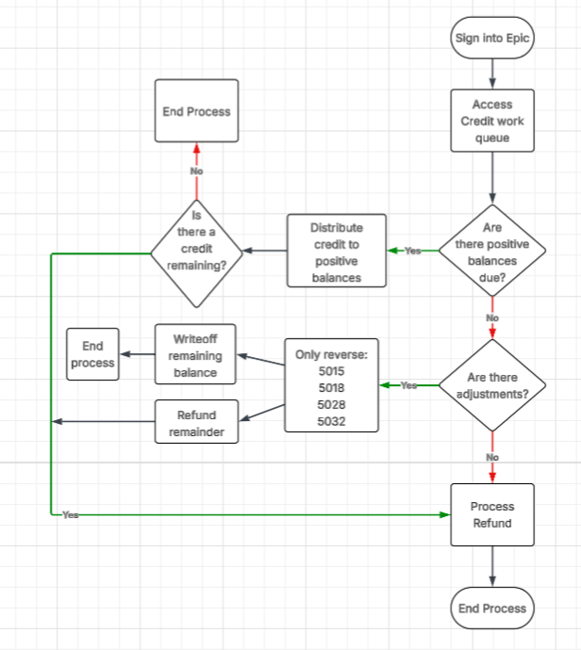

2.3.2 Detailed Level Process Map

HHC Rev Cycle - Detailed Flow AS IS.pdf

2.4 Exceptions Handling

Exception Type | Application Involved | Exception Details | Action(s) To be taken by the Bot(s):
Business Exception | All | BE000: Unknown business exception occurred. Please research. | 1. Email Business team  barbara.rossignol@hhchealth.org  cynthia.twining@hhchealth.org  Cc the RPA Support team with the exception details.  EBSRPASupport@hhchealth.org
Business  Exception | Microsoft Excel | BE001: Input file is missing. Please research | - Retry 3 times at the top of the hour  - Fail job  - Send email to:  barbara.rossignol@hhchealth.org  cynthia.twining@hhchealth.org  cc the RPA Support team with the exception details.  EBSRPASupport@hhchealth.org  Re: Missing SQL Report for Credit/Refund Bot
Business  Exception | Epic | BE002: Patient is deceased. Please research. | 1. Include in exception report that gets emailed to Business team  barbara.rossignol@hhchealth.org  cynthia.twining@hhchealth.org  Cc the RPA Support team with the exception details.  EBSRPASupport@hhchealth.org
Business  Exception | Epic | BE003: Less than 45 days since date of service. Skip record. | 1. Include in exception report that gets emailed to Business team  barbara.rossignol@hhchealth.org  cynthia.twining@hhchealth.org  Cc the RPA Support team with the exception details.  EBSRPASupport@hhchealth.org
Business Exception | Epic | BE004: Adj code not eligible for reversal. | 1. Include in exception report that gets emailed to Business team  barbara.rossignol@hhchealth.org  cynthia.twining@hhchealth.org  Cc the RPA Support team with the exception details.  EBSRPASupport@hhchealth.org
Business Exception | Epic | BE005: Adj amount(s) for 5015, 5018, 5028, 5032 in Epic do not = PBADJAMT from queue. Please research | 1. Include in exception report that gets emailed to Business team  barbara.rossignol@hhchealth.org  cynthia.twining@hhchealth.org  Cc the RPA Support team with the exception details.  EBSRPASupport@hhchealth.org
Business Exception | Epic | BE006: Patient credit amount in Epic does not match Refund Bot amount from report. Please research | 1. Include in exception report that gets emailed to Business team  barbara.rossignol@hhchealth.org  cynthia.twining@hhchealth.org  Cc the RPA Support team with the exception details.  EBSRPASupport@hhchealth.org
Business Exception | Epic | BE007: No line items in distribution section. Please Review | 1. Include in exception report that gets emailed to Business team  barbara.rossignol@hhchealth.org  cynthia.twining@hhchealth.org  Cc the RPA Support team with the exception details.  EBSRPASupport@hhchealth.org
System Exception | All | SE000: Unknown system exception occurred. Please research. | - Take a screenshot of the current screen.  - Email screenshot and any additional exception details to RPA Support Team  EBSRPASupport@hhchealth.org  for investigation and remediation.
System Exception | Epic | SE001: Epic not opening. Please research | 1. Email Business team  barbara.rossignol@hhchealth.org  cynthia.twining@hhchealth.org  Cc the RPA Support team with the exception details.  EBSRPASupport@hhchealth.org

2.5 Input Details
#Action | Sample | Input Type | Location | Are inputs Natively Digital*? | Are the Inputs Structured*?
An excel file is exported from the Epic database and placed in a network folder for the automation to ingest and use as a worklist | Input Sample File.xlsx | Structured data from Microsoft Excel spreadsheet | \\HHCsystem.org\AppSrvShares\RoboticProcessAutomation\RPA_RevenueCycle\SBO_Patients_Credits_Process_Production | Yes | Yes

3. TO BE Process details
Epic’s SQL team will create a process gathering certain data points from work queue 154 and 129 to run daily and export into an excel file format. This file will be placed in a network folder. The automation will ingest this data and be used as a worklist. The automation will determine from that data if it needs to enter certain areas in Epic (balances, adjustments, or refunds). This will be ideal so that the automation does not need to search in certain Epic areas if unnecessary.

3.1 High Level Process Map
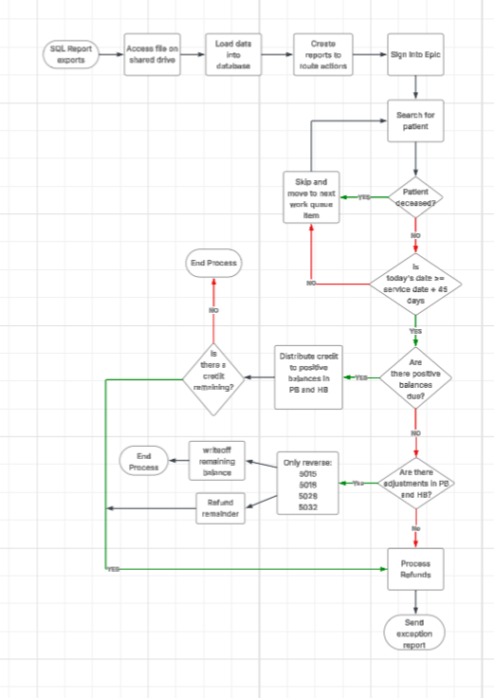

3.2 Detailed Level Process Map

HHC Rev Cycle - Dispatcher Flow BOT1.pdf
HHC Rev Cycle - PB ADJ Bot2.pdf
HHC Rev Cycle - HB ADJ Bot3.pdf
HHC Rev Cycle - Distribution Bot4.pdf
HHC Rev Cycle - Refund Bot5.pdf

3.3 In Scope For RPA
The actions in scope for this process are listed below:
- PB patient credits
- Work queue 154
- Work queue 129

3.4 Out of Scope for RPA
- Noncredit work queues
- HB patient credits
- Deceased patients
- Less than 45 days from date of service
- Insurance credits

3.5 Business Exceptions Handling

Known Business Exceptions
Send an email to:
barbara.rossignol@hhchealth.org
cynthia.twining@hhchealth.org
EBSRPASupport@hhchealth.org

Unknown Business Exceptions

Send an email to:
barbara.rossignol@hhchealth.org
cynthia.twining@hhchealth.org
EBSRPASupport@hhchealth.org

3.6 Applications Errors & Exceptions Handling

3.6.1 Known Applications Errors and Exceptions
1. Take a screenshot of the current screen.
2. Send an email to:
EBSRPASupport@hhchealth.org

Unknown Applications Errors and Exceptions
1. Take a screenshot of the current screen.
2. Send an email to:
EBSRPASupport@hhchealth.org

3.7 Reporting
Report Type | Update frequency | Details | Sample output report
Microsoft Excel | Daily after process runs | 1 Tab for Success  1 Tab for exceptions with details | Sample Exception Report.xlsx

4. Other

4.1 Additional sources of process documentation
Additional Process Documentation
Video Recording of the process | Presidio-HHC RevCycle Patient Credits Design Session (300161250637079) 3-3-2026 Recording.mp4  Presidio-HHC RevCycle Patient Credits Process Discussion (3001612506370) 9-25-25 Recording.mp4  Presidio-HHC RevCycle Patient Credits Process Working Session (-569633533) 12-22-2025 Recording.mp4  Presidio-HHC RevCycle Patient Credits SQL Report Development Assistance (3001612506370) 10-22-2025 Recording.mp4  Presidio-HHC RevCycle Patient Credits SQL Report Modification (3001612506370) 2-5-2026 Recording.mp4  Presidio-HHC RevCycle Patient Credits SQL Report Template Review Questions (3001612506370) 11-24-2025 Recording.mp4  Presidio-HHC RPA Engagement RCM SME Use Case Shadow Session (3001612506370) 8-27-25.mp4  Presidio-HHC RevCycle Patient Credits EPIC Process Discussion (3001612506370) 10-8-2025 Recording.mp4
Video Recording of Proof Of Concept (Optional) | N/A
Step by Step Guide/Detailed level process map | HHC Rev Cycle Credit Refund RPA Step by Step Guide.docx  HHC Rev Cycle - Detailed Flow AS IS.pdf  HHC Rev Cycle - Dispatcher Flow BOT1.pdf  HHC Rev Cycle - PB ADJ Bot2.pdf  HHC Rev Cycle - HB ADJ Bot3.pdf  HHC Rev Cycle - Distribution Bot4.pdf  HHC Rev Cycle - Refund Bot5.pdf
As-Is and To-Be flow diagrams/High Level Process Map | HHC Rev Cycle - High Level Flow AS IS.pdf  HHC Rev Cycle - High Level Flow TO BE.pdf
Standard Operating Procedure(s) (Optional) | Outdated document
Work Instructions (Optional) | N/A
Input File Location | \\HHCsystem.org\AppSrvShares\RoboticProcessAutomation\RPA_RevenueCycle\SBO_Patients_Credits_Process_Production
Input File Sample | Input Sample File.xlsx
Output Files | N/A
Output File sample | N/A

4.2 TO BE Process Overview
Item | Description/Answer
Process Full Name | Patient Credits and Refunds
Process Area | Self-pay
Department | Revenue Cycle
Sub Department | Patient Financial Services
Short Description (operation, activity, outcome) | Staff research credits and process a refund to patient on PB side.
Role(s) required in applications to perform the process | Epic Self-pay poster
Process schedule and frequency | Monday – Friday
Number of times the process is ran by selected frequency | Once per day
Process execution time | Off hours preferably
Process Restrictions/Applications availability (Downtime) | Midnight – 3am
Concurrency allowed?  *Max parallel bots that can run on this application/process | Concurrency is not recommended
Peak Volume Approximate increase | Daytime hours
Peak Period (s) | N/A
Expected Volume increase during next periods | N/A
How would you characterize the peaks of the process?  *Regular, Rare but predictable, Rare, Never | N/A
How will your process change in the next 6 months? (Process Stability)  *Very small, some, medium or significant | Very small
How will your applications change in the next 6 months? (Application stability)  *Very small, some, medium or significant | Very small
How difficult are the decisions that you must take to complete the process?  *Linear, Simple Yes or No or Complex decisions | Complex decisions
How many steps does the process have?  *<=10, 10-15, 15-25, 25-40, >40 | 25-40
% of average number of cases where you are unable to complete the entire process? (Either because you require input from a different person or because you end up in a situation that is not covered by a clear rule) | If a patient is deceased with no fiduciary we cannot refund.
What is the number of applications that you use for the process? | 3 - 5
Are any of the applications accessed via virtual machines? | No
How do the majority of your data inputs look like?  *Digital and structured, Digital and Unstructured, Non Digital and structured, Non Digital and Unstructured | Digital and structured
What % of your input data is digital? | 100%
Is any of your digital input scanned? | No
What % of your input data is structured? | 100%
Input data description | A daily file is created and exported from the Epic database for the automation to use as a worklist. The file will be placed in a network folder for the bot to ingest. The file will contain patient information, credit data, and dates of service.
Output Data description | The only output or result of this work are refunds. The bot will create a refund, and the Rev Cycle staff will approve the refunds before processing.

4.3 Version Details
Date | Author | Title | Version | Comments
3/5/2026 | Kim Anderson | Solutions Architect/Tarpon Health | 1.0 | Version 1
3/10/2026 | Kim Anderson | Solutions Architect/Tarpon Health | 2.0 | Adjustments after 3/10/2026 Governance Meeting


