 | | Process Definition Document

Appeals Submission via Fax

Epic System Action for Kaiser ED Down Coding Appeals

Table of Contents

| Process Definition Document 0
Table of Contents 1
I. Introduction 2
I.1 Purpose of the document 2
I.2 Objectives 2
I.3 Process key contact 2
I.4 Minimum Pre-requisites for automation 2
II. As-Is process description 3
II.1 Process Overview 3
II.2. Applications used in the process 4
II.3 As-Is Process map 4
II.4 Process statistics 5
II.5 Detailed As-Is Process Actions 6
II.6 Exceptions Handling 7
III. To-Be Process Description 8
III.1 To-Be Detailed Process Map 8
III.2 Parallel Initiatives/ Overlap (if applicable) 8
III.3 In Scope of RPA 8
III.4 Out of Scope of RPA 9
III.5 Business Exceptions Handling 9
III.6 Application Error and Exception Handling 10
III.7 Reporting 11
IV. Other Observations 11
V. Additional sources of process documentation 12

Introduction

I.1 Purpose of the document
The Process Definition Document outlines the business process chosen for automation using UiPath Robotic Process Automation (RPA) technology.
The document describes the sequence of actions performed as part of the business process, the conditions and rules of the process prior to automation and how they are envisioned to work after automating it, partly or entirely. This specifications document serves as a base for developers, providing them with the details required for applying robotic process automation to the selected business process.
A new feature in Epic allows a system action to create the release of information for a set of criteria to initiate an appeal. The system action will gather patient information and release of information documentation required for payer appeal submission, fax to the payer and send the denial to a work queue. The automation will gather the fax status, update the denial and defer for 30 days. Lastly a correspondence log will be completed before moving on the next account.

I.2 Objectives
The business objectives and benefits expected by the Business Process Owner after automation of the selected business process are:
- Increase annual receivables by up to $250,000 annually.
- Increase payer accountability and decreasing erroneous denials.

I.3 Process key contact
The specifications document includes concise and complete requirements of the business process and it is built based on the inputs provided by the process Subject Matter Expert (SME)/ Process Owner.
The Process Owner is expected to review it and provide signoff for accuracy and completion of the actions, context, impact and a set of process exceptions. The details are to be included in the table below.
Role | Name | Contact details  (email, phone number) | Notes
Patient Account Representative | Rebecca Tobe | rtobe2@uw.edu
Sr. Director of PFS and PASS | Victoria Holland | vah345@uw.edu | Primary workflow SME
Appeals consultant | Shauna Lambeth | slambeth@uw.edu

I.4 Minimum Pre-requisites for automation
- A filled in Process Definition Document
- Test Data to support development
- User access and creation of user accounts (licenses, permissions, restrictions to create accounts for robots)

As-Is process description

II.1 Process Overview
General estimated information about the process selected for RPA prior to automation as the scenario is not currently being addressed in day to day workflow.
# | Item | Description
1 | Process full name | ED Down Coding Appeals Submission via Fax
2 | Process Area | Appeals
3 | Department | Patient Financial Services
4 | Process short description  (operation, activity, outcome) | Epic System Action for Kaiser ED Down Coding Appeals
5 | Role(s) required for performing the process | HB Insurance Template
6 | Process schedule and frequency | Daily early in the day to complete faxing and again late in the workday to update fax status
7 | # of items processed /reference period | 50 per month
8 | Process execution time | 4 min. 18 sec
9 | Peak period (s) | Initial runs to initiate new appeals manually created BDC records
10 | Transaction Volume During Peak period
11 | Total # of FTEs supporting this activity | 0
12 | Expected increase of volume in the next reference period
13 | Level of exception rate
14 | Input data
15 | Output data

*Add more rows to the table to include relevant data for the automation process. No fields should be left empty. Use “n/a” for the items that don’t apply to the selected business process.

II.2. Applications used in the process
The table includes a comprehensive list of all the applications that are used as part of the process to be automated to perform the given actions in the flow.
# | Application name & version | System Language | Thin/Thick  Client | Environment/  Access method | Comments
1 | Epic |  | Thin | Citrix
2 | Adobe Pro |  | Thin | Desktop Application
*Add more rows to the table to include the complete list of applications.

II.3 As-Is Process map

High Level As-Is Process Map:
This chapter depicts the As-Is business process at a High Level to enable developers to have a high-level understanding of the current process.

II.4 Process statistics

High level statistics
Processes | Windows | Actions | Mouse clicks | Keys pressed | Text entries | Hotkeys used | Time
4 | 11 | 83 | 63 | 16 | 5 | 2 | 4 min. 18 sec*
* This process takes longer than the documented 4 minutes if letter creation and approval prior to sending are included.

Detailed statistics
Window name | Mouse Clicks | Text entries | Keys pressed
Open Epic | 1 | 0 | 0
Lakilado, Mary - HAR 27391881 | 6 | 0 | 0
Hyperspace – UW MED BILLING DEPARTMENT 20 – Production - \\Remote | 31 | 4 | 14
Account Note - \\Remote | 1 | 0 | 0
Letter Editor - \\Remote | 5 | 0 | 0
Select a Printer - \\Remote | 4 | 0 | 0
Open - \\Remote | 2 | 0 | 0
Fax Release - \\Remote | 4 | 0 | 0
Save Print Output As | 0 | 0 | 0
CHPW Appeal cover sheet (MAIL FAX EMAIL).pdf - Adobe Acrobat Pro 2020 | 5 | 0 | 0
Save As PDF | 4 | 1 | 2

II.5 Detailed As-Is Process Actions

Sequence
Est. time: 3.8 sec.

Open Epic
Est. time: 3.8 sec.
Action: Click

Hyperspace – UW MED BILLING DEPARTMENT 20 – Production - \\Remote
Begin Appeal Submitted SRG Documentation | Est. time: 17.5 sec.

[Epic screenshots in PDD have been removed]

Denial Activity

[Epic screenshots in PDD have been removed]

Hyperspace – UW MED BILLING DEPARTMENT 20 – Production - \\Remote
Est. time: 0.9 sec.

Add Note to HAR

[Epic screenshots in PDD have been removed]

Account Note - \\Remote
Enter notes | Est. time: 2.8 sec.

FOLLOW UP WITH VICTORIA
 | Est. time: 2.8 sec.
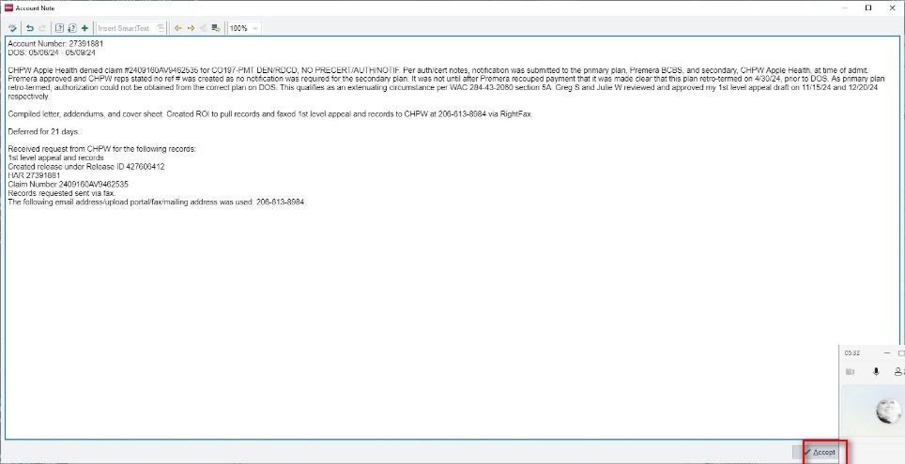 | Action: Click

Hyperspace – UW MED BILLING DEPARTMENT 20 – Production - \\Remote
Add required details to Appeal Submitted SRG. Prep letter to generate. | Est. time: 13.2 sec.

Add appeal tracking

[Epic screenshots in PDD have been removed]

[Epic screenshots in PDD have been removed]

appeal tracking

[Epic screenshots in PDD have been removed]

[Epic screenshots in PDD have been removed]

Letter Template Selection

[Epic screenshots in PDD have been removed]

Press ‘Down’
 | Est. time: 0.9 sec.
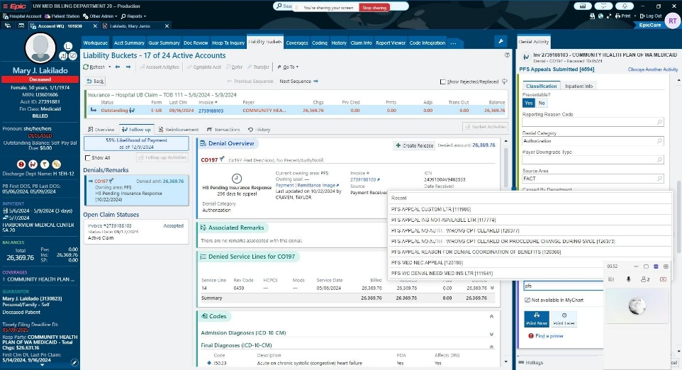 | Action: Special Key

Select letter template

[Epic screenshots in PDD have been removed]

Hyperspace – UW MED BILLING DEPARTMENT 20 – Production - \\Remote
Edit letter | Est. time: 1.1 sec.

Edit Letter

[Epic screenshots in PDD have been removed]

Letter Editor - \\Remote
Edit Letter | Est. time: 3.7 sec.

Does not apply for system action
 | Est. time: 0.3 sec.
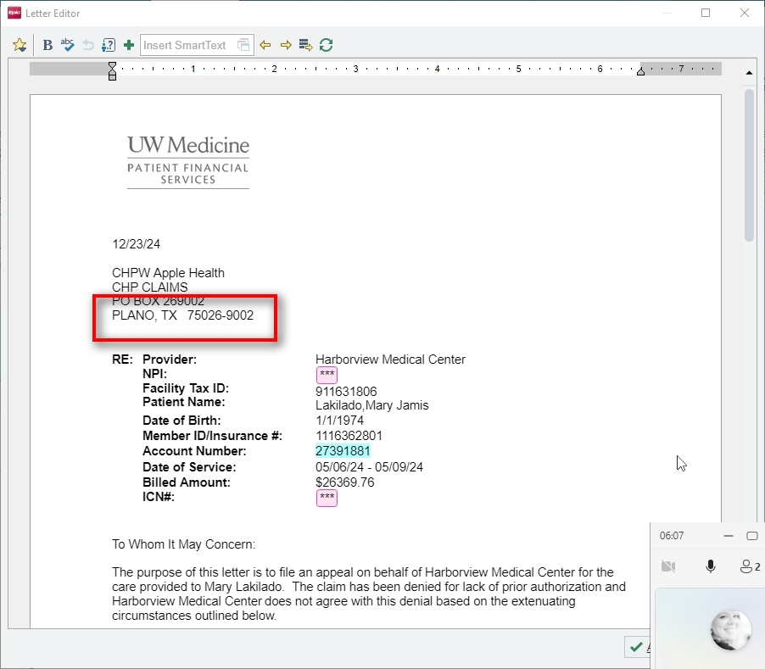 | Action: Click

 | Est. time: 0.8 sec.
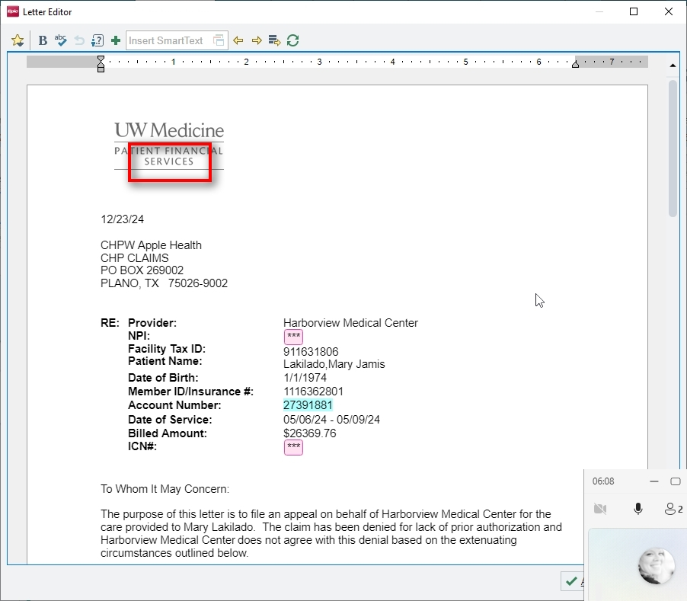 | Action: Click

Press ‘Del’
 | Est. time: 1.0 sec.
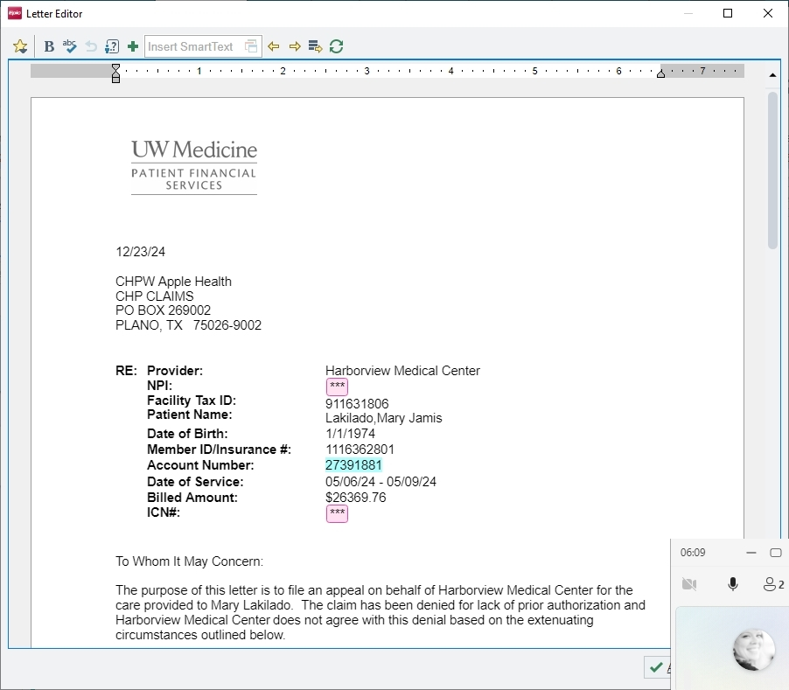 | Action: Special Key

 | Est. time: 0.10 sec.
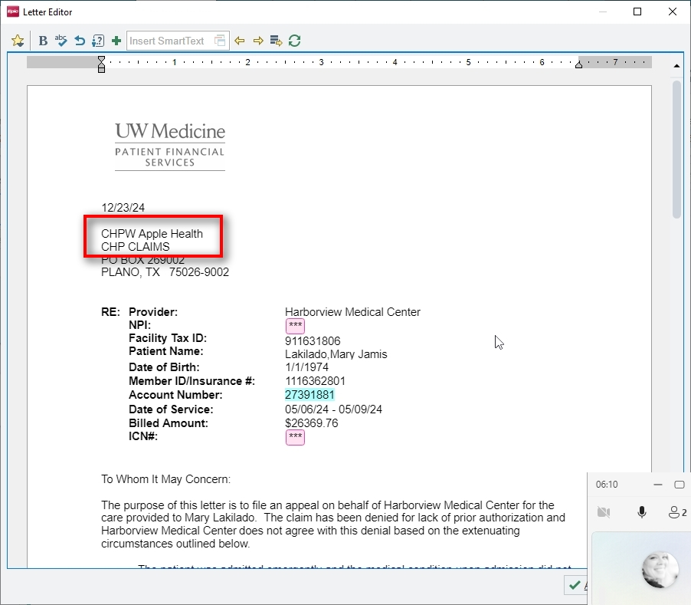 | Action: Click

 | Est. time: 0.3 sec.
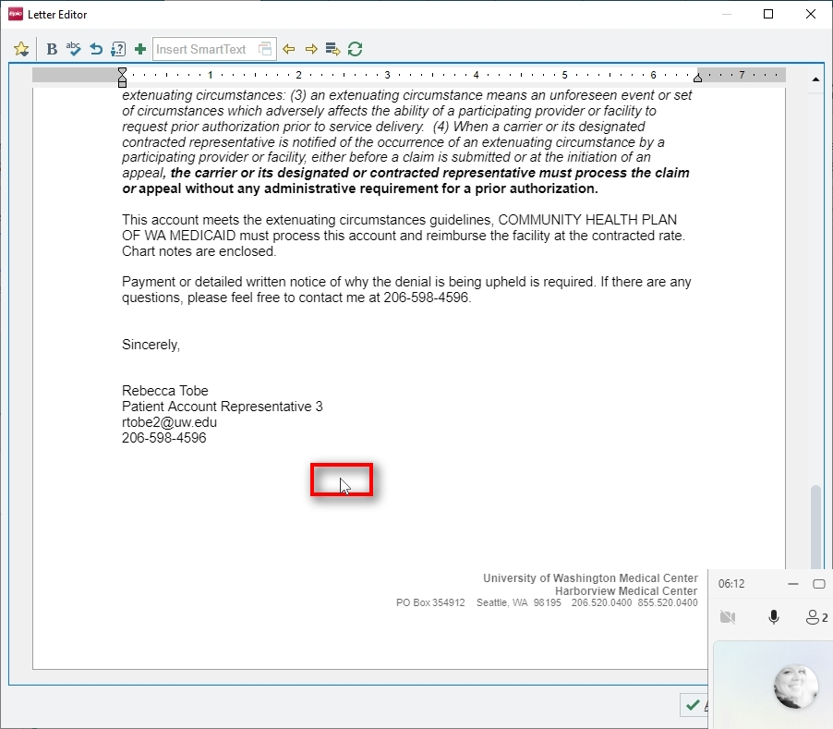 | Action: Click

Press ‘Ctrl+v’
 | Est. time: 0.3 sec.
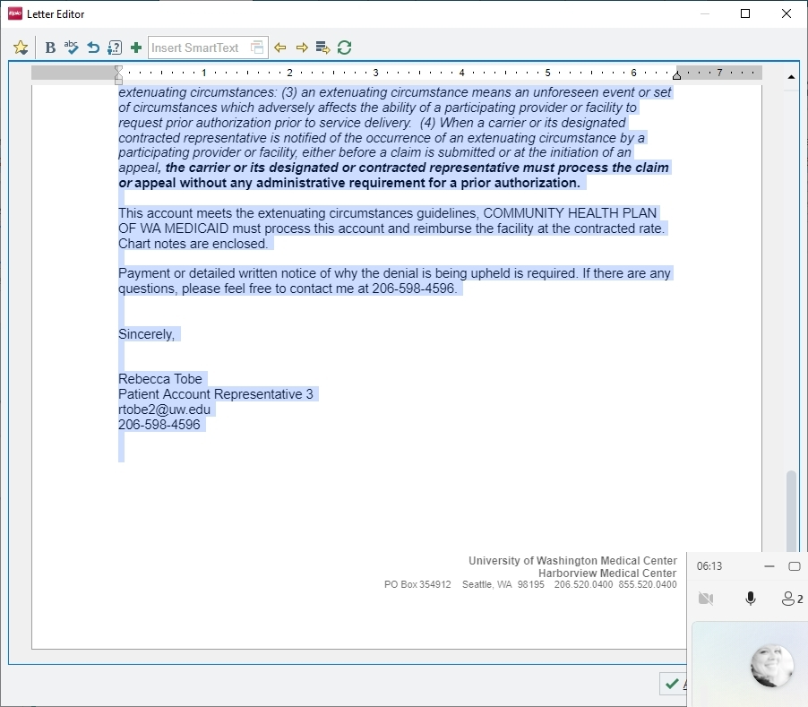 | Action: Hotkey

Letter Editor - \\Remote
Edit Letter | Est. time: 2.7 sec.

Click to accept letter
 | Est. time: 2.7 sec.
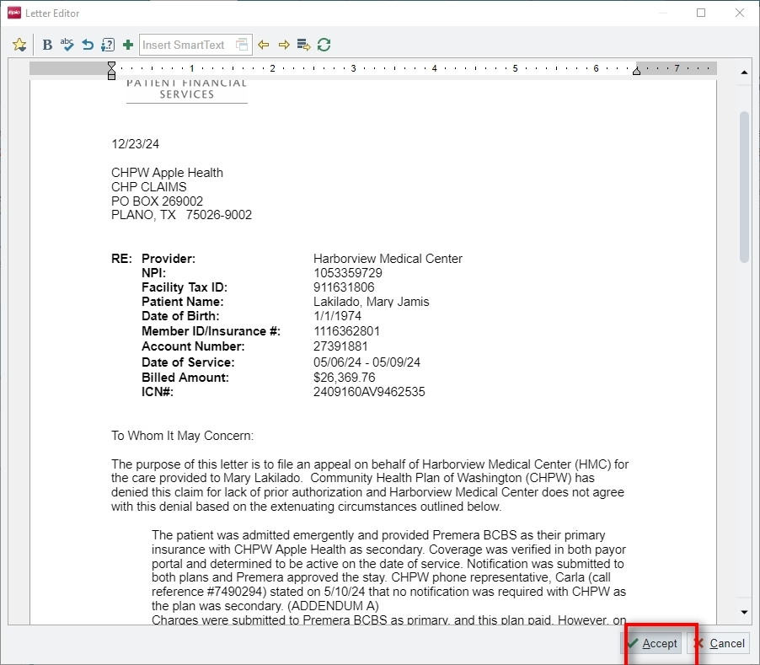 | Action: Click

Hyperspace – UW MED BILLING DEPARTMENT 20 – Production - \\Remote
Prepare to generate | Est. time: 2.9 sec.

[Epic screenshots in PDD have been removed]

Select a Printer - \\Remote
Prepare to generate letter | Est. time: 18.4 sec.

Print to PDF
 | Est. time: 3.2 sec.
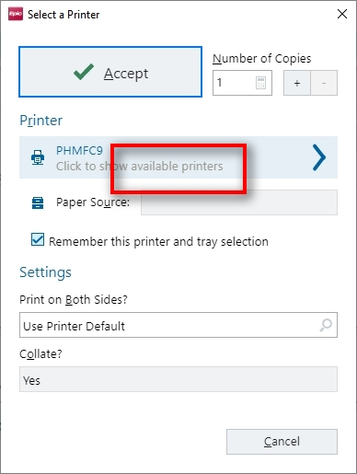 | Action: Click

 | Est. time: 5.9 sec.
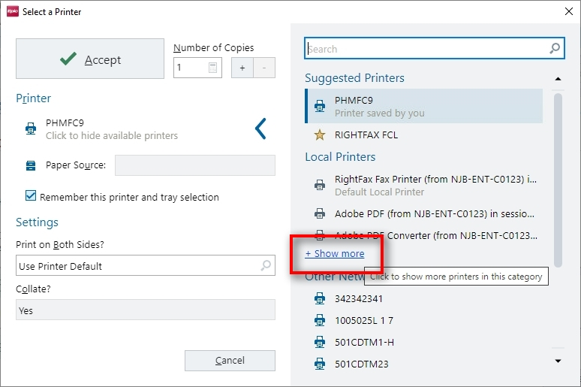 | Action: Click

 | Est. time: 5.5 sec.
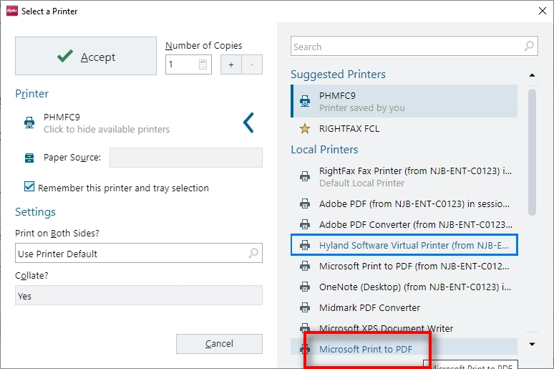 | Action: Click

 | Est. time: 3.8 sec.
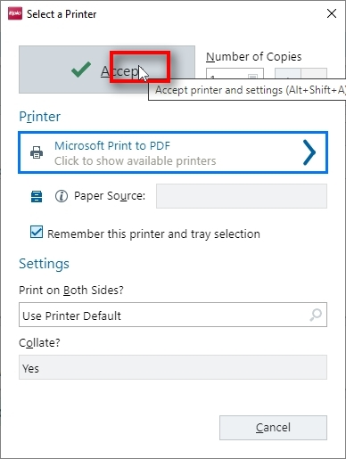 | Action: Click

Hyperspace – UW MED BILLING DEPARTMENT 20 – Production - \\Remote
Est. time: 4.6 sec.

Select No Action for WQ Action

[Epic screenshots in PDD have been removed]

Save Print Output As
Save letter | Est. time: 0.6 sec.

Press ‘Ctrl+v’ Press ‘Enter’
 | Est. time: 0.1 sec.
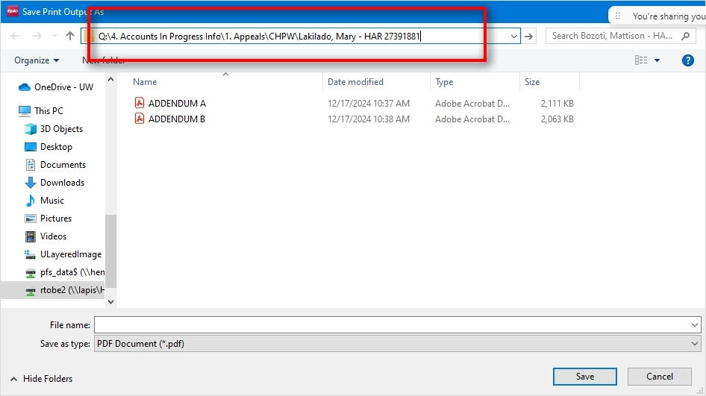 | Action: Special Key

Press ‘Ctrl+v’ Press ‘Back’ Press ‘Enter’
 | Est. time: 0.5 sec.
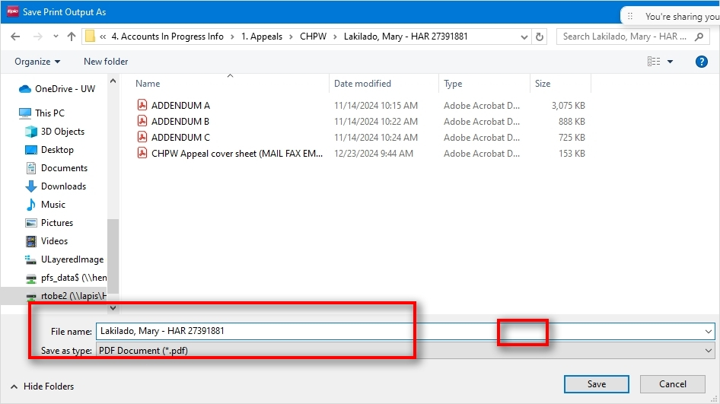 | Action: Special Key

Lakilado, Mary – HAR 27391881
Est. time: 10.3 sec.

 | Est. time: 1.5 sec.
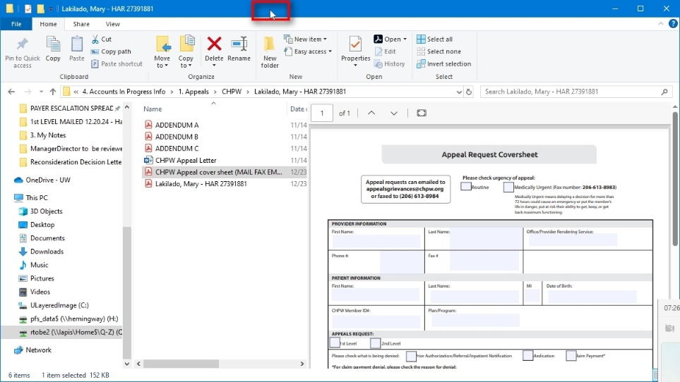 | Action: Click

 | Est. time: 3.0 sec.
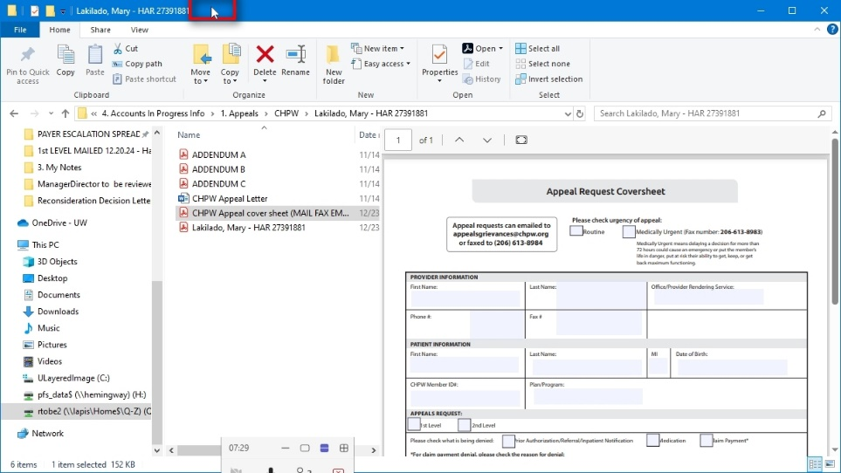 | Action: Click

 | Est. time: 1.7 sec.
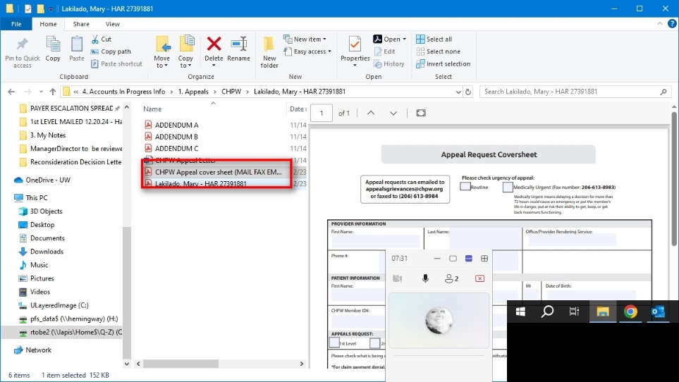 | Action: Click

 | Est. time: 3.4 sec.
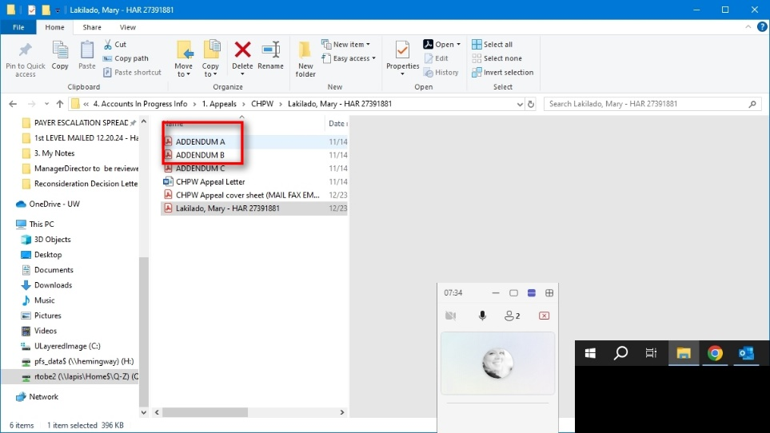 | Action: Click

 | Est. time: 0.0 sec.
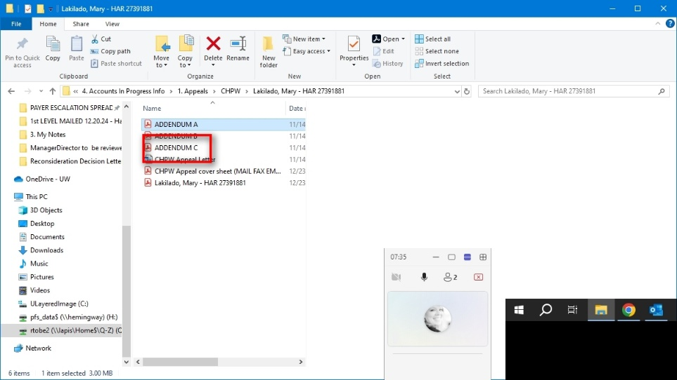 | Action: Click

 | Est. time: 0.6 sec.
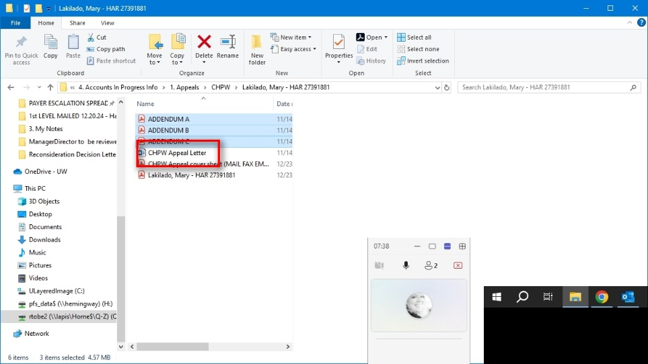 | Action: Click

CHPW Appeal cover sheet (MAIL FAX EMAIL).pdf – Adobe Acrobat Pro 2020
Compile letter addendums | Est. time: 41.2 sec.

Merge documents into one PDF
 | Est. time: 5.10 sec.
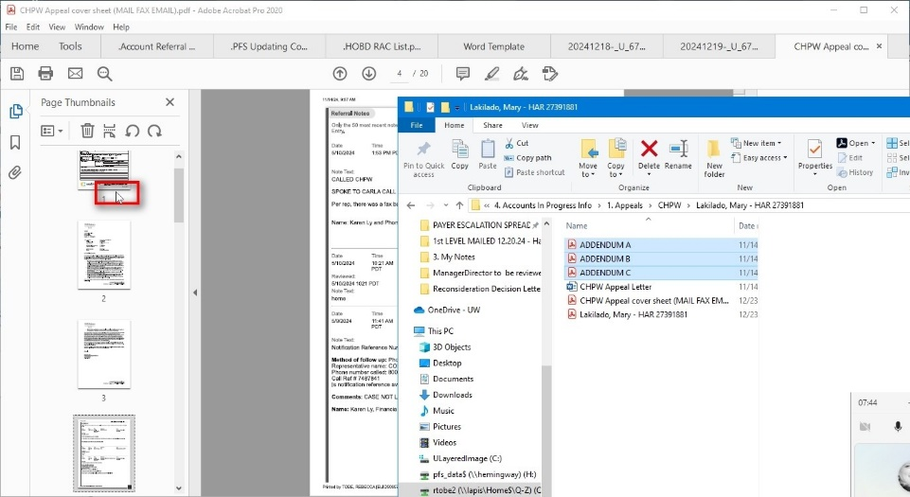 | Action: Click

Press ‘Down’
 | Est. time: 8.0 sec.
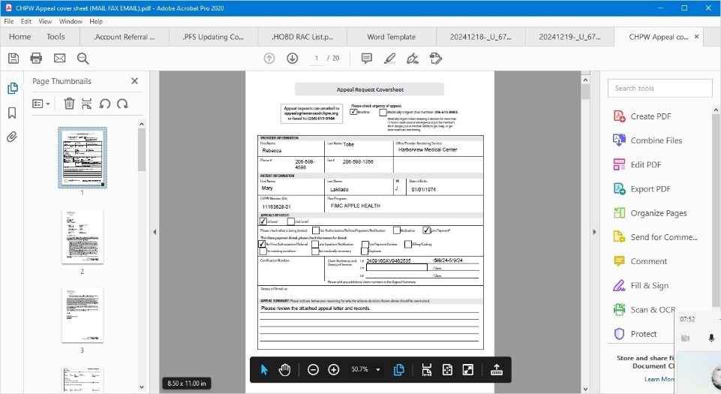 | Action: Special Key

 | Est. time: 15.2 sec.
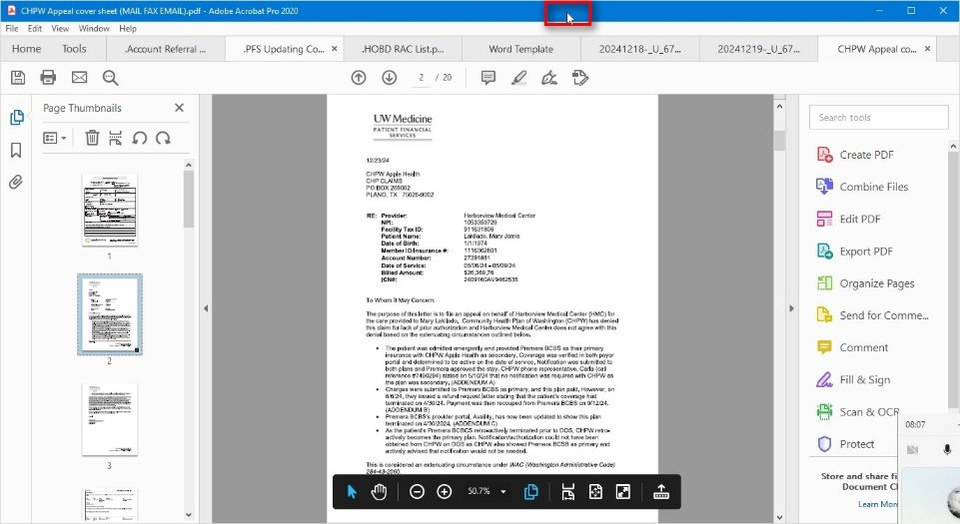 | Action: Click

Press ‘Down’
 | Est. time: 0.6 sec.
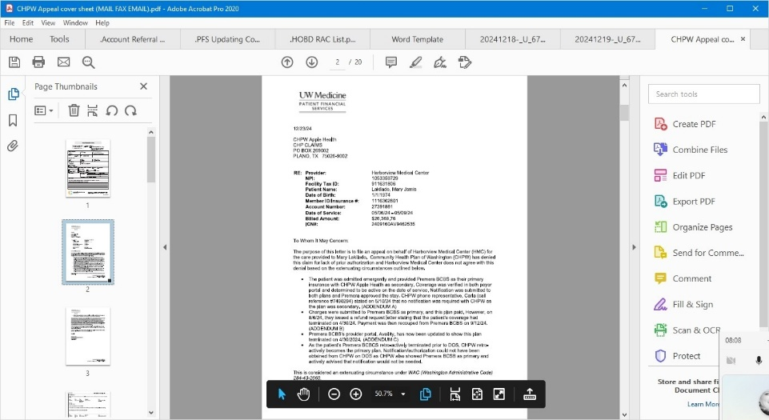 | Action: Special Key

Press ‘Up’
 | Est. time: 0.8 sec.
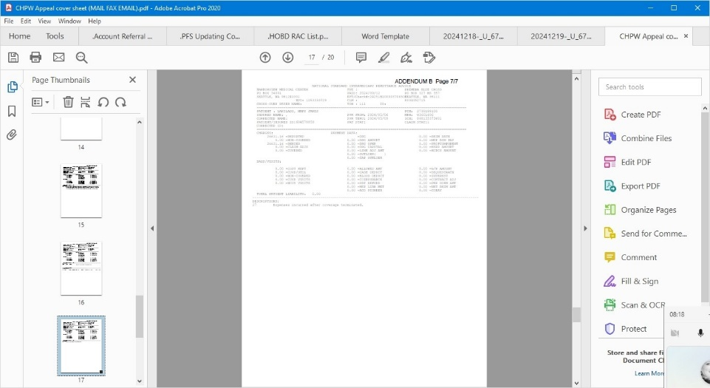 | Action: Special Key

Press ‘Down’
 | Est. time: 0.3 sec.
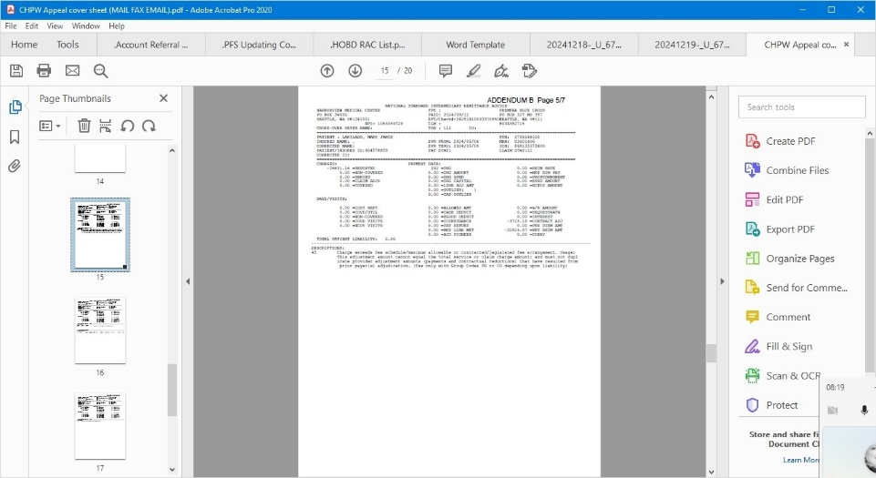 | Action: Special Key

 | Est. time: 3.6 sec.
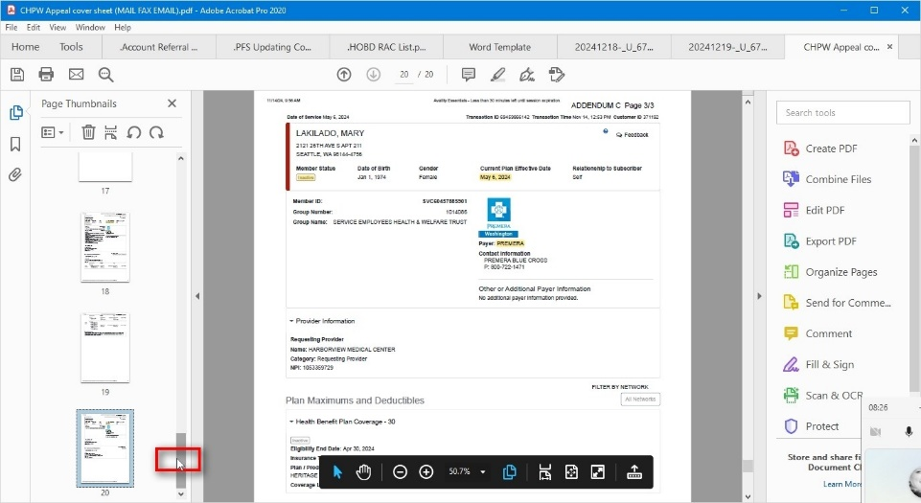 | Action: Click

 | Est. time: 3.7 sec.
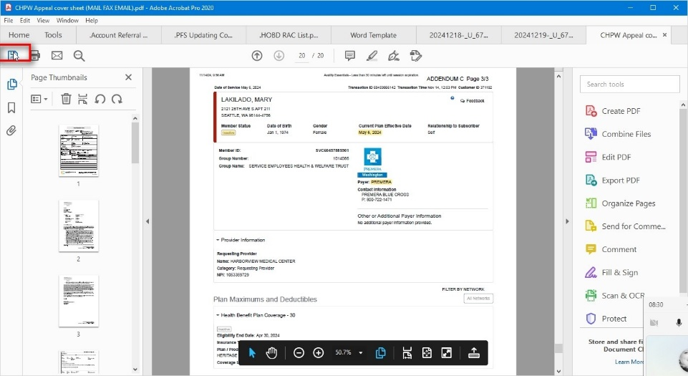 | Action: Click

 | Est. time: 2.8 sec.
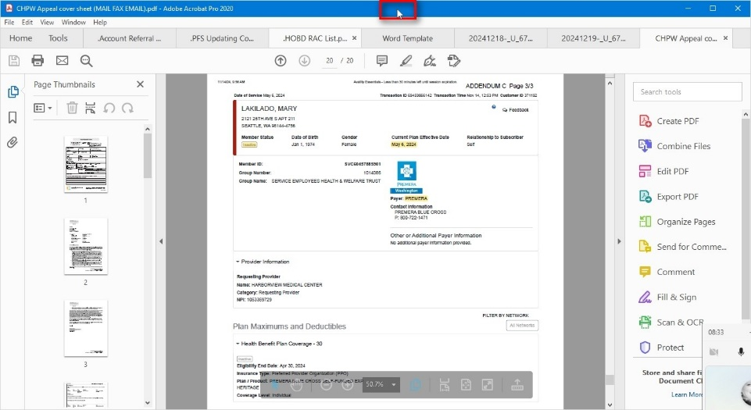 | Action: Click

Press ‘Ctrl+Shift+S’
 | Est. time: 0.2 sec.
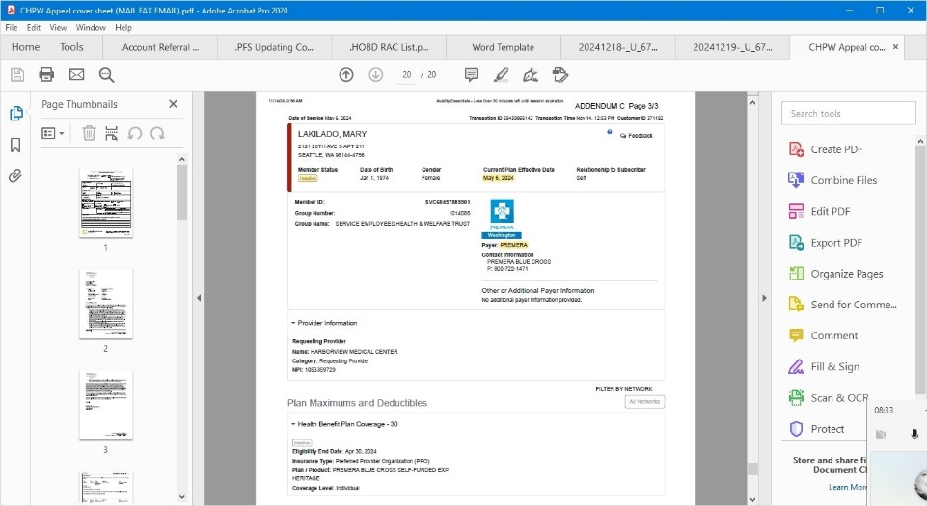 | Action: Hotkey

Save As PDF
Save letter for ROI | Est. time: 7.1 sec.

Press ‘Ctrl+c’
 | Est. time: 0.2 sec.
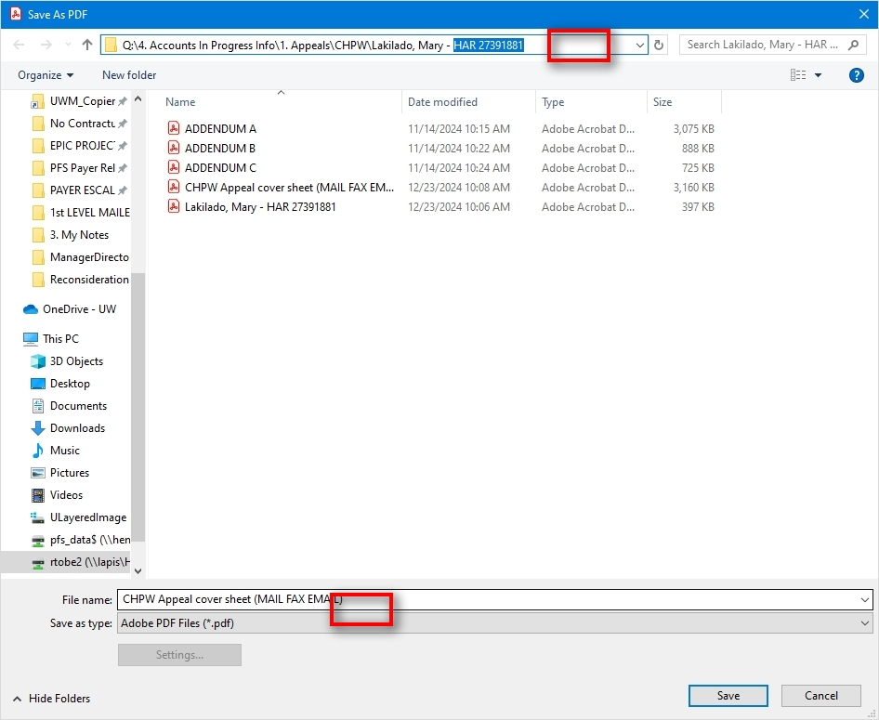 | Action: Click

Press ‘Ctrl+v’ Press ‘Ctrl+a’ Press ‘Ctrl+v’ Press ‘Del’
 | Est. time: 2.7 sec.
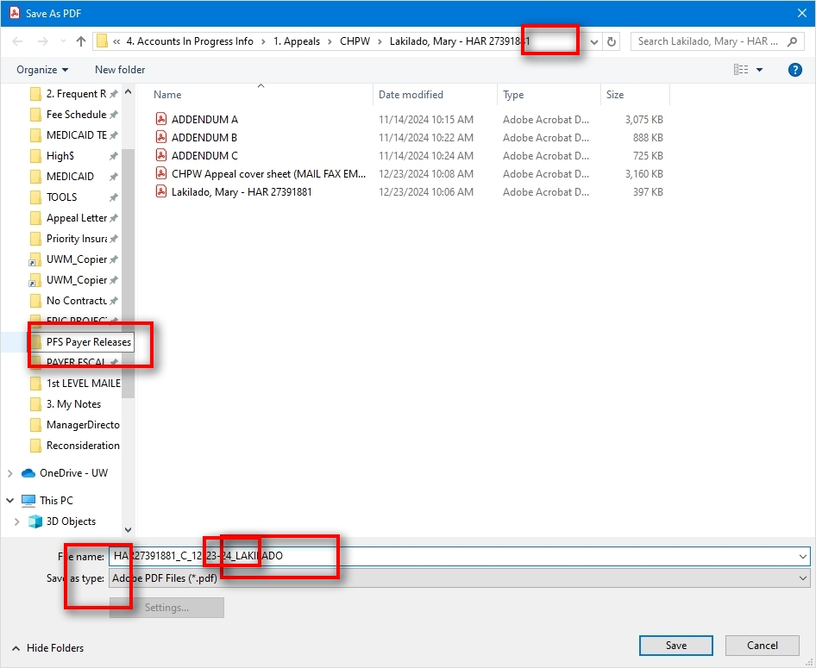 | Action: Click

 | Est. time: 0.10 sec.
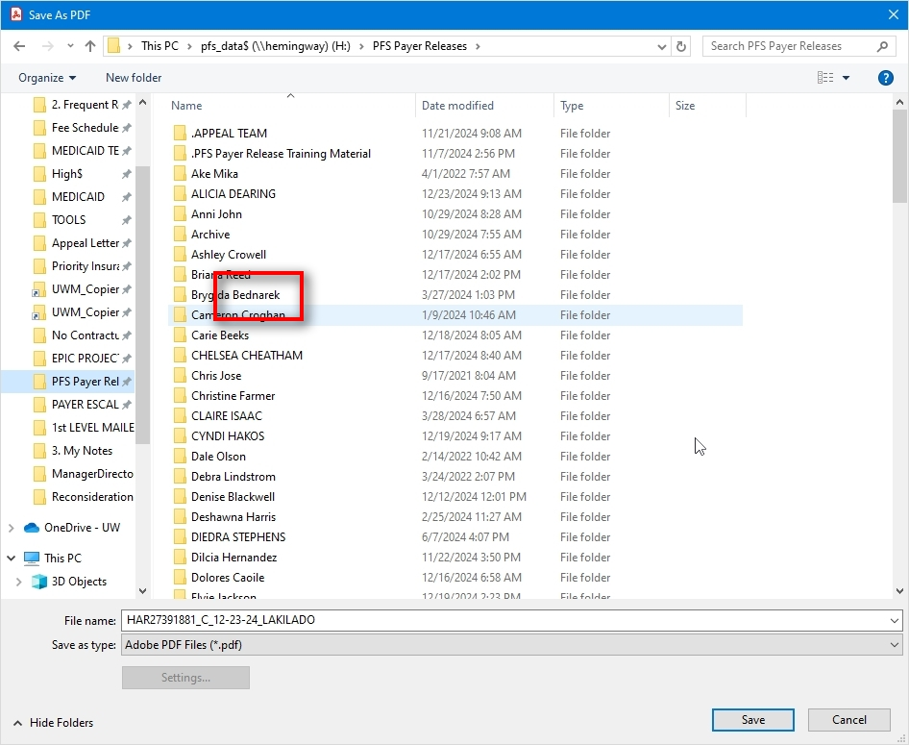 | Action: Click

 | Est. time: 0.2 sec.
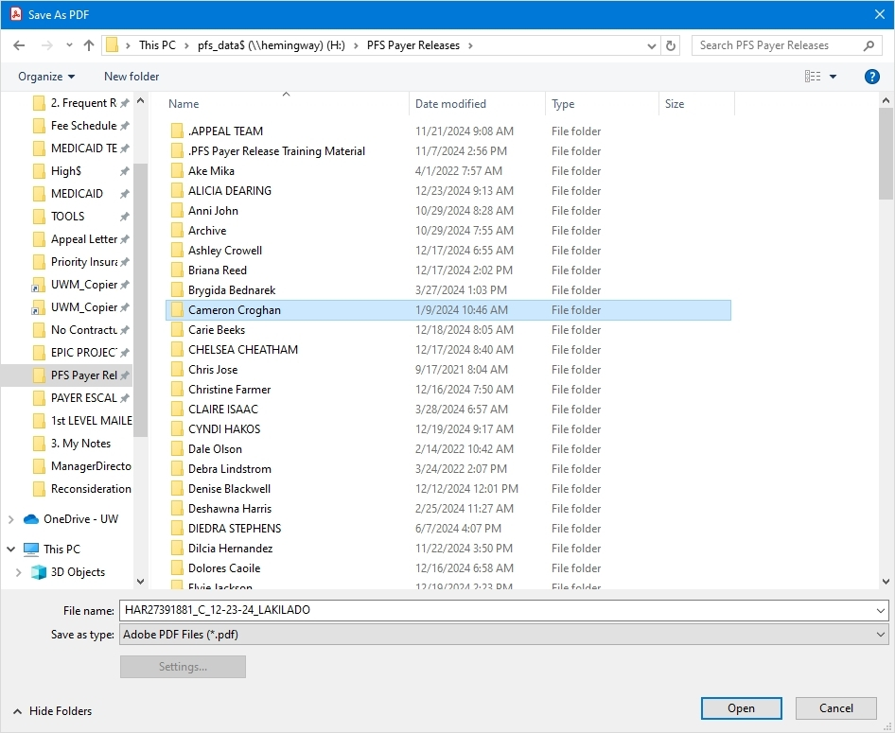 | Action: Keyboard Input

Press ‘Enter’
 | Est. time: 0.6 sec.
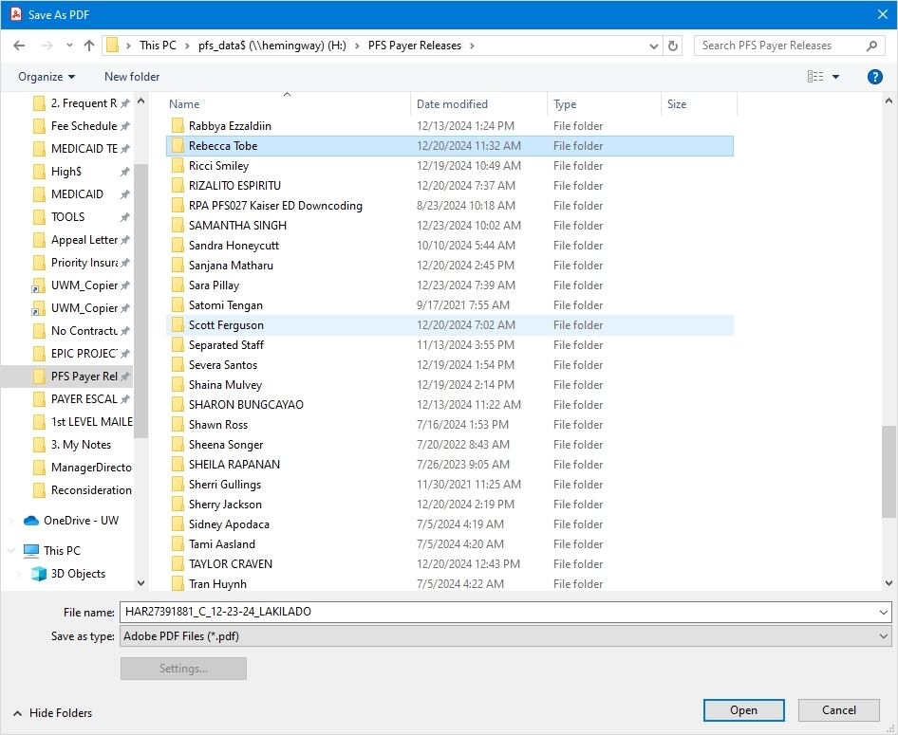 | Action: Special Key

 | Est. time: 2.4 sec.
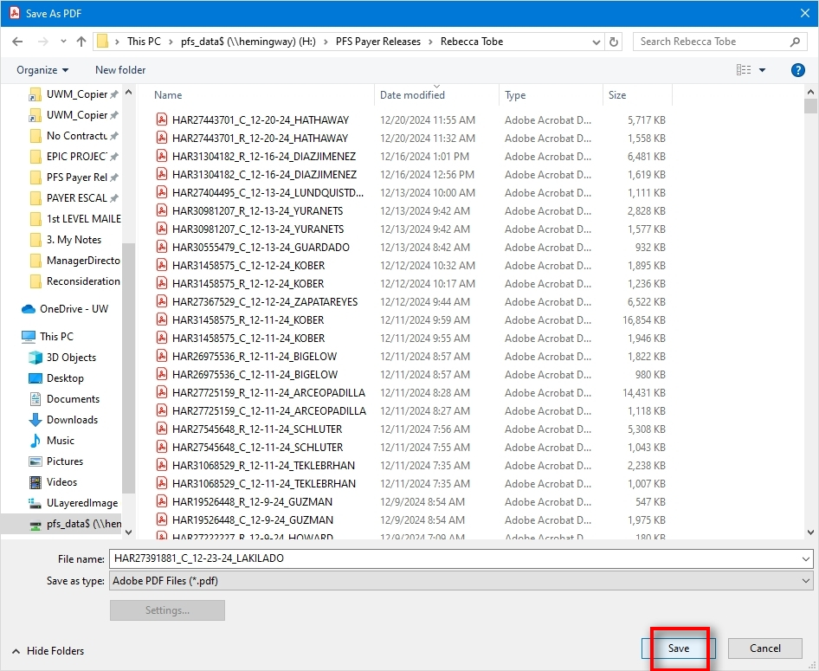 | Action: Click

Hyperspace – UW MED BILLING DEPARTMENT 20 – Production - \\Remote
Upload letter to ROI | Est. time: 4.6 sec.

[Epic screenshots in PDD have been removed]

[Epic screenshots in PDD have been removed]

[Epic screenshots in PDD have been removed]

Open - \\Remote
Upload letter to ROI | Est. time: 4.6 sec.

 | Est. time: 2.7 sec.
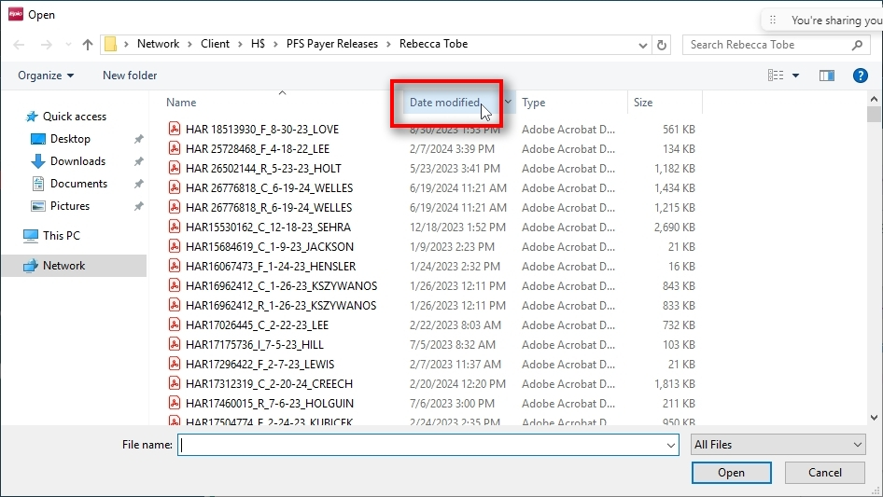 | Action: Click

 | Est. time: 1.9 sec.
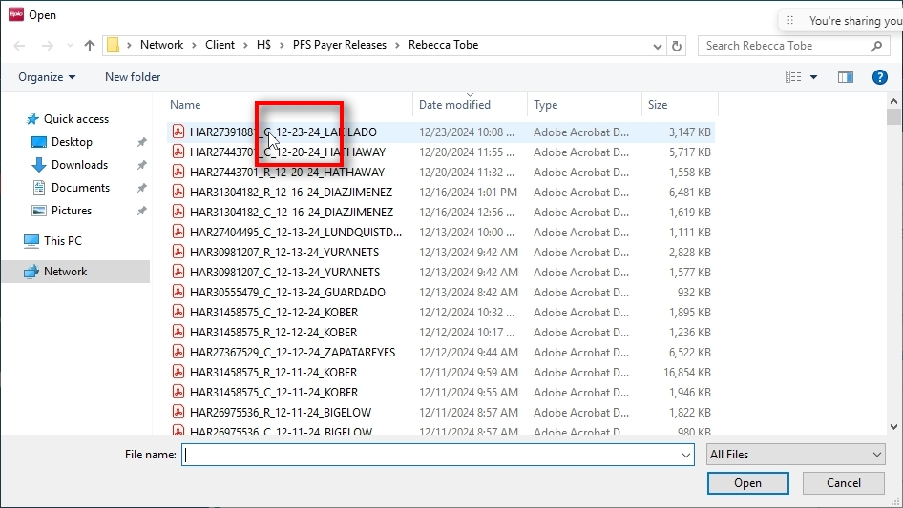 | Action: Double Click

Hyperspace – UW MED BILLING DEPARTMENT 20 – Production - \\Remote
Save letter to ROI | Est. time: 20.1 sec.

Edit Release Information

[Epic screenshots in PDD have been removed]

Deliver

[Epic screenshots in PDD have been removed]

Fax Release - \\Remote
Prepare ROI to fax letter and records | Est. time: 12.9 sec.

 | Est. time: 2.6 sec.
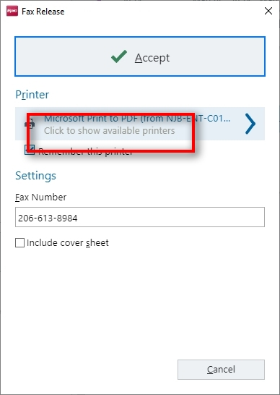 | Action: Click

 | Est. time: 1.1 sec.
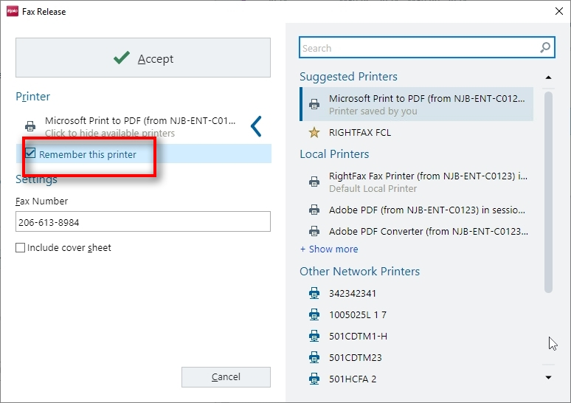 | Action: Click

 | Est. time: 0.9 sec.
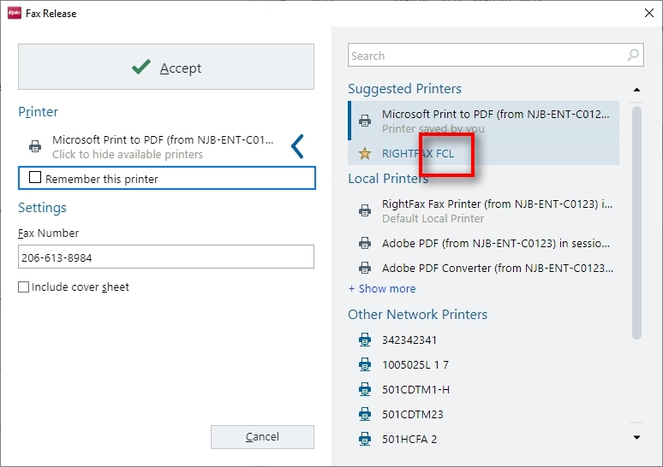 | Action: Click

 | Est. time: 8.4 sec.
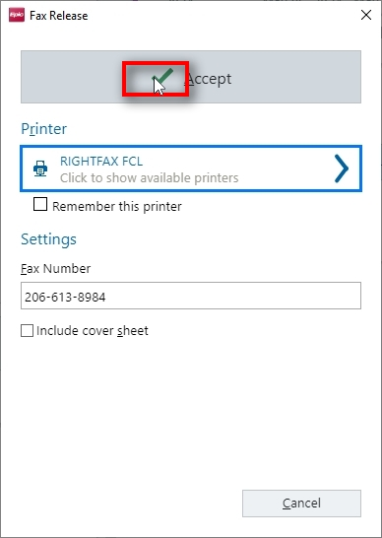 | Action: Click

Hyperspace – UW MED BILLING DEPARTMENT 20 – Production - \\Remote
Check fax status, complete ROI, go back to HAR | Est. time: 18.6 sec.

Once Fax’d complete release

[Epic screenshots in PDD have been removed]

[Epic screenshots in PDD have been removed]

[Epic screenshots in PDD have been removed]

Hyperspace – UW MED BILLING DEPARTMENT 20 – Production - \\Remote
Log Appeal Correspondence | Est. time: 3.4 sec.

Log Correspondence

[Epic screenshots in PDD have been removed]

[Epic screenshots in PDD have been removed]

Hyperspace – UW MED BILLING DEPARTMENT 20 – Production - \\Remote
Reopen ROI to check fax status. When fax is successfully sent, will need to edit Appeal Submitted documentation with details on submission. Completed Log Appeal Correspondence. | Est. time: 1 min. 3 sec.

[Epic screenshots in PDD have been removed]

[Epic screenshots in PDD have been removed]

[Epic screenshots in PDD have been removed]

[Epic screenshots in PDD have been removed]

[Epic screenshots in PDD have been removed]

[Epic screenshots in PDD have been removed]

[Epic screenshots in PDD have been removed]

\
[Epic screenshots in PDD have been removed]

Press ‘Enter’

[Epic screenshots in PDD have been removed]

[Epic screenshots in PDD have been removed]

[Epic screenshots in PDD have been removed]

Press ‘Tab’

[Epic screenshots in PDD have been removed]

[Epic screenshots in PDD have been removed]

Press ‘Tab’

[Epic screenshots in PDD have been removed]

[Epic screenshots in PDD have been removed]

[Epic screenshots in PDD have been removed]

[Epic screenshots in PDD have been removed]

II.6 Exceptions Handling
Failed fax – Fax assigned to “HB Background”
Testing required for failed faxes and possible “resend”. Don’t touch if faxed more than once.
Claim not in "outstanding" status
Release not in "pending delivery" status
Duplicate denial codes on account

To-Be Process Description
This chapter highlights the expected design of the business process after automation.

III.1 To-Be Detailed Process Map
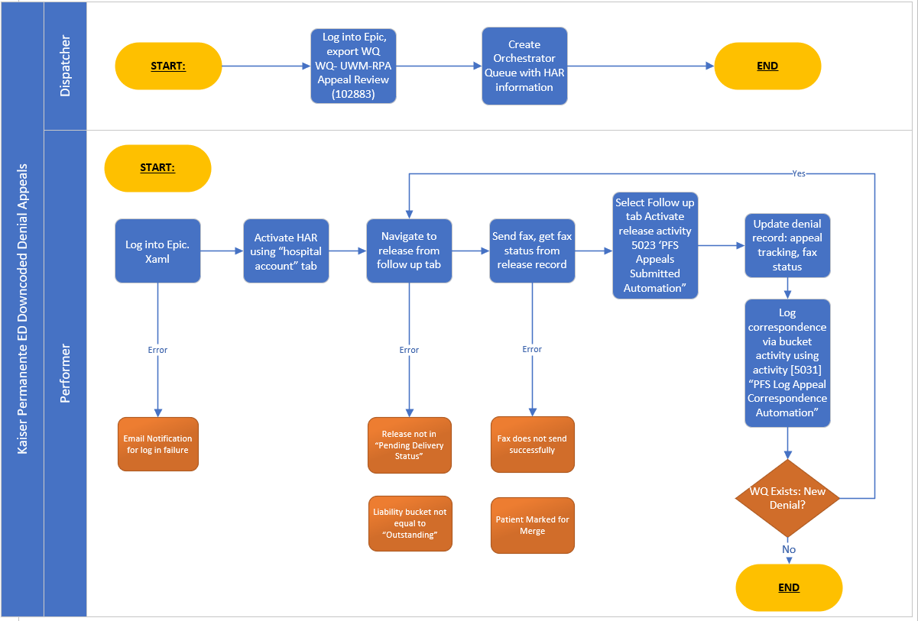

III.2 Parallel Initiatives/ Overlap (if applicable)
This chapter covers the proposed Business, Process & System changes to be made in the near future and their impact.
# | Initiative Name | Process Action( s) where it is identified | Impact on current automation request? How? | Expected Completion Date | Contact person for more details
 | None identified

III.3 In Scope of RPA
The activities In scope of RPA, are listed here:
- Actions 1-5, 8 – 10, 15-18
- Actions 19 – 21 will be a second process because of its required delay from the fax submission.

III.4 Out of Scope of RPA
The activities Out of scope of RPA, are listed here:
Sub-process (if applicable) | Activity (action) | Reasons for Out of scope* | Impact on the To-Be | Possible measures to be taken into consideration for future automation
*Add more rows to the table to reflect the complete documentation provided to support the RPA process.

III.5 Business Exceptions Handling
The Business Process Owner and Business Analysts are expected to document below all the business exceptions identified in the automation process. These can be classified as:
Known | Unknown
Previously encountered. A scenario is defined with clear actions and workarounds for each case. | New situation never encountered before. It can be caused by external factors. Cannot be predicted with precision, however if it occurs, it must be communicated to an authorized person for evaluation.

Known Exceptions
The table below reflects all the business process exceptions encountered during the process evaluation and documentation. These are known exceptions that occurred before. For each of these exceptions, define a corresponding expected action that the robot should complete if it encounters the exception.
BE # | Exception name | Action | Parameters | Action to be taken

Unknown Exceptions
For all other unanticipated or unknown business (process) exceptions, the robot should:
Note transaction as failed and move to the next transaction.

III.6 Application Error and Exception Handling
A comprehensive list of all errors, warnings or notifications should be consolidated here with the description and action to be taken, for each, by the robot.
Errors identified in the automation process can be classified as:

Area | Known | Unknown
Technology/Applications | Experienced previously, an action plan or a workaround available. | Never encountered before or may happen independently of the applications used in the process.

Known Errors or Exceptions
The table below reflects all the errors identified in the process evaluation and documentation.
For each of these errors or exceptions, define a corresponding expected action that the robot should complete if it is encountered.

System Exceptions:
# | Error name | Action | Parameters | Action to be taken
1 | Epic application unreachable | Process | Application not available via Citrix | Retry 3 times
2 | Unable to log into Epic | Business |  | Retry 3 times

Business Exceptions:
# | Error name | Action | Parameters | Action to be taken
1 | Fax failure | No action |  | No automation action. There is an Epic process to send failed faxes to a workqueue.
2 | HAR not found in Epic | Business |  | Send HAR to exception report or work queue and proceed to next transaction
3 | Claim not in "outstanding" status | Business
4 | Release not in "pending delivery" status | Business
5 | Duplicate denial codes on account | Business

Unknown Errors and Exceptions
For all the other unanticipated or unknown application exceptions/errors, the robot should:

III.7 Reporting
# | Report type | Update frequency | Details | Monitoring Tool to visualise the data
1 | Transaction logs | Monthly | How many transactions were run by this process since the beginning of the month
2 | Error logs | Daily | Errors by type per day
* For complex reporting requirements, include them into a separate document and attach it to the present documentation

Other Observations
Include below any other relevant observations you consider needed to be documented here.
Example: Specific Business monitoring requirements (audit and reporting) etc.

Additional sources of process documentation
If there is additional material created to support the process automation please mention it here, along with the supported documentation provided.

Additional Process Documentation
Standard Operating Procedure (s)  Appeals Team Workflow  Appeal Workflow Diagram | Appeals team workflow high_09-21-2023.docx  UW Appeal Workflow Diagram - Manager Review 10.11.2023.vsdx | Insert any relevant comments
Dispatcher/Performer Design Matrix | PFS Downcoding_Dispatcher_Performer
*Add more rows to the table to reflect the complete documentation provided to support the RPA process.

Signed off by Victoria Holland on March 6, 2025

