

Amplify
Meditech Transfer Balance

Process Definition Document (PDD)

Table of Contents
I. Change Control 3
1.1 Control Guidelines 3
1.2 Document Revisions 3
1.3 Known Future Initiatives 3
II. Introduction 4
2.1 Purpose 4
2.2 Objectives 4
2.3 Key Contacts 4
2.4 Prerequisite Checklist 4
III. Process Outline 5
3.1 Process Overview 5
3.2 Applications Used 5
3.3 Data Inputs 6
3.4 Process Map 6
3.4.1 High Level Process Map 6
3.4.2 Detailed Level Process Map 9
3.4.3 Exceptions Handling 9
3.5 Out of Scope for RPA 10
IV. Metrics 10
4.1 Automation Performance 10
4.2 Business Performance 11
V. Approval 11
5.1 Approval 11

Change Control
This section serves as documentation of all known changes, revisions, and future initiatives that arise.

1.1 Control Guidelines
The guidelines below are followed when changes are requested from the first finalized document. This ensures that the change is feasible and appropriate.
Description | Point of contact(s) | Notes/comments
Approval  (PDD completion, user acceptance, and go-live) | Casey Peters
Must review  (change requests, deliverables, etc.) | Steve Strenkowski  Bethany Miessner  Brandy Simpson

1.2 Document Revisions
Rev. # | Date | Section/page# | Revision summary | Author

1.3 Known Future Initiatives
The table below will capture the proposed business, process or application changes to be made soon that would impact the process at hand (if any).
Process action(s) identified | Impact on current automation | Contact person | Expected completion date
Payer Compliance Enhancement | Without fully developed payer compliance CARC/RARC assignment, automation will lack 100% capability in terms of queue size and impact. | Brandy Simpson

Introduction
This section outlines the documents intended use, as well as applicable stakeholders who will be involved in decision making throughout the automation process.

2.1 Purpose
The Process Definition Document is a development guide that details the process being automated. It serves as a consolidated document for development approval, and should be used following completion of the Identify & Prioritize Toolkits.
The PDD should be authored by a Solution Architect. A Process Owner should consult on the accuracy of the content. Once completed, the Solution Architect can hand off to the RPA developer(s) for development.
The PDD should always be kept up to date.

2.2 Objectives
The automation objectives expected by the Process Owner after automation of the selected business process are: AR management enhancement by automatically transferring amounts to next responsible party (sequential COB or Self Pay). Automation will replace the need to manually transfer PR amounts due to next payer and/or self pay buckets.

2.3 Key Contacts
Add stakeholders that contribute to the content and need to be informed of changes:
Governance member | Name | Title | Contact
Account Executive | Scott Cooper | President | Scott.cooper@ovationhc.com
Project Sponsor | Casey Peters | SVP | cpeters@amplify-rcm.com
Operational Owner | Bethany Miessner  Brandy Simpson  Steve Strenkowski | Senior Consultant  VP, Rev Cycle Optimization  Sr Product Manager, RCM | bmiessner@amplify-rcm.com  bsimpson@medcoservices.com  sstrenkowski@ovationhc.com
Solution Architect | Nicholas Lyons | Solution Architect Manager | Nick.lyons@tarpon.health
Development team | TBD
Maintenance Team | TBD
*Add additional columns and titles as needed – this should be limited to key stakeholders in the automation process, and not the entirety of the Governance team

2.4 Prerequisite Checklist
- Return on investment and complexity analysis (Identify & Prioritize Toolkit completion)
- Availability of data to support development (data consolidation, export, queue structure, output)
- Developer access and account creation (licenses, permissions, restrictions to create accounts for robots)
- Credentials required to access applications (usernames/passwords, service accounts, etc.)

Process Outline
This section outlines the applicable details required for automation development.

3.1 Process Overview
The Process Overview contains general information about the process before the automation is built. The Solutions Architect and Process Owner will coordinate to fill out required details below; most of which can be transferred from the Identify Toolkit.
Item | Answer/description
Process name | Meditech Claxton Transfer Balance
Short description | Automation will open Meditech, search accounts from SQL generated, and transfer balances to correct COB based upon PR 1,2,3 assignment
Process area/department | Billing/Follow-up
Process restrictions/prerequisites | Credentials – Service account has been obtained
Process schedule & frequency | Daily
Process execution time (per action) | 1 Minute
Data input source | Produced by S.Moore.  Folder Location: QHR/Q24274/Download/TransferBalance  File Name: Meditech_txfr_YYYYMMDD
Data input time (export/queue) | TBD
Current manual daily volume | 241 (Low) / 337 (High)
*Add more rows to the table to include relevant data for the automation process. No fields should be left empty. Use “n/a” for the items that don`t apply to the selected business process.

3.2 Applications Used
Populate the table below with a comprehensive list of all applications utilized throughout the automation process.
Application | Environment | Access requirements | Notes/comments
Meditech | Remote apps | Credentials | Service account obtained  Username: RES.AMPLI
Windows credentials
Username: AmplifyUser
*Add more rows to the table to include the complete list of applications used throughout the automation process.

3.3 Data Inputs
The following table captures data input details of the process being automated. Outline the data points in the table below if the data field is used in the automation.
File Name: PENDING EXPORT Example from Scott Moore
Field sequence | Field name | Data type | Input Natively Digital? | Input Structured?
1 | Account ID | General | Y | Y
2 | Bill number | General | Y | Y
3 | Account Balance | Accounting | Y | Y
4 | Transfer from | General | Y | Y
5 | Transfer to | General | Y | Y
6 | COB 1 Payer | General | Y | Y
7 | COB 1 Amount | Accounting | Y | Y
8 | COB 2 Payer | General | Y | Y
9 | COB 2 Amount | Accounting | Y | Y
10 | COB 3 Payer | General | Y | Y
11 | COB 3 Amount | Accounting | Y | Y
12 | Cob 4 Payer | General | Y | Y
13 | COB 4 Amount | Accounting | Y | Y
14 | Self Pay Amount | Accounting | Y | Y
* Native Digital: This is data that was created digitally e.g., excel, database or application reports etc. The non-native digital inputs are usually scanned images.
* Structured Data: has a predictable format and exists in fixed fields (e.g., an excel cell or a field in a form) and is tangible. Non-structured data would be a concatenated field, or free text note containing one specified field.

3.4 Process Map
This section contains a process map that represents a step-by-step guide to the process being automated.

3.4.1 High Level Process Map
This section should be used in discussions with the Automation Governance team to approve development.

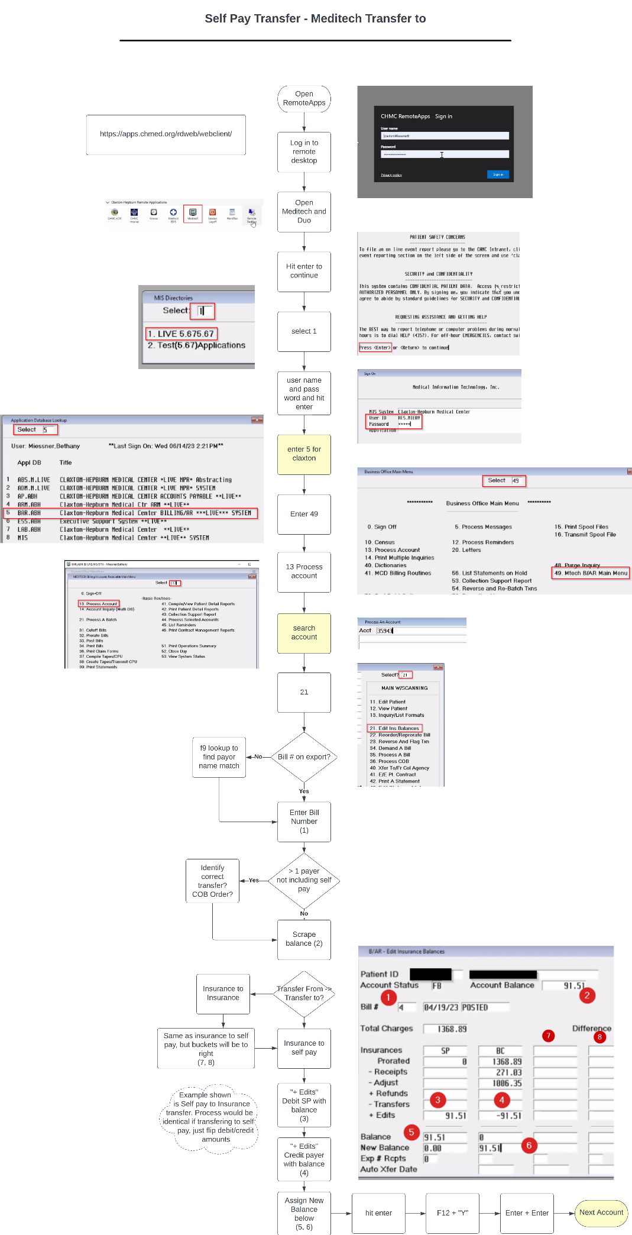

3.4.2 Detailed Level Process Map
This section describes the process at key-stroke level, providing additional details to its corresponding step shown above. The identification of exceptions is essential for developers and must be called out in the table below.

#Action | Input/Action | Description | Exception
1-6 | Log in | Log in to RemoteApps with service account and select Meditech – log in to meditech as well
7-8 | Access BAR Menu | Follow prompts to get to Bar Menu (5, 49)
9-11 | Process account and search | (13) to process account, (21) to edit ins balances, search account | Y
12-21 | Enter Bill number and transfer balances | Insert Bill number from queue, leverage transfer from/transfer to details and process balance transfer | Y
22-23 | Post and go to next account | Hit enter, confirm with F12 + Y, Enter x2 and search next account to repeat 12-21 steps | Y

3.4.3 Exceptions Handling
All exceptions must be documented in the table below. An exception is any scenario where the automation decides based on business or process variables. Examples are error messages and proprietary results from an application.
There are two exception types:
Business = Decision based, where a data input requires an output or record assigned.
Process = Application based, where a screen/application requires a predetermined action.
Please list the applicable process step from the section above and its exception below:
Process step | Exception type | Scenario encountered (If) | Resolution (Then)
1 | Process | RemoteApps environment is down and will not allow for access to Meditech | Automation will send error report of failure – indicating that function cannot occur
1 | Process | Meditech is unreachable within RemoteApps environment | Automation will send error report of failure – indicating that function cannot occur
1 | Process | Queue was not generated at correct time, and scheduled run time was missed | Retry automation every 15 minutes for 1 hour – if no file, or conflict of other automations resulting in no run – send error report of failure
12-21 | Process | Necessary Field for automation is blank within file column | Distinct record is marked as Skip
12-21 | Business | record is unactionable and/or does not qualify for process | Indicate as failure
12-21 | Business | action successfully processed | Indicate as Success
12-21 | Business | If transfer from is COB 1,2,3,4 | Reference details populated for COB field (COB 1 amount, COB 1 payer)
12-21 | Business | If transfer to is COB 2,3,4,SP | Reference details populated for COB field (COB 2 amount, COB 2 payer)
12-21 | Business | Searched record does not appear | Mark as skipped if record does not return result
22-23 | Business | End of list reached | Close automation

3.5 Out of Scope for RPA
Please list all automation actions that are out of scope or unobtainable in the table below:
Activity/action | Reason for out of scope | Impact on process | Possible measures for future avoidance
*Add more rows to the table to reflect the complete documentation provided to support the RPA process.

IV. Metrics
This section outlines the reporting requirements needed for performance management.

Automation Performance
Report name/type | Description/purpose | Frequency | Location
Average process time | How much time, on average, does it take the automation to resolve 1 record | Monthly
Error rate | How many actions were skipped or received a failed status due to automations inability to receive queue/trigger/valid information | Weekly
* For complex reporting requirements, include them into a separate document and attach it to the present documentation

Business Performance
Report name/type | Description/purpose | Frequency | Location
FTE Savings | Reduction in FTE’s needed to resolve populations assigned to automation | Monthly
Cash Increase | Due to automation automatically transferring balances to initiate a new claim, payments can be received without human intervention | Monthly
* For complex reporting requirements, include them into a separate document and attach it to the present documentation

V. Approval
This section should be used when the PDD has been reviewed and approved by all stakeholders.

Approval
Upon review and approval of this Process Definition Document (PDD), I approve this plan for development with the understanding that changes to this project may be needed.

______________________________________ __________________________
Project Sponsor Today’s Date



