Functional Design Document

UT Southwestern Medical Center
Medical Records Denial
Version: 1.3
Date: 10/31/2022



Document Version Control
Date | Version | Description | Author
5/11/2022 | 1.0 | First Draft | Michelle Nguyen
6/22/2022 | 1.2 | Final Draft | Michelle Nguyen
10/31/2022 | 1.3 | Updates to Citrix | Jennifer Gloria

Contributors
The content of this document has been authored with the combined input of the following group of key individuals.
Name | Role | Area
Suni George | Rev Cycle Analytics Manager | UTSW
Diana Rodriguez | Manager - Technical Denials Management | UTSW
Michael Laukaitis | Project Lead | UTSW
Jennifer Gloria | Program Manager | UT IASG
Kapil Gupta | Solutions Architect | UT IASG
Michelle Nguyen | Developer | UT IASG

Source Documents
Title | Author | Date
Current State – Screen Shots and Steps.xlsx | Jennifer Gloria | 5/13/2022
Medical Records Denials Future State Flow.vsdx | Jennifer Gloria | 5/13/2022
Notes.docx | Jennifer Gloria | 5/13/2022

Document Sign-off Requirements
The following table contains the people required to sign-off and/or review this document and those that require the document for information only.
Name | Title | Date | Responsibility | Signature
Michael Laukaitis | Director of Revenue Cycle |  | Signer

Table of Contents
1. Purpose of document 4
2. Automation Scope 5
3. Process Overview 6
3.1 Current State Process Overview 6
3.2 Future State Process Overview 6
3.3 Process Details 7
4. Impacted Business Area(s) 16
5. Exceptions 16
5.1 Business Exceptions 16
5.2 Technology Exceptions 16
6. Reporting and Other Outputs 17
6.1 Management Reporting 17
6.2 Other Outputs 17
7. Specifications 18
7.1 Target Application Requirements 18
7.2 Processing Metrics 18
7.3 Service Level Agreements 18
7.4 Operating Hours 18
7.5 Data Preservation 19
7.6 System Unavailability 19

1. Purpose of document

The Functional Definition Document (FDD) captures the flow of a business process to be developed within RPA Software.

The flowcharts contained within the document captures, at a high level, the business process to be automated and any assumptions that have been taken into account.

Once agreed as the basis for the automation of the target process, the flowchart and assumptions will be used as a platform from which the automated solution will be designed.

Changes to this business process may constitute a request for change and will be subject to the agreed program change procedures.

Note: This document must be completed in the absence of existing process documentation that provides the level of detail required for the process to be automated. If existing process documentation is to be used instead of a new FDD the following steps should still be undertaken

- Existing process documentation reviewed to ensure it is still up to date and fully captures the current manual process
- Existing process documentation provides the same level of detail that is required for automation
- Agreed by the business as an accurate description of the manual process

2. Automation Scope

Description of the process (Who does what and when)

Medical records denials within EPIC indicate that a claim has been denied from payor. EPIC generates a claims request form pdf and moves to a work queue in which the attachment denials team locates to upload to Availity for remittance payment from payor. This automation will reduce the administrative burden of uploading the pdfs to Availity and increase the time to collect.
Digital worker will have access to EPIC work queue or claims status, and Availity for payor, Blue Cross Blue Shield.
The major steps in the future state process include:
- Get EPIC Queue extract from Clarity*
- Log into Citrix and authenticate
- Log into EPIC
- Active Needs Attachment RPA dedicated work queue 63250 (manual remains 34298)
- Filter to Blue Cross Blue Shield Payor
- Navigate to Professional Transaction Inquiry Tab to locate Invoice
- Select the Attachment Record ID containing the detail report
- Print to PDF file and save to O: drive using file name Invoice Number and Patient Name
- Log into Availity and authenticate
- Navigate to Refund Management eRM for Blue Cross Blue Shield
- Select Claim Inquiry Resolution tab
- Create New Claim Inquiry
- Reference the group NPI# and claim number from EPIC to BCBS claim form and include reason code Additional Information
- Enter Comments “Requested medical records are attached for review and payment of services”
- Attach detail report from O: drive
- Save and obtain assigned claim Inquiry Tracking ID number
- Navigate back to EPIC
- Add account note in EPIC activity appeal [1143]. Include Inv#, DOS, Reason for Appeal, and Appeal ID
- Defer Workqueue Action for 30 days
- Autoroutes to Active Workqueue if payment not received within 30 days
- Follow up on BCBS Claims website or phone call for status (Manual Step)
- Send Management Report defined in section 6.1 to the email notification group
The major application this process interacts with are as follows:
- Citrix
- EPIC*
- Availity
- eRM (Refund Management)**
- FTP

*Note 1: Access EPIC through Citrix gateway
**Note 2: Access eRM (Refund Management) through Availity website

Scope Limitations:
- Automation can only access EPIC through Citrix Gateway
- Automation can only access Network Drive (O:) through the Clinical Desktop once logged into Citrix Gateway
- Only including payors interfacing with Availity
  - Blue Cross Blue Shield
  - Aetna (TBD)
  - Amerigroup (TBD)
  - Cigna (TBD)
  - Humana (TBD)
  - Molina (TBD)
- Digital worker cannot have EPIC account
- Digital worker will be dependent on an employee account for UTSW access
- Digital worker will be dependent on an employee account for EPIC access
- Digital worker will be dependent on an employee account for Availity access

3. Process Overview

3.1 Current State Process Overview

3.2 Future State Process Overview
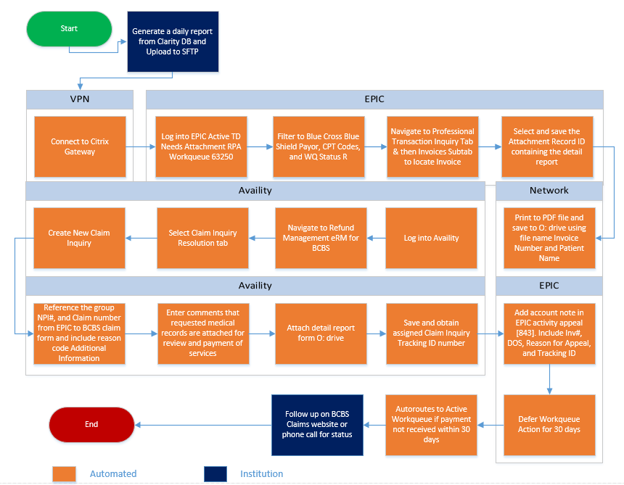

3.3 Process Details (Detailed description of the new automated process)

3.3.1 Input File Template (will contain EPIC data from Clarity)

3.3.2 Process Details Flow

3.3.3 Process Details Steps

4. Impacted Business Area(s)
Attachment Denials Team

5. Exceptions

5.1 Business Exceptions

5.1.1 PDF link is blank in EPIC. Record might not be attached but still exists.
5.1.2 Availity doesn’t find patient after entering claim information from EPIC
5.1.3 Cannot submit claim in Availity
5.1.4 Claim has already been submitted in Availity
5.1.5 Citrix/Availity/EPIC Login Failed - Password needs to be updated, System Unavailability
5.1.6 Clarity Input File not found or named incorrectly. An e-mail will be sent to the contacts within the MR Denials team notifying of inability to find the source files and the process will be stopped.*
5.1.7 Failure post EPIC Upgrade (ex: screens change)

Attached are the Business Exceptions in detail with remediation steps.

*Note: Only applies if Input file (i.e. Export file from Clarity) is used in process

5.2 Technology Exceptions

5.2.1 EPIC upgrade(s) changing the environment (Note: Updated once every quarter)
5.2.2 Availity site not available
5.2.3 Citrix Workspace not available or unable to connect
5.2.4 EPIC application not available or down for upgrade
5.2.5 Cannot connect to O: Network Drive to retrieve/download files
5.2.6 Cannot send email. SMTP server down or security rules in place.
5.2.7 eRM application not available

6. Reporting and Other Outputs

6.1 Management Reporting

6.1.1 Number of claims processed
6.1.2 Number of claims submitted
6.1.3 Number of claims with no PDF linked
6.1.4 Number of claims not submitted

6.1.2 Other Outputs

6.2.1 Email with Management Report details sent to emails specified by MR Denials Team

7. Specifications

7.1 Target Application Requirements

Name | Description | Access Needed | Operating Times
Citrix | Citrix Gateway allows remote access to EPIC through SSO | User ID and Password | 24/7/365
EPIC | System with MR Denials claim data labeled in work queue to be worked | User ID and Password, read access only | 24/7/365
Availity  website | Website to access eRM application | User ID and Password, Full access | 24/7/365
eRM (Refund Management)  application | Application where MR denial claims are submitted | Submit/View claim(s) access | 24/7/365
Network Drive | Used to store PDF attachments,  (O: MSRDP > Billing Operations > Team 4 - Purple > Appeals) | Read/Write access | 24/7/365
MS Edge | Browser to see Citrix, Availity and eRM | Full access | 24/7/365
Microsoft  Outlook | Send emails when process is complete/fails | Create and Send Emails access | 24/7/365

7.2 Processing Metrics

7.2.1 List any minimum or maximum expected volume loads
Minimum: BCBS - the minimum per day can be 1 invoice – once other invoices are included the volume would be higher
Maximum: 400-500 per month (all payors)

7.2.2 List any periods when a higher or lower workload are anticipated
Higher: Expected to be level
Lower: Expected to be level

7.2.3 List all time, volume, and people metrics identified
- Number of people performing this process currently: 3
- Number of yearly volumes:
- Average time spent performing this process: currently staff are working status R invoices for UHC and BCBS – approximately 1 – 2 hours a day depending on the volume
- How often this process is performed: daily
- Total time spent performing this process:

7.3 Service Level Agreements

7.3.1 Are there any SLAs this solution must conform? If so, what are they?

7.3.2 Should the solution be expected to recognize an SLA breach? If so, how?

7.4 Operating Hours

7.4.1 Will the solution run outside normal working hours? The process should run until completed

7.4.2 What time will the solution start? The process can be started as early as 6 a.m. each day

7.4.3 Will the solution work to a stop time?
No
7.4.4 What days of the week will the solution run? Monday - Friday

7.4.5 Are there any days or times when the solution must not run?
Saturday - Sunday

7.5 Data Preservation

7.5.1 How long should input data be kept?
Input Data File: no more than 30 days
PDFs: until claim is submitted
7.5.2 How long should output data be kept?
N/A

System Unavailability

7.6.1 How would the business like to be informed of system unavailability?
Email to MR Denials PDL or specified contacts
7.6.2 What is the business effect of the process not running for one hour?
None the bot will reattempt next day
7.6.3 What is the business effect of the process not running for four hours?
None the bot will reattempt next day

