Business Requirements
COVID Vaccine encounters for patients with Medicare Advantage (MA) coverage requires the claim to be sent to Medicare using the patient’s Medicare Beneficiary ID (MBI). Claims logic has been added for both professional and hospital billing to pull from the patient’s Medicare Advantage coverage “Medicare # for IME” field (CVG 2500). However, most patient records do not have this field populated as it is not a required field. MA payers are not providing the MBI yet on their realtime eligibility responses.

As of 4/9/21, ~21,000 claim edits are holding for invalid subscriber ID due to MBI’s missing ($1.3M). To work these manually, would require paying outsourcing resources $1.11 per transaction (~$23,310).

Epic has the ability to provide coverage record (CVG) exports of all patients with Medicare Advantage plans. The goal is to populate the Epic export spreadsheet with the MBI. The user will then review the spreadsheet for accuracy and submit the request for the import the spreadsheet back into Epic. For payers that are unable to provide the MBI to Duke, PRMO would like to utilize a bot to look-up the MBI and populate the spreadsheet.

Medicare provides an MBI look up tool through the Palmetto eServices website. Fields required: Patient First and Last Name, Date of Birth and SSN. This website would require interfacing with an Epic API to get the patient’s SSN to pass to the website. No storage of the SSN would be in Blue Prism or on the export spreadsheet. This website can be used for all MA plans.

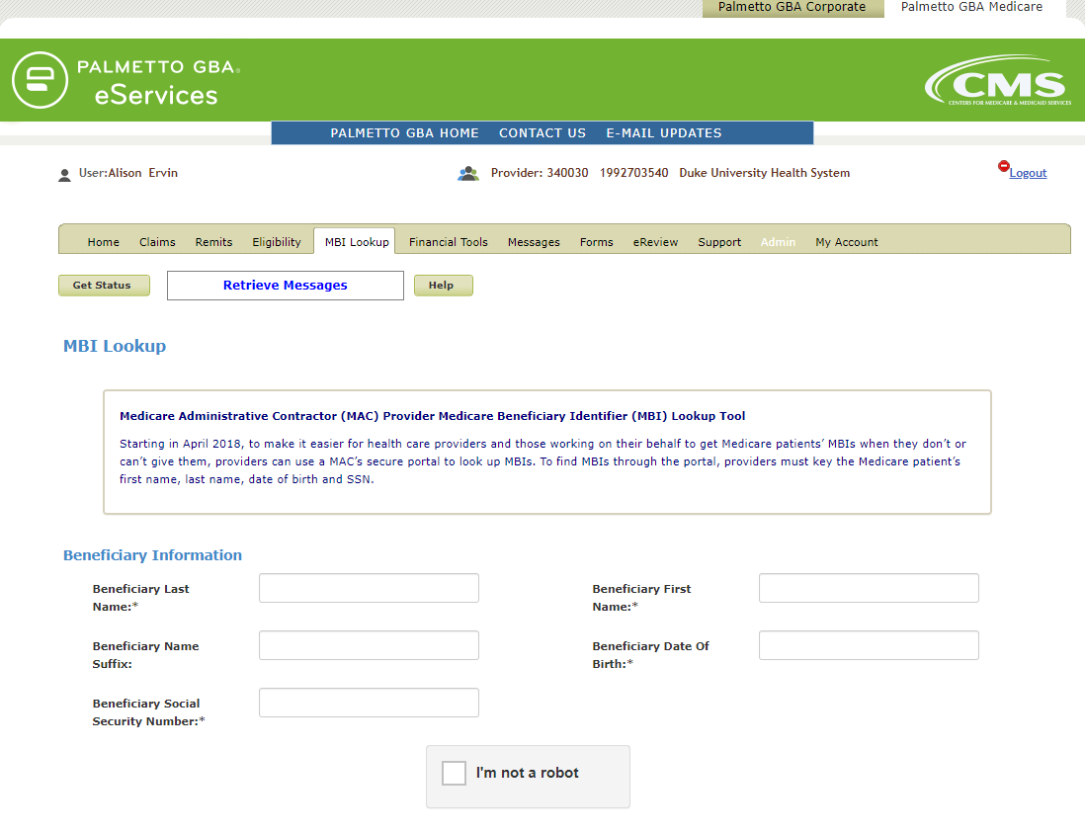

Other payers also have MBI look-up tools on their website, such as UHC (www.unitedhealthcareonline.com). Fields required: Patient’s Member ID and Date of Birth.
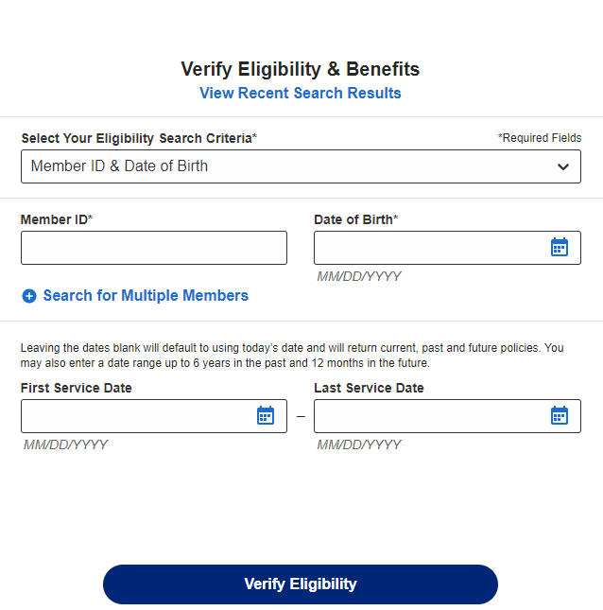

Data Flow Diagrams
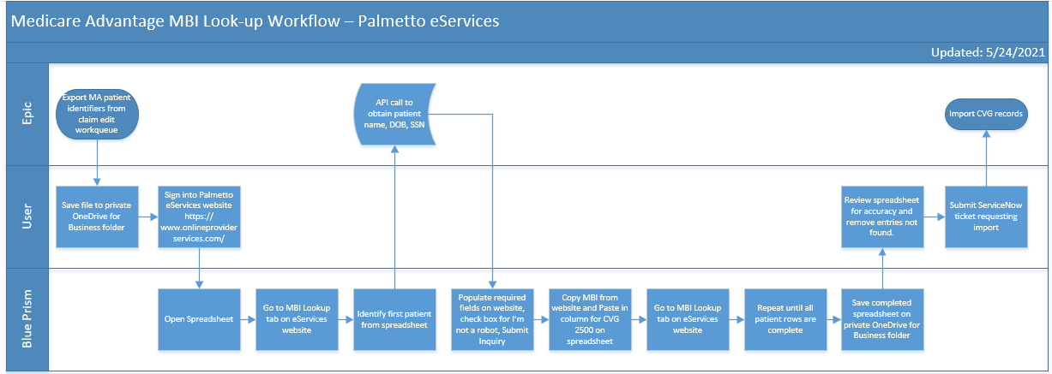

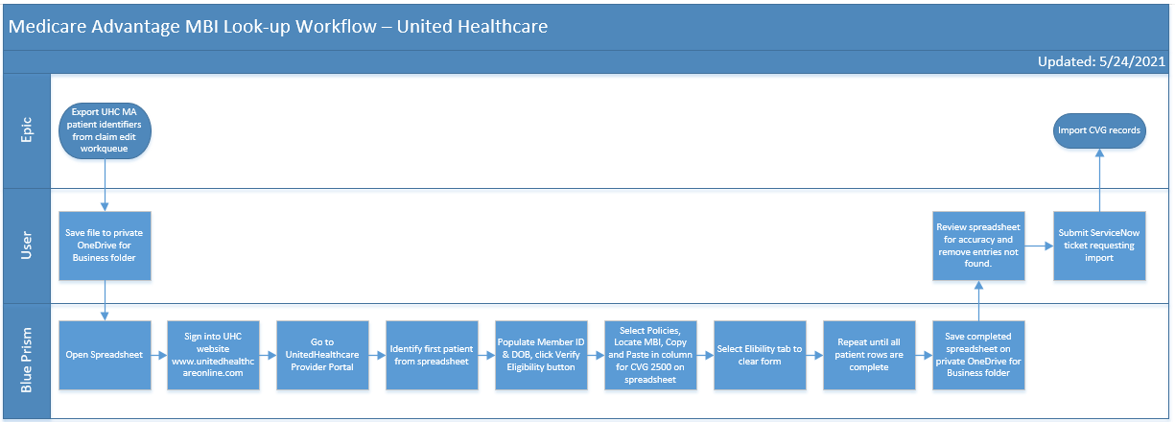

Programming Requirements

Epic –
- Standard workqueue export
- Standard CVG import
- API call required for Palmetto eServices website to obtain patient demographics

Blue Prism – bot for each payer website to process MBI look-up

Outstanding Issues

Date | Status | Description

