

  - Process Definition
Document

Charge Recon Process
Use Case

Document History
Rev. # | Date | Section/Page# | Revision Summary | Author
1 | 03/27/2023 | ALL | discuss for Charge Recon new requirement | Helen Chen
2 | 04/03/23 | ALL | Discuss drafts for Charge Recon requiremnet | Helen Chen
3 | 04/10/23 | ALL | Review for Charge Recon PDD | Helen Chen
4 | 04/17/23 | ALL | Sign-off | Helen Chen

Table of Contents
I. INTRODUCTION 4
1.1 Purpose 4
1.2 Objectives 4
1.3 Key Contacts 4
1.4 Minimum Pre-requisites for the Automation 4
II. AS IS Process description 5
2.1 Process Overview 5
2.2 Applications Used 6
2.3 AS IS Process Map 7
2.3.1 High Level Process Map 7
2.3.2 Detailed Level Process Map 7
2.4 Process Statistics 7
2.5 Detailed As Is Process Actions 8
2.6 Input Data Description 8
III. TO BE Process description 9
3.1. Detailed TO BE Process Map 9
3.2. Parallel Initiatives 9
3.3. In Scope For RPA 9
3.4. Out Of Scope for RPA 10
3.5. Exceptions Handling 10
3.5.1. Known Business Exceptions 10
3.5.2 Unknown Business Exceptions 10
3.6. Applications Errors & Exceptions Handling 11
3.6.1. Known Applications Errors and Exceptions 11
3.6.2. Unknown Applications Errors and Exceptions 11
3.7. Reporting 11
IV. Other 12
4.1. Additional sources of process documentation 12

INTRODUCTION

Purpose
The Process Definition Document outlines the business process chosen for automation. The document describes the sequence of actions performed as part of the business process, the conditions and rules of the process prior to automation (AS IS) as well as the new sequence of actions that the process will follow as a result of preparation for automation (TO BE).
The PDD is a communication document between:
- The RPA Business Analyst and the SME/Process Owner. The goal is to ensure that the RPA Business Analyst has the correct understanding of the process and has represented it accurately.
- The RPA Business Analyst and the Development team (represented by the Solution Architect and RPA Development Lead). The goal is to ensure that the process is documented appropriately and to a sufficient level of detail so that the Solution Architect can then create the solution based on the PDD content.

Objectives
The Charge Recon process, submitted by Department of Revenue Integrity, that has been selected and approved by UW Medicine RPA Council for automation.
The business objectives and benefits expected by the Business Process Owner after automation of the selected business process are:
- Reduce time to create ALL Cost Center metrics report and single department metrics report in spreadsheet
- Better Monitoring of the overall activity by using the logs provided by the robots.

Key Contacts
The specification document includes concise and complete requirements of the business process, and it is built based on the UWM Charge Capture Manager Dashboard, Epic-HB Posted Charges Summary report, Open Encounter Report and Charge Log in Epic-Hyperdrive
with citrix by Department of Revenue Integrity
The Process Owner is expected to review it and provide signoff for accuracy and completion of the steps, context, impact, and complete set of process exception

Role | Name | Contact Details (email, phone number) | Notes
Manager Of Program Operations | Brenda Schwilke | schwib@uw.edu | Point of contact for questions related to business exceprion
Program Manager | Sarah Bidgood | sbidgood@uw.edu | Point of contact for questions related to business exceprion
Program Operations Analyst | Cheryl Mustard-Adams | cmustard@uw.edu | Point of contact for questions related to business exceprion
Business Analys | Helen Chen | Xchen27@uw.edu | Write PDD document
Program Operations Analyst | Barry Madsen | madsenb@uw.edu | Point of contact for questions related to business exceprion
Approver for production | Matt Tuller | mtuller@uw.edu | Escalations, Delays

Minimum Pre-requisites for the Automation
- Filled in Process Definition Document
- Test Data to support development
- User access and user accounts creations (licenses, permissions, restrictions to create accounts for robots)
- Credentials (user ID and password) required to logon to Epic-Hyperdrive, machines and applications

AS IS Process description
General information about the process selected for RPA prior to automation.2.1
2.1

Process Overview
Section contains general information about the process before automation.
Item | Description/Answer
Process Full Name | Charge Recon Process
Process Area | Epic-Hyperdrive
Department | Revenue Integrity
Short Description (operation, activity, outcome) | Login to Epic-Hyperdrive to get metrics data for creating 3 reports, send email to department or escalation
Role(s) required in applications to perform the process | Run process at 3:00 am
Process schedule and frequency | Run report every work day
Number of times the process is ran by selected frequency | Once a day (only for business day)
Process execution time | 3 hours approximately
Process Restrictions | N/A
Peak Period (s) | N/A
Peak Volume Approximate increase | N/A
Number of persons performing the process
Expected Volume increase during next periods | N/A
Percentage Un-handled exceptions | <5%
Input data description | Spreadsheet input that contains Department, Cost Center, CC Owner, CC owner’s email, RI Speciallist, RI Speciallist’s email, metrics Reports, Revenue Guardian Encounters Report, Charge Logs, HMC and UWMC Encounters report, email content
Output Data description | Single department data Report  - Charge Log  - Metrics data Reports  - HMC or UWMC Encounters Reports  Send email to cost center owners, RI Specialists and department manager
*Add more rows to the table to include relevant data for the automation process. No fields should be left empty. Use “n/a” for the items that don`t apply to the selected business process.

Applications Used
The table includes a comprehensive list of all the applications that are used as part of the process to be automated to perform the given actions in the flow.
# | Application Name | Version |  | Application  Language | Thin/Thick Client | Environment/  Access method | Comments  (Include URLs)
1 | Epic Hyperdrive |  | Spring22 | EN | Thin | Citrix | Ctrix online login
2 | Excel |  | 365 | EN | Thick | Local desktop | Charge Recon spreadsheet for send email
3 | Outlook |  | 365 | EN | Thick | Local desktop
*Add more rows to the table to include the complete list of applications.

AS IS Process Map
This section contains various process maps contributing to a better understanding of how the process is performed pre-automation.

High Level Process Map
This section is useful for the Business Analyst in presentations and discussions with management to underline areas of weakness, inefficiency or to demonstrate which actions could be in scope for automation.

Email accounts To: each Cost Center Owner and RI spec email account
Email send using bot account: rpabotdev@uw.edu, rpabotprod@uw.edu

Get 13 Metrics data from Epic Hyperdrive:
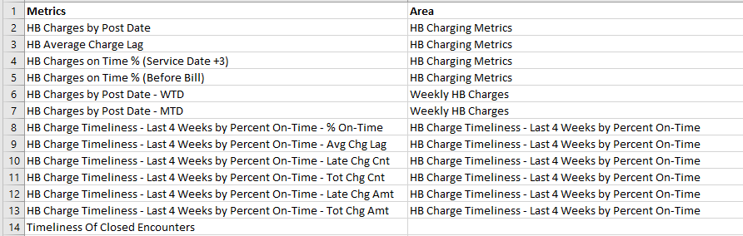

Detailed Level Process Map
This section describes the process at key-stroke level and is an essential part for the communication with the developers.

Process Statistics
High Level statistics for Score Card
Processes | Windows | Actions | Mouse clicks | Keys pressed | Text entries | Hotkeys used | Time
5 | 12 | 120 | 95 | 83 | 18 | 0 | 17 min. 51 sec.

Detailed statistics for Score Card
Window name | Mouse clicks | Text entries | Key pressed
Hyperspace - UWMC ADMIN SUPPORT SERV - Production - \\Remote | 28 | 2 | 25
 | 2 | 0 | 0
Hyperspace - Production - \\Remote | 1 | 2 | 21
Report Settings - (New) - \\Remote | 5 | 2 | 4
 | 7 | 0 | 0
UNW Urology ClinicCharge Recon Score Card _ 05122022.xlsx - Excel | 26 | 7 | 12
Open Encounters 5.13.22.xlsx - Protected View - Excel | 1 | 0 | 0
Open Encounters 5.13.22.xlsx - Read-Only - Excel | 10 | 0 | 0
 | 8 | 2 | 9
Inbox - jfoskett@uw.edu - Outlook | 3 | 0 | 0
New Mail Alerts | 1 | 0 | 0
Calculator | 3 | 3 | 12

High Level statistics for Charge Log
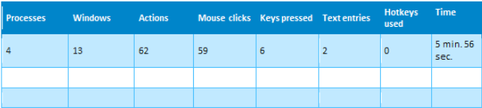

Detailed statistics for Charge Log
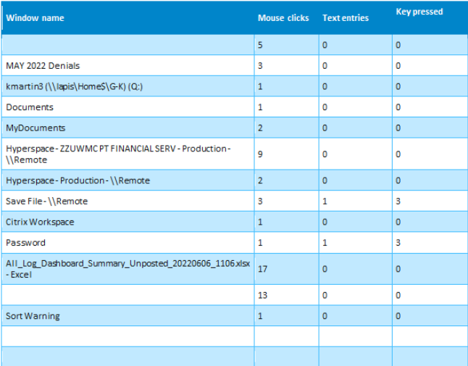

Detailed As Is Process Actions
Step | Short Description of Key Process Steps | Notes
1 | Go to Citrix Workspace, click Epic-HyperDrive TST button | 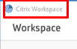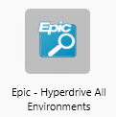
1.1 | Login to Epic Hyperdrive UWMC ADMIN SUPPORT SERV – Production | 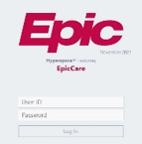
1.2 | Login failed with wrong user ID or password,  This is credential issue | 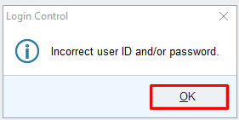
2 | After login, pick up job “D1 HB Revenue Integrity Director [T1085105]” and click Continue button  Click “Coutinue” button again | 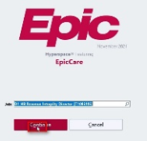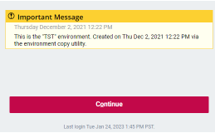
3 | Display  Hyperdrive – UWMC ADMIN SUPPORT SERV | 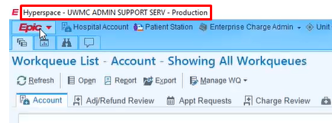
4 | Click Epic dropdown list and click “My Report” and “My Dashboards” | 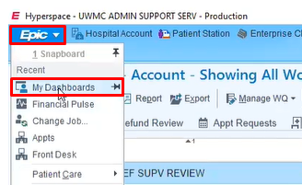
4.1 | Or click “my dashboard” tab, both navigate to “HB Revenue Integrity” | 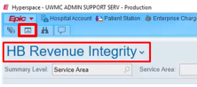
5 | 1. Click “HB Revenue Integrity” drop down list to do research  2. Type “UWM charge capture manager” here for searching  (this is option 1 for searching, you can leave it blank to use option 2 for searching on step 5.1)  3. Click “Show Catalog” button to navigate to | 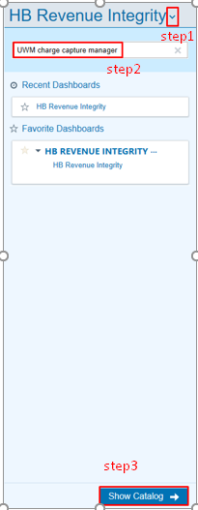
5.1 | Type “charge capture manage” text in the input box, then enter  This another option for searching “charge capture manager” | 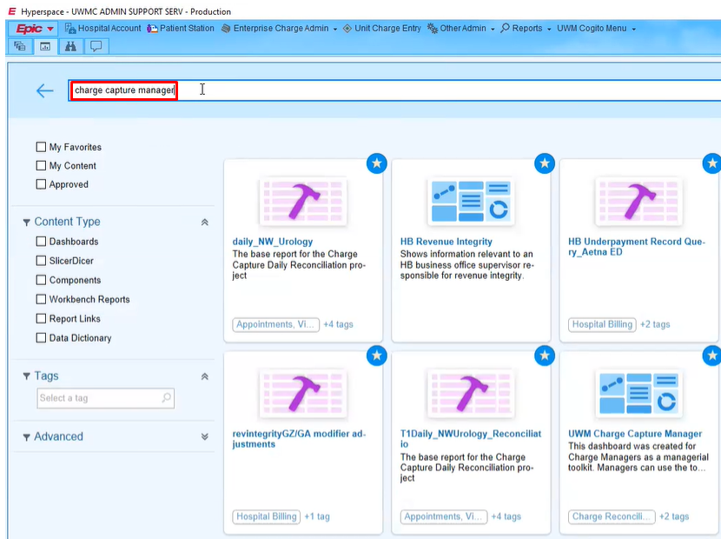
6 | Display “UWM Charge Capture Manager” image | 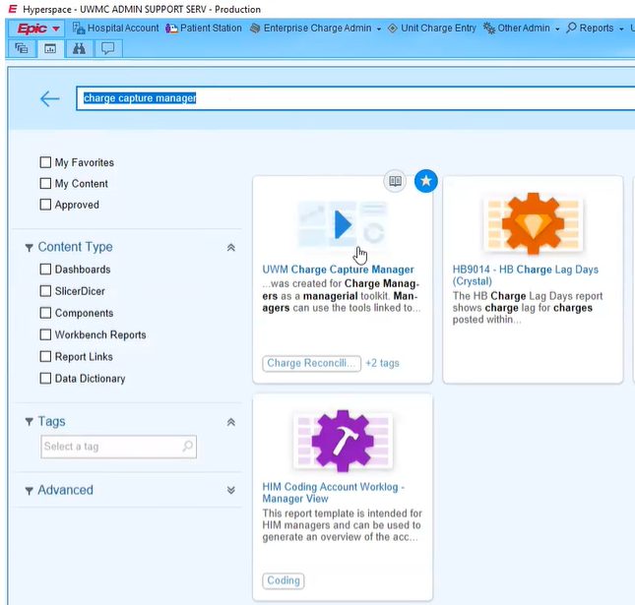
7 | Click “favorite” button to make it favorite and click Run Button | 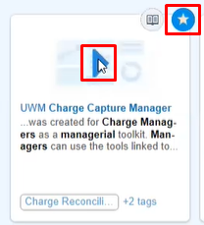
8 | Display “UWM Charge Capture Manager” dashboard | UWM Charge Capture Manager has 6 sections:  HB Charging Metrics --- Contains 4 metrics data  Yearly HB Charge Comparison  Weekly HB Charges --- Contains 2 metrics data  HB Charge Timeliness – Last 4 Weeks by Percent On-Tim --- Contains 6 metrics data  Workqueues Needing Attention  Toolkit  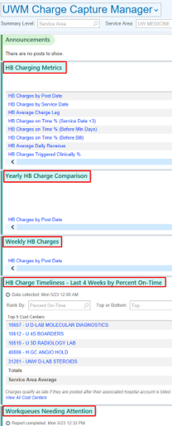  Summary Level: The default value is “Service Area”  Service Areas – for ALL Cost Center  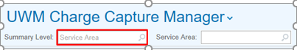
8.1 | If Summary Level is Service Area, the ALL Cost Cernter metrics data wil add together, you don’t know the metrics data for each Cost Center | 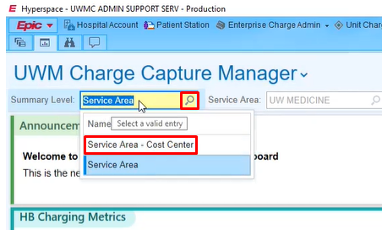  Summary Level: The default value is “Service Area”  Service Areas: for ALL Cost Center  Service Area – Cost Center: for specific Cost Center
8.2 | Sould insert each Cost Center  To get All Metrics data for each Cost Center | 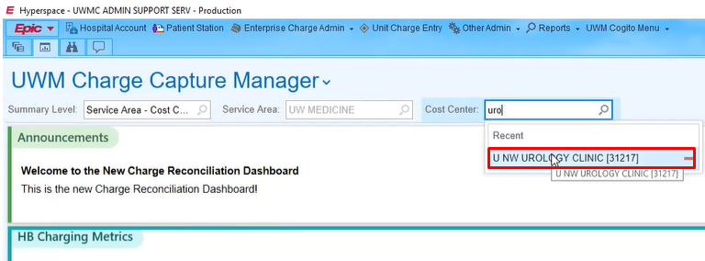
9 | On top of right corner, click “Select a Date” button to setup date  Select “Day” Button first, then  insert t-1 to t-1 for daily report  then click  “Accept” button | 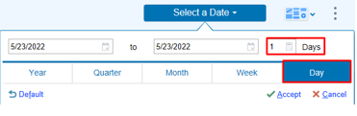  The ALL Cost Certer report is daily report
10 | Get all metrics data from Epic – UWM Charge Capture Manager Dashboard for different cost centers daily report | 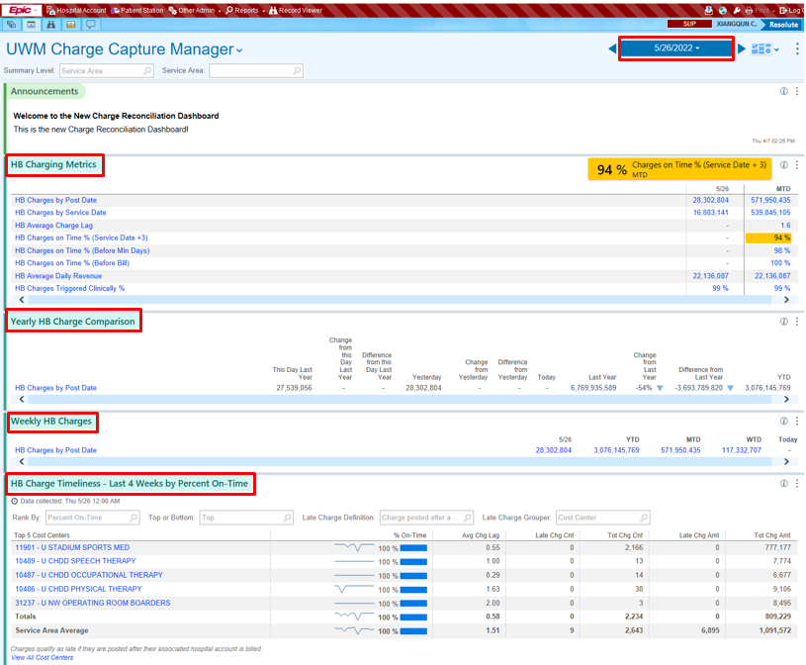
10.1 | Get 4 data from “HB Charging Metrics” section | HB Charges by Post Date  HB Average Charge Lag  HB Charges on Time % (Service Date +3)  HB Charges on Time % (Before Bill)  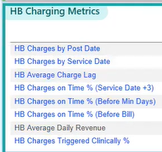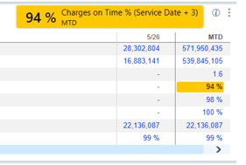
10.2 | Get 2 Data  from “Weekly HB Charges” section | HB Charges by Post Date- MTD  HB Charges by Post Date- WTD  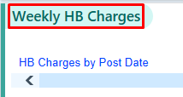  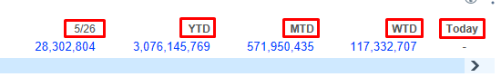
10.3 | Get data from “HB Charge Timeliness – Last 4 weeks by percent On-Time” section  Click “View All Cost Centers” button, display report | 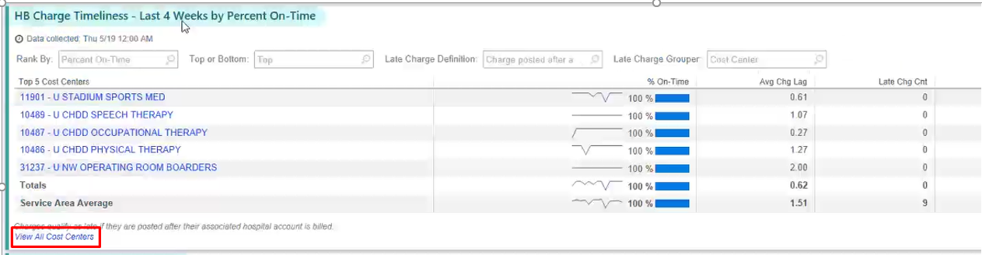
10.3.1 | the bot select the definition “Charge posted more than 3 days from service date” and scrape the values after that value has been selected | 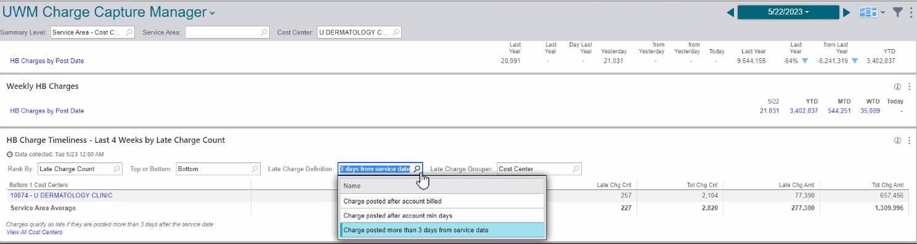
10.3.2 | Get 6 Data  from “HB Charge Timeliness – Last 4 Weeks by Percent On-Time” section  These matrix date for ALL Cost Centers in one report, can get Timeliness data first for ALL Cost Center, then get other matrix data one by one for each cost center | 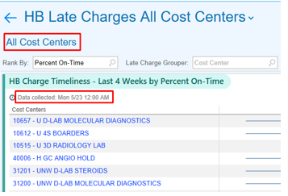  HB Charge Timeliness Last 4 Weeks by Percent On Time - % On Time  HB Charge Timeliness Last 4 Weeks by Percent On Time - Avg Chg Lag  HB Charge Timeliness Last 4 Weeks by Percent On Time - Late Chg Cnt  HB Charge Timeliness Last 4 Weeks by Percent On Time – Tot Chg Cnt  HB Charge Timeliness Last 4 Weeks by Percent On Time – Tot Chg Amt  HB Charge Timeliness Last 4 Weeks by Percent On Time - Tot Chg Amt  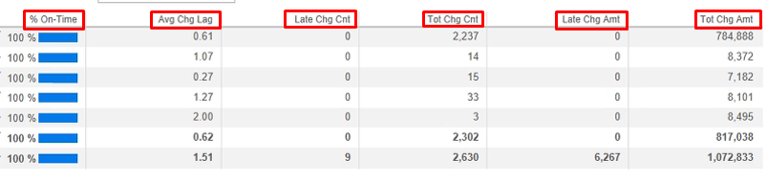
10.3.3 | Click back button back to “UWM Charge Capture Manager” dashboard | 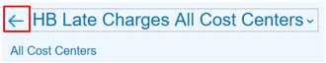
10.3.4 | Repeat 8.2 – 10.3.2 to get each Cost Center Metrics data from dashboard | 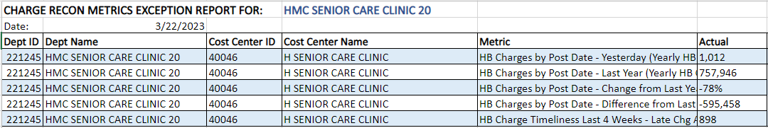
10.4 | Get Epic – RWB data - 31C group | Timeliness Of Closed Encounters
10.5 | In the “Revenue Guardian Encounter Report”,  1.get one Epic – RWB data.  Click “Revenue Guardian Encounters Report” | 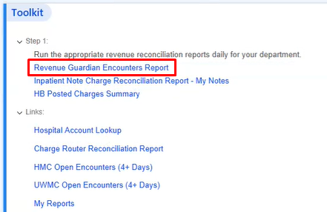
10.5.1 | Display “Find Scheduled Encounters and Admissions” window  On the left side, search “charge capture” on the Available Reports, then enter, display “Charge Capture Daily Reconciliation Base Report”, click it  check the Date Range | 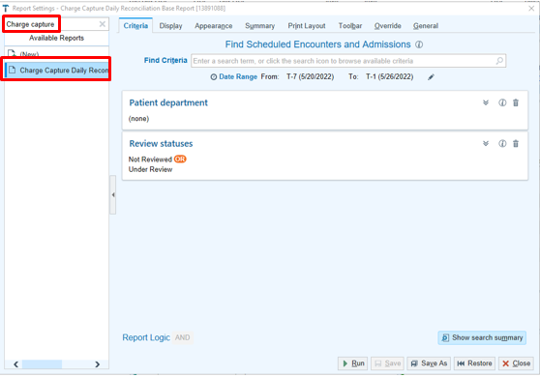
10.5.2 | Click “Edit” button to setup Date Range | 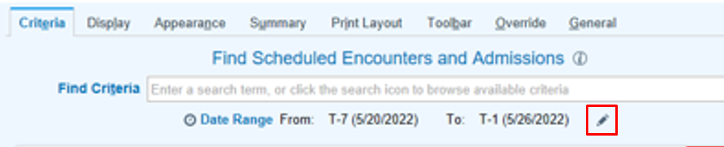
10.5.3 | Click trash can image to remove “Review statuses”  Click “Patient department” dropdown list to select department | 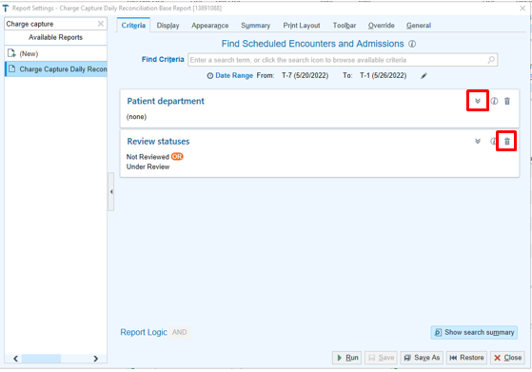
10.5.4 | Add patient department, click “Run” button  display “Encounter Status” report for one department  This report based on department level  If you do not choose the department, the report will add all the data for each department | 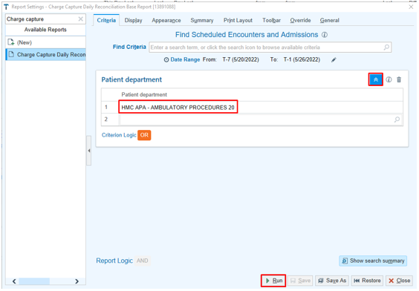
10.5.5 | Click on “Encounter Status” tab | 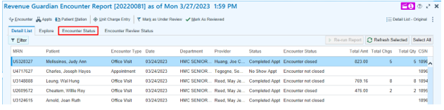
10.5.6 | Scrape Grand Total and Encounter Closed from Encounter Status Summary report to use to calculate “Timeliness of Closed Encounters” data | 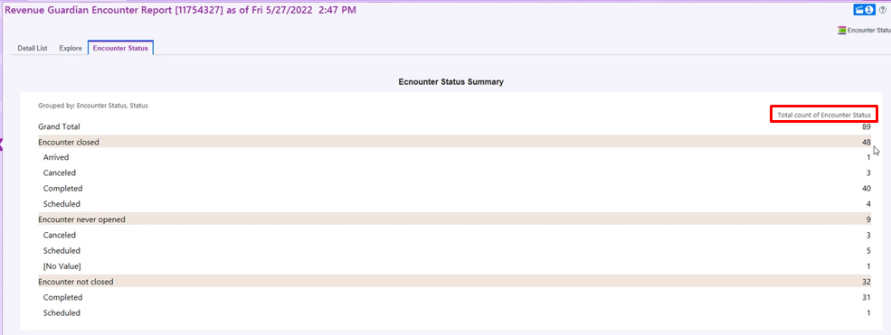
10.5.7 | If no “Encounter not closed” data, “Timeliness of Closed Encounters” data is | 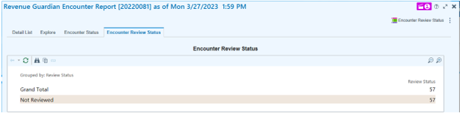
10.6 | Calculate the“Timeliness of Closed Encounters” | Timeliness Of Closed Encounters = 1 - (Encounter not close/Grand Total), change to percentage
10.6.1 | Get RWB data – Timeliness Of Closed Encounters | 'Based on "Encounter Status Summary" report, get “Timeliness of Closed Encounters” data
11 | Insert 12 metrics data and one Epic-RWB data to each Cost Center base on the input file with CC email account | 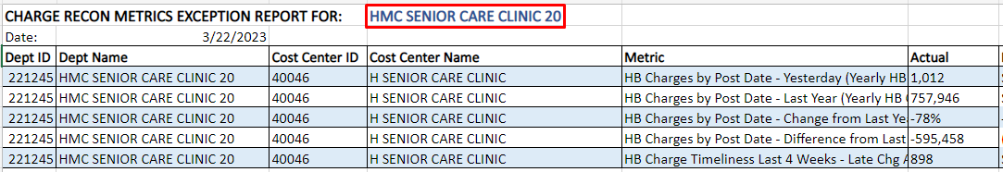
12 | Get Charge Log for All departments | Attached Charge Log for All departments
13 | Get Single Dept Notification requirement from this spreadsheet | 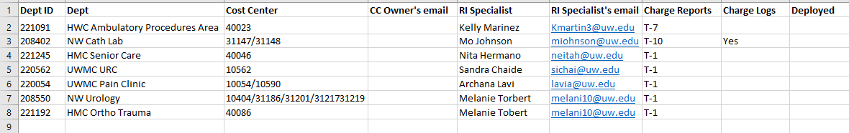
14 | Filter1 data for single department | For the Charge Log report, filter Charge log base on single department, location is same as department  get ALL cost center metrics for one department (because maybe one department has multiple Cost Centers)
15 | CL-1 to CL-23 | Filter “Charge Log” base on the single department  Attach “Charge Log” for one department based on input request
16 |  | email to the Cost Center, attach metrics data report and Charge log
Step | Short Description of Key Process Steps | Notes for getting Open Encouter report
OE-1 | Go through 1-8 | Navigate to “UWM Charge Capture Manager” dashboard
OE-2 | In the “Toolkit” section, click “HMC Open Encounters (4+ Days)” and click “UWMC Open Encounters (4+ Days)”  If no open encounters more than 4 days?  Then no Open Encounter (4+ Days) report | 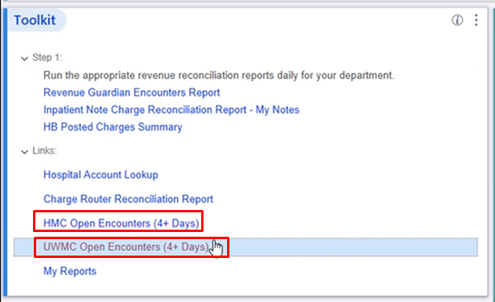
OE-3 | Run HMC and UWMC in parallel | 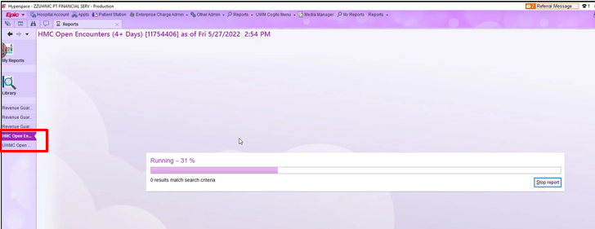
OE-4 | Display “HMC Open Encounters (4+ Days)” report for ALL department | 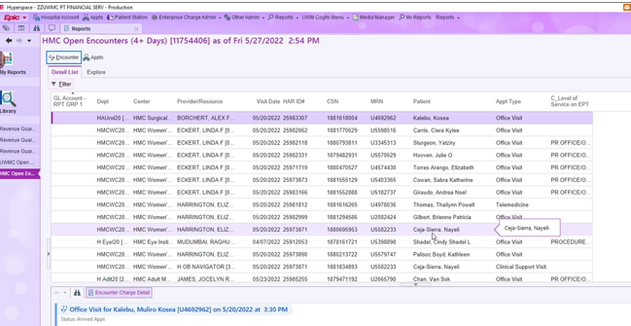
OE-5 | Display “UWMC Open Encounters (4+ Days)” report for ALL department | 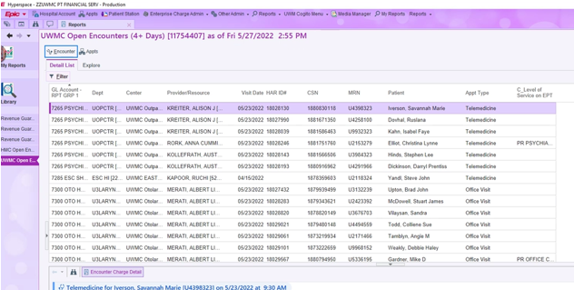
OE-6 | Click three dots on the right top corner and click “Export Results” export the results to a file | 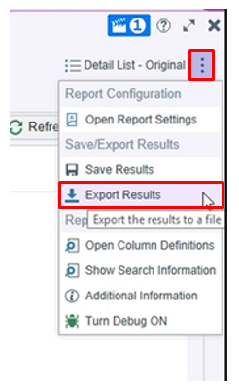
OE-7 | Filter the OE report base on the Cost Center

Step | Short Description of Key Process Steps | Notes for getting Charge Log
CL-1 | Go to Citrix Workspace, click Epic-HyperSpace button | 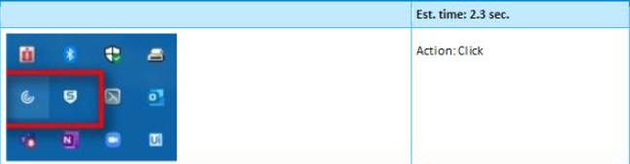  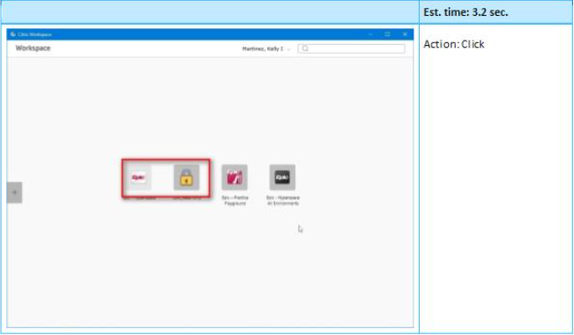
CL-2 | Login to Epic Hyperdrive | 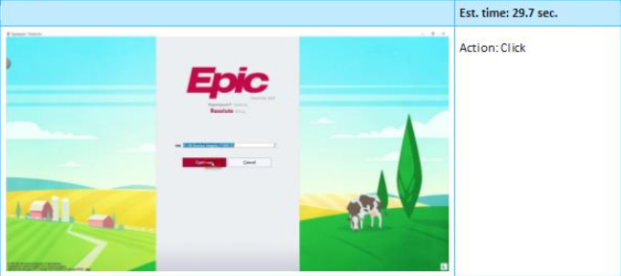
CL-3 | Click “Search” button to choose correct job ID | 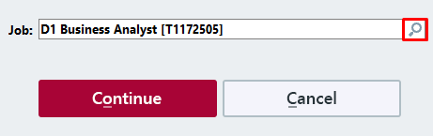
CL-4 | Choose Job ID T1085113, click “Accept” button | 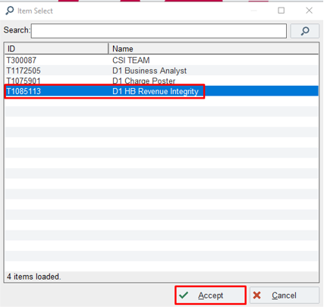
CL-5 | Job: D1 HB Revenue Integrity [T1085113]  Click “Continue” button | 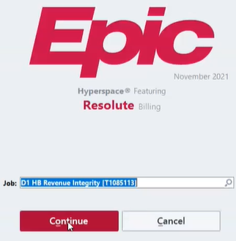
 | Click “Continue” button
CL-6 | Display  Hyperdrive – ZZUWMC PT FINANCIAL SERV | 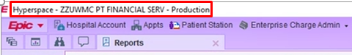  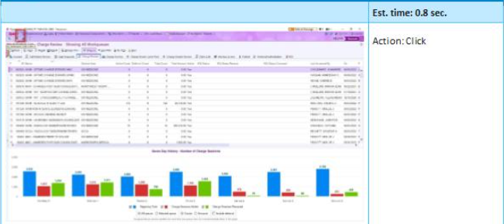
CL-7 | Display “Workqueue List – Charge Review – Showing All Workqueues” page  Click “My dashboard” button | 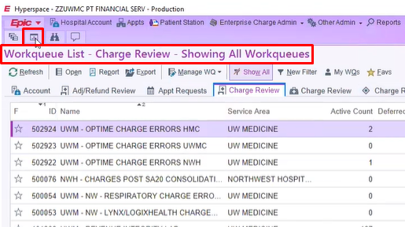
CL-8 | Navigate to “HB Revenue Integrity” page | 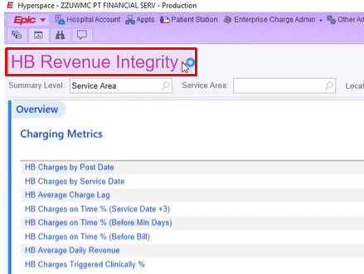
CL-9 | Click on the dropdown menu pop up window, search “Unposted”,  Then click “Show Catalog” button | 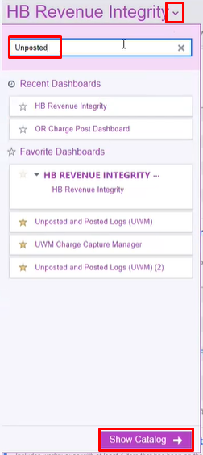
CL-10 | Click “Unposted and Posted logs(UWM)” image | 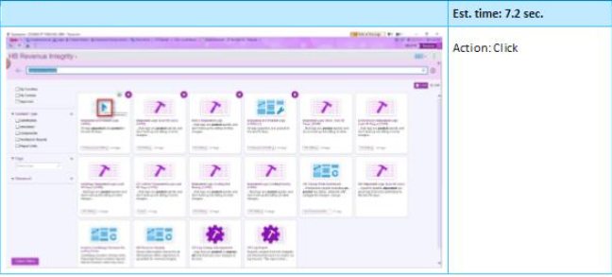  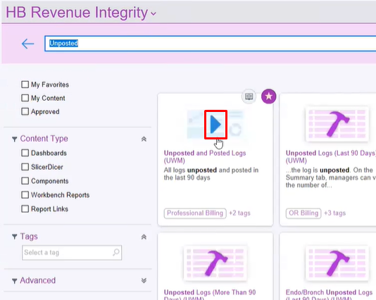
CL-11 | Click “Run Report” button to get report for ALL departments | 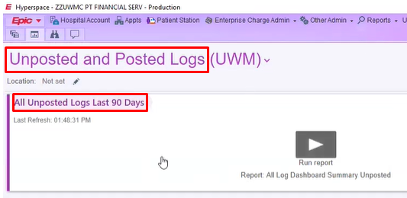
CL-12 | Get ALL departments charge logs  Location is generally one to one relation with department  Filter this report with all departments  that Avg Age > 3 days | 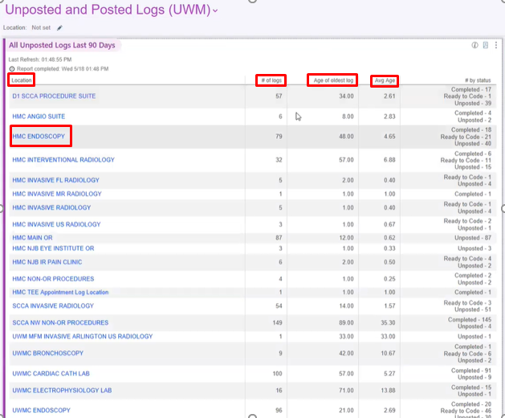
CL-13 | Click “view report” icon to display “All Log Dashboard Summary Unposted” report | 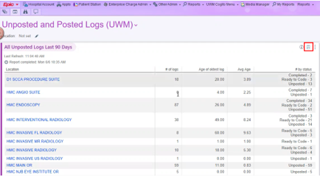
CL-14 | Display “All Log Dashboard Summary Unposted” report | 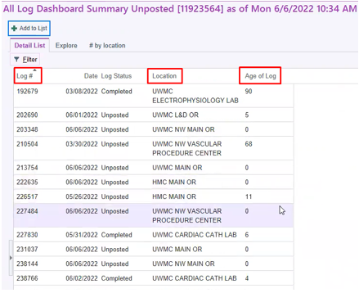
CL-15 | Hit the three dot buttons on the right top corner to export this report | 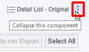  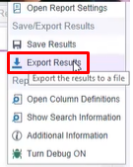
CL-16 | Save the report to Data/output directory, type password, then click “Accept” button | 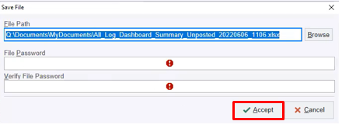
CL-17 | Once save the report, open it and filter it in the spreadsheet | 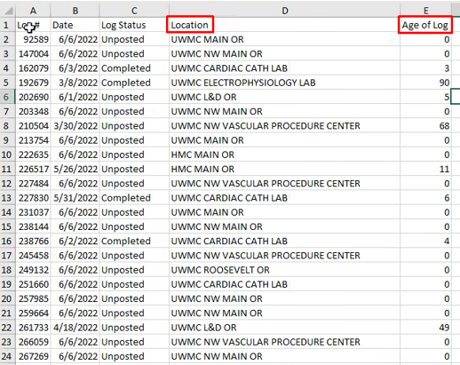
CL-18 | In the spreadsheet, click “Sort & Filter” dropdownlist, click “Filter | 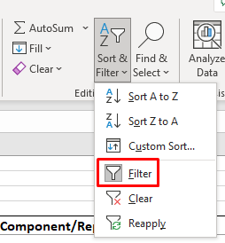
CL-19 | Filter “Age of Log” more than 3 days | 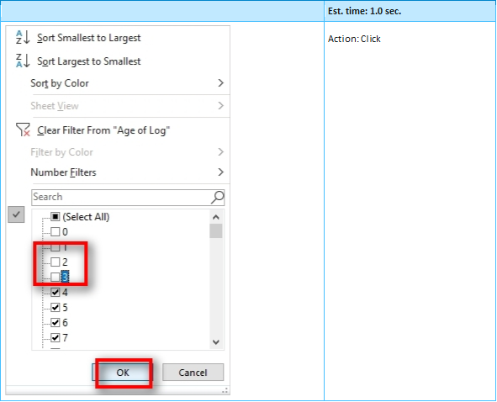
CL-20 | Filter “Location” exclude SCCA | 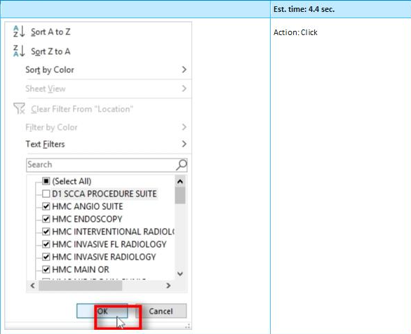  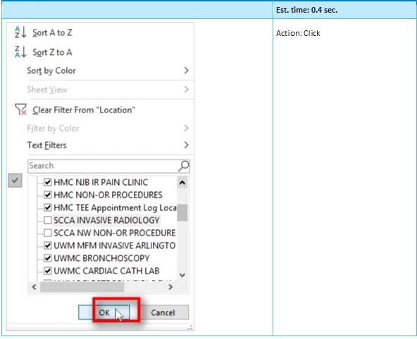
CL-21 | Sort Column “Location” | 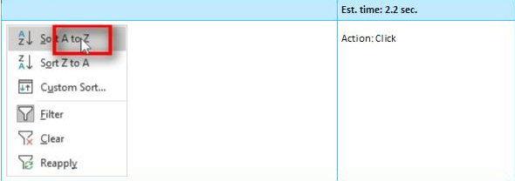
CL-22 | Get filtered and sorted report for ALL department | 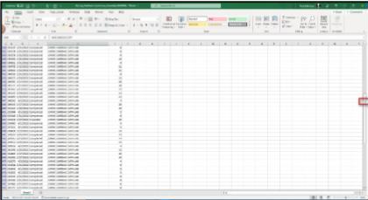
CL-23 | Filter this report | For single department Charge Log, filter this report with single department

 | Est. time: 54.7 sec.
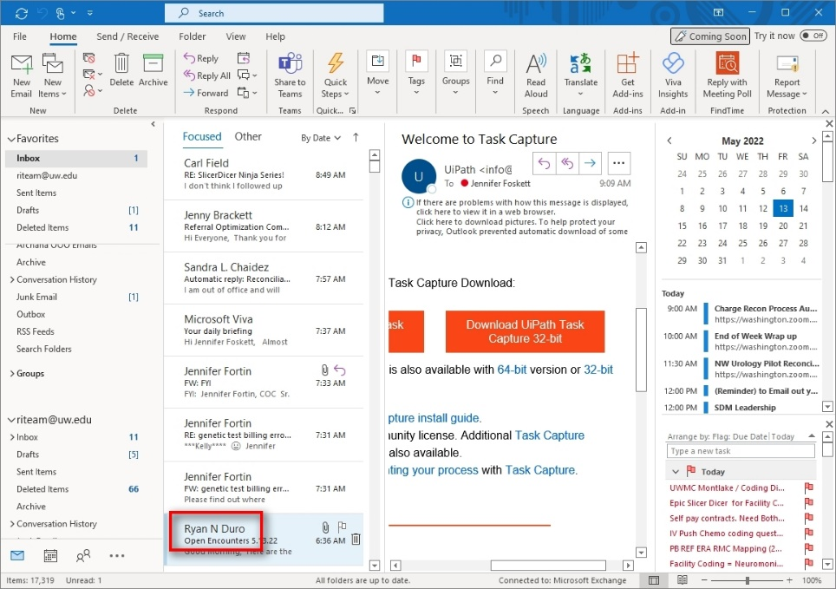 | Action: Click

 | Est. time: 2.5 sec.
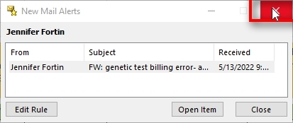 | Action: Click

 | Est. time: 1.6 sec.
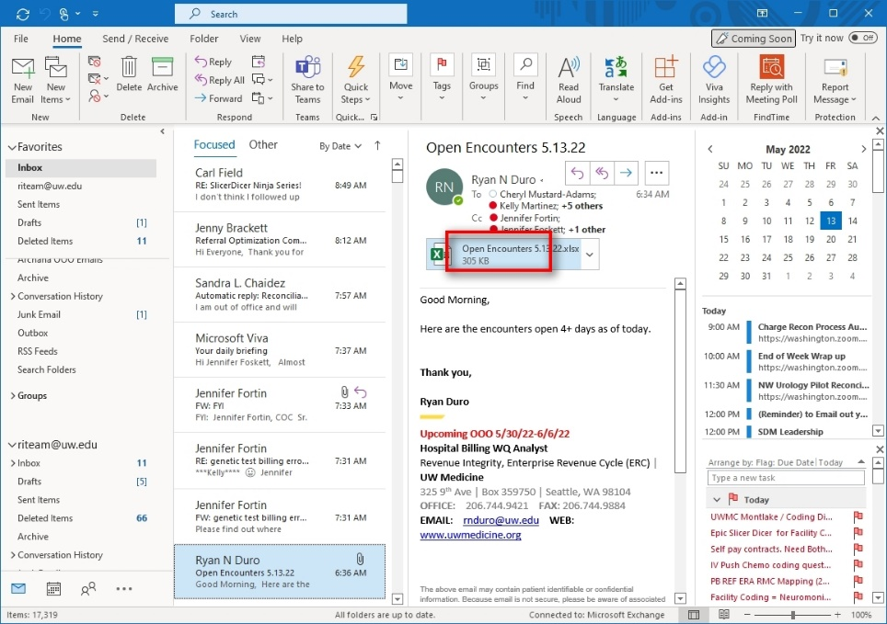 | Action: Double Click

Here are the scripts for the Charge Recon emails:

INDIVIDUAL cost center NOTIFICATION for metrics report and charge log

Dear (Cost Center),

We have attached important information related to your charge reconciliation metrics that are directly impacting the revenue of your department.
CostCenter.xlsx
Please review this information. If your department does not use charge logs, you will not get a report.
Remember, you also have access to your Dashboard in Epic, for “how to” instructions click here.
Finally, to run your department charge reconciliation report(s), for “how to” instructions click here.
If you have questions, please contact your Revenue Integrity Specialist.
Thank you,

Revenue Integrity Team, Enterprise Revenue Cycle
riteam@uw.edu

INDIVIDUAL DEPT NOTIFICATION for Open encounters report
Dear (department),
We have attached important information related to your open encounter metrics that are directly impacting the revenue of your department.
Department.xlsx
Please review this information.
Remember, you also have access to your Dashboard in Epic, for “how to” instructions click here.
Finally, to run your department charge reconciliation report(s), for “how to” instructions click here.
If you have questions, please contact your Revenue Integrity Specialist.
Thank you,

Revenue Integrity Team, Enterprise Revenue Cycle
Email: riteam@uw.edu

Input Data Description
The following table should contain details regarding the inputs that every action of the process takes.
#Action | Sample | Input Type | Location | Are inputs Natively Digital*? | Are the Inputs Structured*?
1 | REV queue | Dictionary | spreadsheet | Yes | Yes

* Native Digital: This is data that was originally created digitally e.g. excel, database or application reports etc. The non-native digital inputs are usually scanned images.
* Structured Data: has a predictable format and exists in fixed fields (e.g. an excel cell or a field in a form) and is easily detectable via search algorithms.

TO BE Process description

In this section the proposed improvements to the process, actions to the process will be outlined as well as the actions proposed for automation and the type of robot required. This will be cross-checked by the Solution Architect.

Detailed TO BE Process Map
A detailed process map of the process as it will look like post-automation will be outlined here.
Highlight Bot interventions/ To-Be automated actions with different legend/ icon (purple).
Mention below if process improvements were performed on the To-Be design and provide details.

Mock output REPORT2
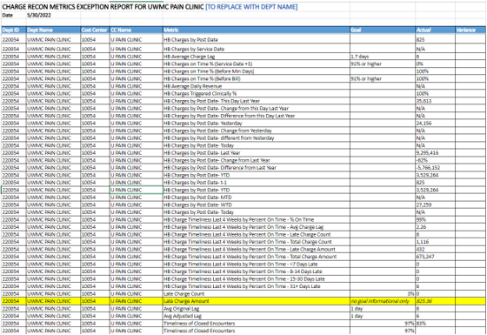

Parallel Initiatives
The table below will capture the proposed Business, Process or Application changes to be made in the near future that would impact the process at hand (if any).
Initiative Name | Process Action(s) where it is identified | Impact on current Automation Request | Expected Completion Date | Contact Person
N/A

In Scope For RPA
As-Is process is in scope for the automation.

Out Of Scope for RPA
The actions out of scope for RPA should be listed in the table below together with the reasoning.
Activity/Action* | Reason for out of scope | Impact on the TO BE | Possible measures to be taken into consideration for future automation
N/A | N/A | N/A | N/A
*Add more rows to the table to reflect the complete documentation provided to support the RPA process.

Exceptions Handling
The Business Process Owner and Business Analysts are expected to document below all the business exceptions identified in the automation process. Exceptions are of 2 types and both need to be addressed:
Known exceptions = previously encountered. A scenario is defined with clear actions and workarounds for each case.
Unknown = New situation that was not encountered before. It cannot be predicted and in case it happens it needs to be flagged and communicated to an authorized person for evaluation.

Known Business Exceptions
Details regarding how the robot should handle the exceptions.
Exception Name | Action | Parameters | Action to be taken
Login validation issue | Re-login | N/A

3.5.2 Unknown Business Exceptions
An umbrella rule that includes a notification needs to be designed for all other exceptions that could happen and cannot be anticipated.
e.g.: for all other cases which do not follow the rules defined an e-mail should be sent to: exceptions@company.com with a screen shot and robot should proceed to next transaction.

3.6 Applications Errors & Exceptions Handling
A comprehensive list of all errors, warnings or notifications should be consolidated here together with the action to be taken for each by the Robot. There are 2 types of exceptions/errors:
Known = Previously encountered and action plan or workaround available for it (e.g. SAP unresponsive during peak times)
Unknown = these are exceptions and errors that cannot be anticipated but for which the robot needs to have a rule so that the RPA solution is sustainable.

3.6.1 Known Applications Errors and Exceptions
Details regarding how the robot should handle the exceptions.
Error/Exception Name | Action | Parameters | Action to be taken
Epic Hyperapace website , crash, or incorrect credentials | Send nitification | Error message | recover and retry 3 times
 | Send nitification

3.6.2 Unknown Applications Errors and Exceptions
An umbrella rule that includes a notification needs to be designed for all other exceptions that could happen and cannot be anticipated.
e.g. robot should attempt to access the application 3 times then it should terminate thread.

3.7 Reporting
In this section all the reporting requirements of the business should be detailed so that when the RPA solution is moved to production the administrators can track the performance of the solution.
Report Type | Update frequency | Details | Monitoring Tool to visualize the data
Single department daily report | Daily | e.g. How many robots worked on this process per each month? | e.g. Csv file posted daily on share drive
Open Encounters report | Daily | e.g. How many transactions were run by this process since the beginning of the month and what was the average transaction duration? | e.g. Kibana
Charge log report | Daily | e.g. How many transactions were run by this process since the beginning of the month and what was the average transaction duration? | e.g. Kibana
* For complex reporting requirements, include them into a separate document and attach it to the present documentation

Other

Additional sources of process documentation
If there is additional material created to support the process automation please mention it here, along with the supported documentation provided.

Additional Process Documentation
Video Recording of the process (Optional) | Acme-System1-Process-WI5-Manual-Walkthrough | Insert any relevant comments
Business Rules Library (Optional) | Insert link to Business rules library | Insert any relevant comments
Other documentation (Optional) | Insert link to any other relevant process documentation (L4, L5 process description, fields mapping files etc.) | Insert any relevant comments
Standard Operating Procedure(s) (Optional) |  | Insert any relevant comments
High Level Process Map (Optional) |  | Insert any relevant comments
Detailed level process map (Optional) |  | Insert any relevant comments
Work Instructions (Optional) |  | Insert any relevant comments
Input Files (Optional) |  | Insert any relevant comments
Output Files (Optional) |  | Insert any relevant comments
*Add more rows to the table to reflect the complete documentation provided to support the RPA process.

