
The Seven Core Structures of an RPA Process
This paper will serve as an informative guide to building UiPath projects and will help identify the core components of a project. It will outline these concepts in a basic process, then map them to the Robotic Enterprise Framework.

What is a “core component”? In short, it’s a recognition of the automation states that all automations move through to accomplish their tasks, expressed as high-level containers. The easiest way to demonstrate this idea is to walk through each core component and its responsibilities while sketching them out in a simple process. These core components are as follows: primary flow, data retrieval, cleanup, login, setup, the core loop and results.

The Simple Project
At the head of every simple process is the primary flow, the first of our core components and the home base for any automation project. The primary flow is the first sequence/workflow in your project and contains all others. It serves as the basic organizational structure for your project, the highest scope for your variables, and a place to leave notes, reminders, and warnings for yourself and others who work on the process going forward. It is highly recommended that you delete the sequence that populates here by default and replace it with a flowchart activity, as will be the case for the rest of this example.

After establishing your primary flow, the next core component you will encounter is data retrieval. This is the part of your bot where you check to see if you have any data available for processing. If not, your process ends with minimal time wasted. If data is available for processing, this is where it is brought in. Ideally, a database is used for this, but any construct that allows the entirety of the data to be brought in as a data table will work.

After verifying that there is indeed work to be done and retrieving said information, the process moves to a cleanup phase. Cleanup is when the bot cleans its workspace in preparation for its work. This means making sure that all applications on the workspace are closed. Usually, this is done by killing a list of applications known to be used in the environment to ensure they are closed. This reduces faults caused by unrelated applications being opened at runtime, or applications left in an incorrect state for use.

Once the cleanup is complete, we can move on to the next core component: Login. The login component does more or less what it says. It logs into the applications we want to work in. This can sometimes pose a bit of a challenge, depending on your application and whether MFA (multi-factor authentication) is required. By this point, we have confirmed that we A: have data to work on and B: have a clean environment to work in. Now we can begin preparing to do the work. Just to make it as clear as possible, this component only handles login and multifactor authentication; anything more complex will be handled by the next component.

Now for an intermediary component that often gets broken up and scattered throughout your code that really needs to have its own place to live. Setup. The setup component is responsible for getting an application into the desired application state for the core loop of your process. This can be as simple as a few activities that navigate you to a particular web page or as complex as setting up search filtering. It’s nice to have this section separate so when issues occur, they will be easy to recognize and fix. It is highly recommended that this section be its own distinct workflow in a process.

Finally, we come to the core component considered the “meat and potatoes” of any process: The Core Loop. This is where all the work gets done, where your business logic lives, and where your bot iterates over its queue row by row to perform its work. In a basic process, this is usually in a “for each” loop. There isn't much detail to add here, as this component is simultaneously the most complex and the most variable across processes. Just make sure whatever you do here meets your organization's coding standards and includes the next core component.

The last core component of any RPA process is the results component. This one is a bit strange as it’s the only one in a basic process that is nested inside another. As a rule, the results component is nested inside the core loop. This is because it needs to happen every time that loop finishes an iteration. Essentially, this is the last step of the core loop; it is useful to consider it a separate component as its function is entirely different from the previous. Whereas the core loop performs the work to be done, the results component captures it. In short, it handles all the data resulting from the work. This needs to be captured row-by-row for data integrity, should the process fail. Ideally, this outputs to an SQL table. Massage your data into whatever form it needs to be in and capture it. Below is a quick sketch of what the end results of a simple project should look like:
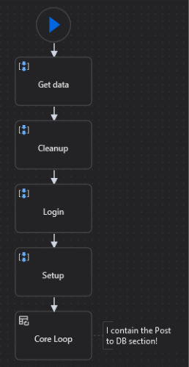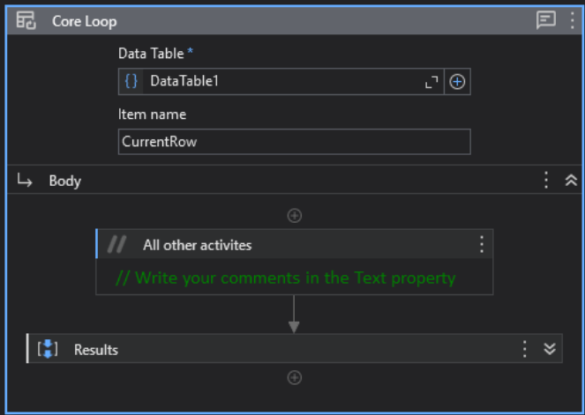

REF & Core Structures
Now that we have an understanding of what each core component is and its place in an automation's function, we can begin mapping it onto other structures, particularly the Robotic Enterprise Framework. The Robotic Enterprise Framework (REF) includes several default workflows that are preconfigured with information. Many of these are not necessary to edit to get a REF project to do what we want it to do. However, there are several workflows in the REF structure we do need to change. These workflows tend to line up nicely with some of our core components, merely in a slightly different order.

Let's start off with the “General Business Logic” workflow. This section corresponds to the primary flow component from our basic project. Unlike our basic project, it comes mostly filled out for us. This particular section doesn't need any development work performed on it. It is worth mentioning, as you will regularly loop through this section when navigating the REF. Like our primary flow component, this organizes the state machine that makes up the beating heart of the REF.

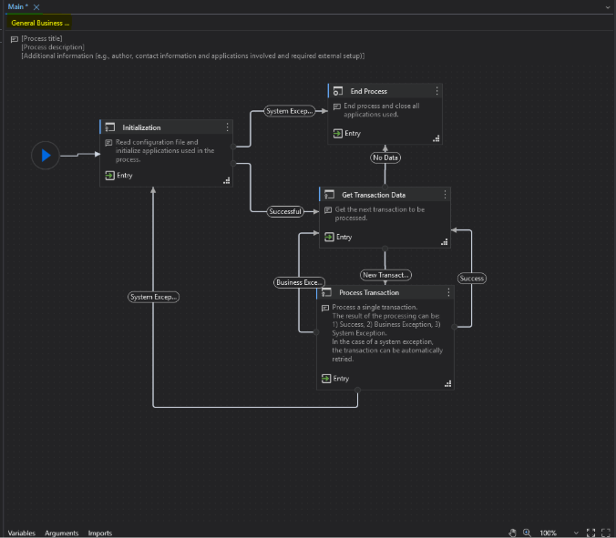

The second REF workflow that lines up nicely is KillAllApplications. This workflow provides you with a space to create the cleanup section of your process. Note that this happens before we check whether we have data to process. This workflow is also invoked twice, once during initialization and once in the end process section

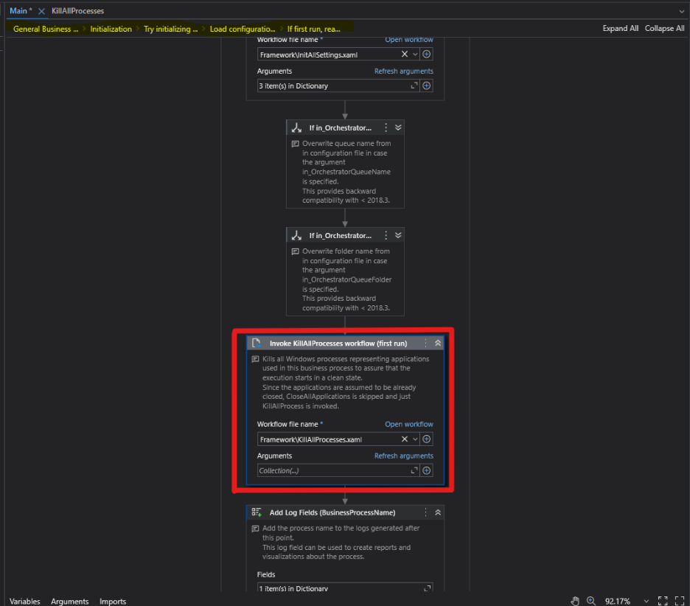

Next up is InitAllApplications. This workflow will contain several core components, namely your login and setup components. You can keep these separated inside this workflow for debugging, but both correspond to this section. This entire workflow sets up your process for the main event: logging in and performing the setup required for your primary flow.

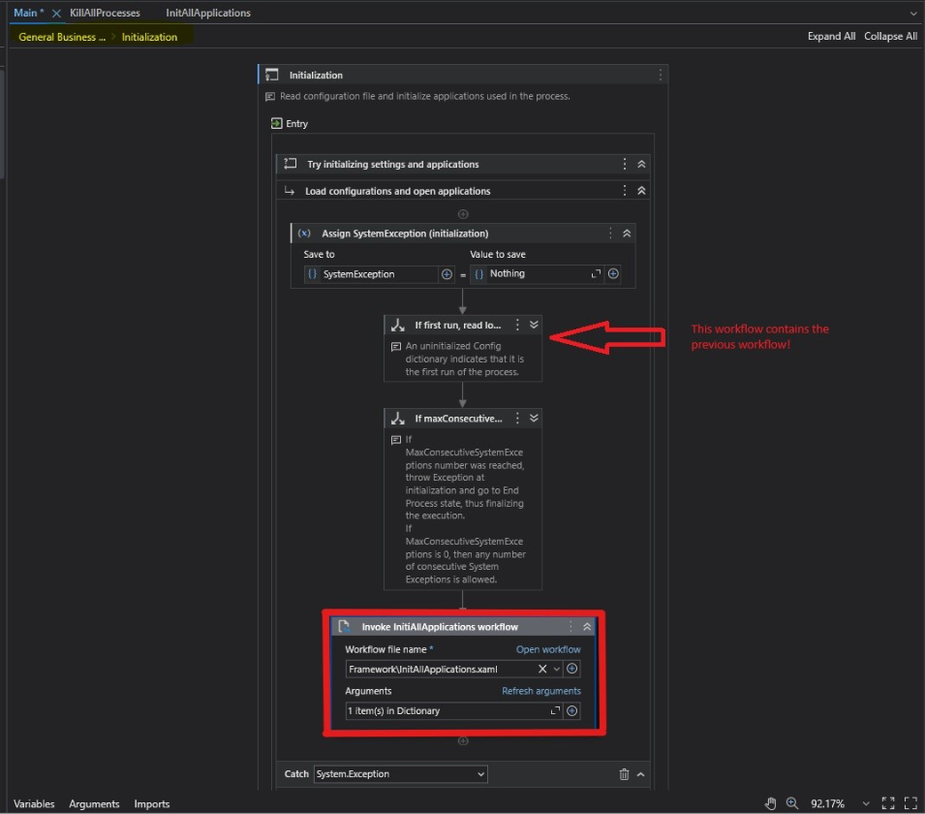

After the InitAllApplications workflow comes the GetTransactionData workflow. Note that this workflow doesn't require any development; you only need to set the queue name in the config file for this section to work properly. However, this section does line up with the function of our data retrieval core component, so it’s worth calling out.

Following that, the REF flows to the Process workflow, which lines up perfectly with the core loop component from our simple process. This is where you will build out the core functions of your process. The only difference between this and our simple process is that the results component isn't nested inside; it resides in the next workflow.

The last step in the REF and the last mapping for our core components is SetTransactionStatus. This section coincides with the results core component. In this section, you're going to want to add some code at the end of this workflow to make sure that your resulting data outputs to the correct place. This is also where the status of the queue items that the REF requires is set. You most likely won't need to touch these, rather, make sure that all three options flow through whatever you're using to record output results.

