Business Summary
The DUHS Bank Deposit Report is obtained, summarized, and distributed by the PRMO Cash Management and Payment Application Team. This process includes accessing the deposit download, separating the deposits by payment types for use in the PRMO Daily Deposit Report and the Cash Models, and emailing it to various DUHS stakeholders. The effectiveness of this report will result in every user, regardless of his/her reporting or reconciliation process, being able to verify that all deposits agree with the Bank Deposit Report. Use of a virtual workforce to automate these simple and repetitive steps would allow the Cash Management and Payment Application Team to focus FTE efforts on higher level activities.

Business Value
Financial Reports form the backbone for financial planning, analysis, benchmarking, and decision making. Deposits made to any organization are a vital part of preparing these financial reports. The DUHS Deposit Download begins with accessing deposits from Wells Fargo Bank. These deposits are then separated by type of payments, summarized, and then balanced with the Bank ZBA total. The Deposit information is formatted and summarized to be used for reporting reconciliation. All reconciliation documents are stored electronically and archived for seven years in accordance with PRMO Cash Management and Payment Application’s financial retention policy.

Introducing bot technology to access, download, separate, summarize, balance, format, and distribute the DUHS Bank Deposit Report will:
- Shift 5 hours per week of labor/time from manual work to critical thinking activities.
- Provide an automated method for routinely validating the DUHS Bank Deposit Report file.

Success can be measured by:
- Reduction in time spent manually preparing the DUHS Bank Deposit Report.

Data Flow Diagrams
High Level DUHS Deposit Report Process

Programming Requirements
Blue Prism
Build a bot that does the following:
- Every weekday, get the daily DUHS Deposit Report (sent via Wells Fargo Autolink) from the BOT_Daily DUHS Detail Deposit Report folder on the shared drive.
  - Report location: \\duhsnas-pri\prmo_departments\Private\Cash Management - Staff\Reports\Bank Download\DUHS Bank Downloads\DUHS BANK STATEMENTS\BOT_Daily DUHS Detail Deposit Report
- Save the daily DUHS Deposit Report as a collection in Blue Prism, then move it to the BOT_Archived Reports folder on the shared drive.
  - Folder location: \\duhsnas-pri\prmo_departments\Private\Cash Management - Staff\Reports\Bank Download\DUHS Bank Downloads\DUHS BANK STATEMENTS\BOT_Archived Reports
- Clear the existing data from any previous reports from the running macro workbook, then paste the data from the daily DUHS Deposit Report into the macro workbook.
- Populate the Order Category for each row of data using Descriptive Text 1 as the key column heading (see crosswalk below), then sort the data alphabetically by Order Category.
- Refresh the pivot table of the new daily DUHS Deposit Report data, calculate the data of the previous working day that corresponds with the new data, then save the report to the BOT_Completed Daily DUHS Detail Deposit Reporter folder on the shared drive using the date of the previous working day.
  - Folder location: \\duhsnas-pri\prmo_departments\Private\Cash Management - Staff\Reports\Bank Download\DUHS Bank Downloads\DUHS BANK STATEMENTS\BOT_Completed Daily DUHS Detail Deposit Report
  - NOTE: The key identifying data field in the Wells Fargo DUHS Deposit Report is the ‘Descriptive Text 1’ column, which should be used to separate the raw data into the corresponding Order Categories. For example, if ‘Descriptive Text 1’ equals BCBS, then write/move row to ‘Order Category’ BCBS.
    - Every weekday, get the Monthly DUHS Deposit Report if it is not the first day of the month, or create a new Monthly DUHS Deposit Report if it is the beginning of a new month, paste the data from the pivot table of the Daily DUHS Deposit Report onto the corresponding row by date, then save it to the BOT_Monthly DUHS Deposit Report folder on the shared drive.
- Folder location: \\duhsnas-pri\prmo_departments\Private\Cash Management - Staff\Reports\Bank Download\DUHS Bank Downloads\DUHS BANK STATEMENTS\BOT_Monthly DUHS Deposit Report
- Email the desired stakeholders to let them know if the bot ran successfully or if it failed. If the bot ran successfully, notify the stakeholder that the daily report is ready for viewing/downloading. If the bot failed, notify the stakeholders that the bot and/or the report process(es) need to be reviewed and fixed.

Notes:
- Wells Fargo often (e.g., twice per year) updates aspects of their reports (e.g., file names, column headings), but they should provide notification months in advance of any changes. These changes may break the bot, so staff will need to run the report manually until the bot is updated if/when this occurs.
- The DUHS Bank Deposit Report is created using the Transaction Detail Report (not the Balance Detail Report), and the account number ends in 9580. (NOTE: The new report created for this project no longer includes the Balance Detail Report.)
- Issue/Exception: Medicare pass-through payments occur biweekly (non-patient payment). Kirti will share information about this scenario so it can be accounted for or kicked out as an error.

Crosswalk of Descriptive Text 1 and Order Categories

Wells Fargo-DUHS Bank Deposit Report (Raw Data Example)

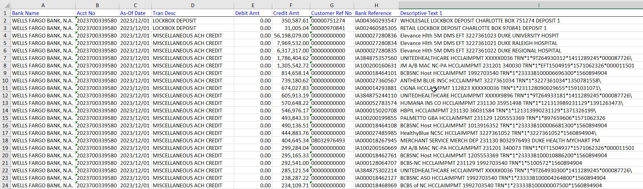

Wells Fargo-DUHS Bank Deposit Report (Summarized Data Example)

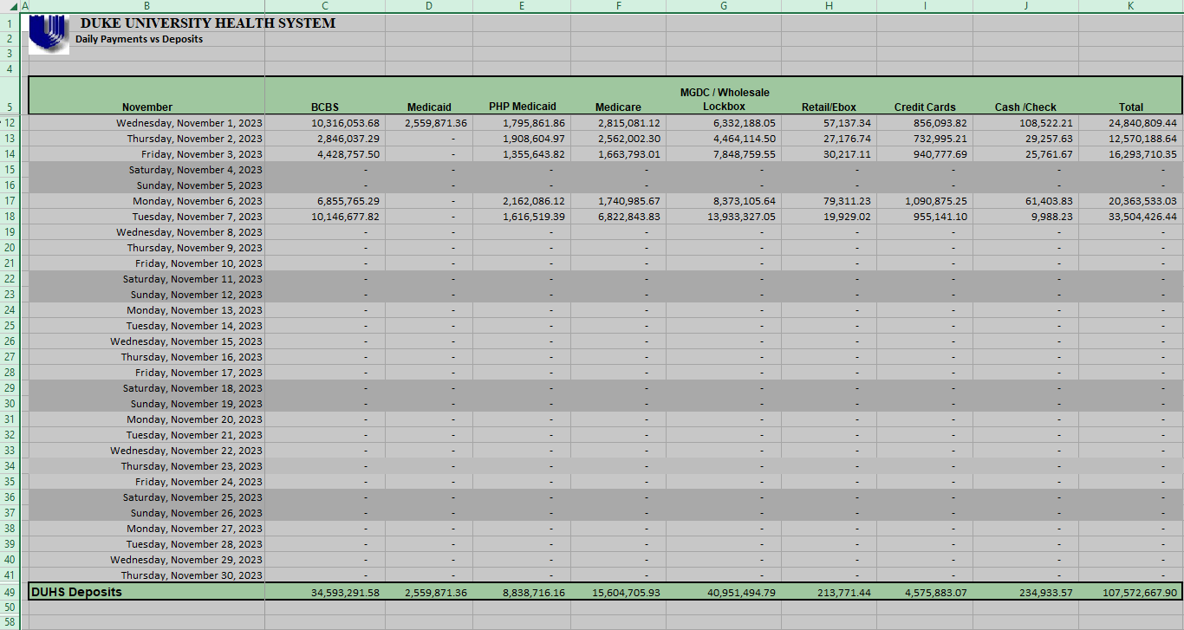
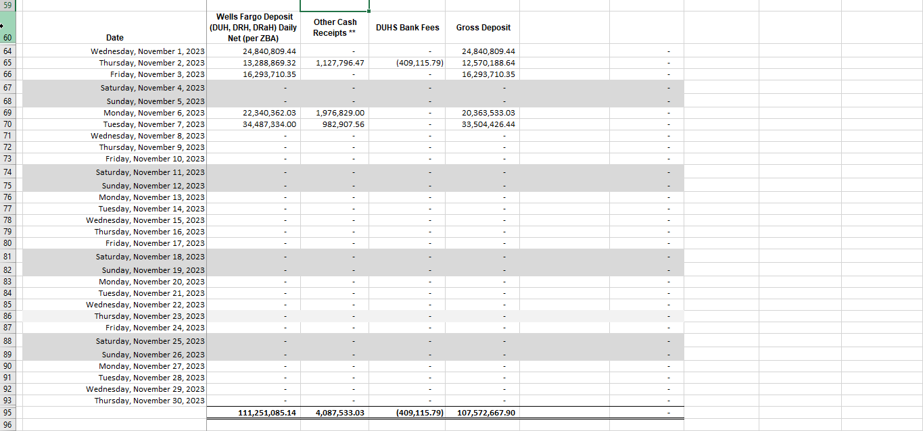
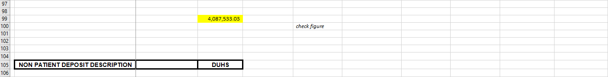

Frequency & Downtime Impact
Frequency
- The bot will run weekday mornings at 5:30 am, and the daily Wells Fargo Autolink report will be saved to the following shared drive location around 5:00 am or shortly thereafter.
  - Name of daily reports from Wells Fargo Autolink: DUHS Deposit Report-Previous Business Day-BOT-YYYYMMDDHHMMSS.xlsx.
  - Location where daily Wells Fargo Autolink reports will be saved, and location where bot will pick up daily saved reports: \\duhsnas-pri\prmo_departments\Private\Cash Management - Staff\Reports\Bank Download\DUHS Bank Downloads\DUHS BANK STATEMENTS\BOT_Daily DUHS Detail Deposit Report
  - Location where completed daily files with order categories and pivot table will be saved: \\duhsnas-pri\prmo_departments\Private\Cash Management - Staff\Reports\Bank Download\DUHS Bank Downloads\DUHS BANK STATEMENTS\BOT_Completed Daily DUHS Detail Deposit Report

Impact of downtime
- No impact

Test Plan
The automated report will be manually reviewed for accuracy by the Cash Management and Payment Application Team as needed to correct any issues and/or report any feedback to the Operations Improvement team to update the bot.

Outstanding Design Issues

Date | Status | Review w/ | Description | Response

Reviewed and approved by RPA Governance: TBD
Attendees: TBD

